

**MSc Project**

**7 COSC012W.3**

**Comparing Sentiment Analysis on Social Media and E-commerce Platforms:**

**Apple Products**

**Hasan Enes Guray**

**Student ID: 19489124**

**MSc Data Science and Analytics student**

**University of Westminster**

**Supervisor: Amit Banik**

**Words Count: 15376**

Table of Contents

1 INTRODUCTION 7

1.1 Aims 7

1.2 Objectives 7

1.3 Design 8

1.3.1 Gathering Data 8

1.3.2 Storing Data 8

1.3.3 Cleansing and Preprocessing Data 9

1.3.4 Sentiment Analysis 9

1.3.5 Machine Learning Model Building 10

1.3.6 Visualisation and Evaluation 10

1.4 Requirements Analysis and Specification 10

2 LITERATURE REVIEW 10

3 IMPLEMENTATION 12

3.1 Data Formatting and Cleansing 12

3.1.1 Introduction 12

3.1.2 Data Collection 12

3.1.3 Pre-processing and Cleaning 14

3.1.4 Summary 18

3.2 Analysis and Findings 19

3.2.1 Introduction 19

3.2.2 eBay 19

3.2.3 Amazon 41

3.2.4 Reddit 61

3.2.5 YouTube 82

3.2.6 Comparison 103

3.2.7 Summary 107

3.3 Testing with Machine Learning Model 107

3.3.1 Introduction 107

3.3.2 Preprocessing for Model 108

3.3.3 Model Results 109

3.3.4 Summary 113

4 ISSUES AND CHALLENGES 113

5 EVALUATION 114

5.1 Introduction 114

5.2 Conclusion of the Objectives 114

5.2.1 Comparative Evaluation of Sentiment Analysis Methods 114

5.2.2 Comparative Sentiment Analysis of Apple Products 114

5.2.3 Analysis of Dominant Emotions Across Platforms 115

5.2.4 Analysis of Sentiment Trends and Key Themes in Consumer Perceptions 115

5.2.5 Utilizing Sentiment Analysis for Strategic Business Insights 116

5.3 Limitation and Future Work 116

5.4 Project Success 116

5.5 Summary 117

6 REFERENCES AND BIBLIOGRAPHY 118

7 APPENDICES 120

A Project Timeline 120

B Project Methodology 120

C Python Code – eBay Scrape 121

D Python Code – Amazon Scrape 121

E Python Code – Reddit Scrape 123

F Python Code – YouTube Scrape 124

G Python Code – EDA 125

H Python Code – Machine Learning Model 132

**DECLARATION**

I, Hasan Enes Guray, hereby affirm that my MSc Project is exclusively the product of my own endeavours. I confirm that all sources utilized or cited have been duly acknowledged and consulted throughout the course of my research. This project is a comprehensive representation of my own efforts and is consistent with the specified word count criteria.

Furthermore, I certify that this work has not been submitted for any other degree or professional qualification and is a unique submission for the purpose of my MSc degree.

Signed:  
Date: 11/01/2024

**FORM OF CONSENT**

I, Hasan Enes Guray, grant my permission for this project, presented as a partial requirement for the attainment of the MSc degree, to be accessible in both printed and digital forms for purposes such as inter-library lending or photocopying, in compliance with copyright laws. Additionally, I agree to the public disclosure of the project's title and abstract to external entities.

Signed:  
Date: 11/01/2024

ABSTRACT

This research paper presents an extensive sentiment analysis of Apple products across various social media and e-commerce platforms, specifically focusing on Amazon, eBay, Reddit, and YouTube. The primary objective is to understand and compare public sentiment on these platforms using advanced data science techniques, including topic modelling and sentiment analysis methods like Naïve Bayes, VADER, SocialSent, and LexMo. The study encompasses the entire process from data collection, storage, cleansing, and preprocessing to the construction of machine learning models. Data collection involved sophisticated scraping techniques, overcoming challenges such as Amazon's stringent security protocols. The preprocessing phase utilized libraries like Pandas and nltk, ensuring data integrity and relevance. The sentiment analysis delved into emotional analysis and linguistic patterns, identifying key feedback aspects from user comments. A novel machine-learning model was developed, focusing on classifying user sentiments from ratings. The findings of this research offer a comprehensive understanding of consumer attitudes and preferences towards Apple products across different digital platforms, providing valuable insights for business strategy development and contributing to the advancement of sentiment analysis methodologies. This comparative analysis is significant for its holistic approach, bridging the gap in understanding how public sentiment varies between social media and e-commerce environments.

**Keywords:** Sentiment Analysis, Apple Products, Data Science Techniques, Consumer Attitudes, Social Media Platforms, E-commerce Websites.

**Acknowledgements**

I express my gratitude to Amit Banik, my project supervisor, for providing unwavering support and direction throughout the project, particularly during the initial planning phase and the critical analysis of my project, which greatly contributed to its continued development.

# INTRODUCTION

In the contemporary landscape of digital advancements, the proliferation of opinions and assessments on the internet has become crucial for businesses and academic investigations. This significance stems from the ability to understand the consensus of individuals. Sentiment analysis, an expanding branch within data science, utilizes algorithmic techniques to decode nuanced emotional nuances in written material. The objective of this study is to undertake an analytical comparison of public sentiments about Apple's products, an influential entity in the technology industry. It intends to assess their portrayal on two significant platforms: social media and e-commerce websites.

In the field of Natural Language Processing, one specialized area is sentiment analysis. This process involves examining and categorizing emotions found within the text to provide a deeper understanding of consumer sentiments and preferences. Given the fast-paced nature of the technology sector, where customer opinions greatly impact brand image and product viability, the importance of sentiment analysis becomes increasingly evident. This is particularly relevant for global brands like Apple, whose products spark widespread discussion across various digital forums.

This research aims to compare and contrast sentiment analysis methodologies applied to Apple products on distinct platforms, which are social media (like YouTube and Reddit) and e-commerce sites (such as Amazon and eBay). By employing advanced data science techniques, including topic modelling this study seeks to uncover the nuances of public sentiment in different online environments.

The significance of this study lies in its holistic approach to sentiment analysis. While most research focuses on a single platform, this project endeavours to provide a comparative analysis, offering a more comprehensive understanding of consumer sentiment. This could have profound implications for business strategies, especially for tech companies striving to understand their market position and consumer expectations.

## Aims

The project aims to investigate user sentiments related to Apple products across diverse digital platforms. It seeks to understand how these sentiments change between social media and e-commerce platforms for business strategies. Additionally, the project aims to contribute to the development of sentiment analysis methodologies within the digital landscape on language processing and sentiment analysis techniques.

## Objectives

* Compare and contrast different sentiment analysis methods like Naïve Bayes, VADER, SocialSent, and LexMo for social media and e-commerce text data, observing they accurately interpret sentiment while considering platform changes, and product features.
* Perform an in-depth comparative sentiment analysis on discussions surrounding Apple products, encompassing both social media and e-commerce platforms, utilizing advanced data science techniques(natural language processing, topic modelling, etc.).
* Investigate and analyse the dominant emotions people feel on separate platforms about Apple products to understand sentiment trends.
* Discover common sentiment trends, key themes, important keywords, and significant topics to understand what influences people's opinions about Apple products on social media and e-commerce platforms.
* Assess how sentiment analysis can benefit business strategies, including innovation, marketing choices, and customer satisfaction, with a specific emphasis on offering actionable advice for companies like Apple.

## Design

### Gathering Data

In this study, data acquisition focused on sentiment analysis comparison between e-commerce platforms and social media, specifically targeting five Apple products: iPhone, Macbook, iPad, AirPods, and Apple Watch. Distinct datasets for each category were compiled, maintaining consistent standards for analysis to ensure accuracy and comparability.

Data scraping from eBay was efficiently executed using Python's BeautifulSoup library, adept at parsing HTML and XML documents. However, Amazon's complex security protocols hindered a similar approach. An alternative method, combining Python's “asyncio” and “playwright” libraries, successfully enabled data extraction from Amazon.

Social media data was accessed directly using APIs. Reddit data utilized the “praw” library, a Python wrapper for Reddit's API, and YouTube data was gathered through the “googleapiclient” library, interfacing with Google's API.

Supplementary data retrieval was enhanced with “Pandas”, “time”, and “datetime” libraries, optimizing efficiency and systematic timestamping. This facilitated structured storage of data in comma-separated values (CSV) format, aiding in subsequent analysis.

### Storing Data

Data was acquired from four sources, totalling 59.8 MB. Considering the dataset's modest size, large database systems were deemed unnecessary. Instead, data in CSV format was stored on a personal computer, enabling easy access for analysis. For added security and remote accessibility, a backup was created on Google Drive. This approach was both cost-effective and suitable for the project's scale.

### Cleansing and Preprocessing Data

Sentient analysis of Apple products on social media and e-commerce platforms is predicated on the integrity and relevance of the dataset. Extensive data scraping was undertaken to ensure a comprehensive collection of content details, providing a robust foundation for analysis. During data refinement, non-contributory columns were pruned and inappropriate content was removed, focusing the dataset on essential elements and increasing analytical precision.

Python’s “Pandas” library was central to data processing, offering versatile manipulation capabilities. The “langdetect” library was crucial for removing non-English entries to prevent bias in sentiment analysis. Additionally, the “contractions” library standardized textual data by expanding colloquialisms, while the “re” library helped in categorizing patterns and removing hyperlinks and special characters. Spelling corrections were made using “TextBlob”, improving data quality.

Further data preparation involved tokenization and lemmatization through the “nltk” library, simplifying text for analysis, and eliminating stopwords, which are generally superfluous in sentiment analysis. The “string” library aided in removing punctuation, deemed non-essential in computational analysis. Consequently, the cleaned and preprocessed data from social media and e-commerce sites were aptly prepared for sentiment analysis of Apple products.

### Sentiment Analysis

The central theme is sentiment analysis, applied to eBay and Amazon datasets, focusing on Apple products. Reviews were sorted by length, with emphasis on the longest 1,000 per category, ensuring data uniformity. The ”collections” library assisted in identifying frequent words and revealing linguistic patterns.

Noun phrases, indicative of key feedback aspects, were extracted using the ”textblob” library. The ”gensim” library's Latent Dirichlet Allocation (LDA) identified dominant themes, aiding thematic sentiment analysis. The Valence Aware Dictionary and sEntiment Reasoner (VADER) through ”nltk”, Naïve Bayes classifier, and ”textblob” for polarity analysis, alongside SocialSent, were employed for nuanced sentiment evaluation. Emotion analysis was conducted using the ”Lexmo” library, uncovering emotional contexts.

These methods collectively provided a comprehensive sentiment and emotional profile for each Apple product, offering insights into consumer sentiment across different e-commerce platforms and social media, fulfilling the research objectives.

### Machine Learning Model Building

A novel sentiment analysis model was developed, focusing on user-generated ratings from eBay and Amazon. Ratings of 4 and above were classified as positive, others as negative. The model leveraged Python libraries for various stages of construction. The nltk toolkit facilitated stemming for natural language processing, while sklearn provided tools for data partitioning, feature extraction via count vectorizer and tf-idf, and model evaluation through confusion matrices. Additionally, sklearn enabled the implementation of algorithms like Logistic Regression, MultinomialNB, and BernoulliNB. A comprehensive evaluation involved training and testing a dozen models employing N-Grams, word-based methods, and feature extraction techniques. Performance metrics guided the comparative analysis, leading to the selection of the most effective model for sentiment classification.

### Visualisation and Evaluation

Data visualization techniques were utilized to enhance the interpretation of analytical results. Python libraries, matplotlib and seaborn, were employed for graphical representations, aiding in understanding data patterns and trends. These visualizations were crucial in the examination and analysis, presenting a clear narrative of the findings. The “wordcloud” library created word clouds to highlight prevalent words, illustrating textual data summaries and recurring themes. These visualizations significantly contributed to the analytical process and findings, offering insights for future research in sentiment analysis on social media and e-commerce platforms, specifically regarding Apple products.

## Requirements Analysis and Specification

In developing the project's specifications, key constraints identified included the availability and accessibility of diverse data sets from platforms like Amazon, eBay, Reddit, and YouTube, and the need for robust compliance with data privacy regulations. The rationale for selecting these platforms was grounded in their relevance to the study's aim and their rich, varied user-generated content. The specification encompassed the development of a multi-faceted data scraping and analysis framework, employing advanced NLP techniques and sentiment analysis tools such as VADER, Naïve Bayes, and LexMo. This was complemented by a plan to create a novel machine learning model, tailored to interpret and classify user sentiments from ratings. The initial work schedule was carefully planned to achieve the research objectives within the stipulated time frame (Appendix A) with the methodology (Appendix B).

# LITERATURE REVIEW

Sentiment analysis in data science has gained significant traction, particularly in understanding consumer perspectives on technology products. This review examines various methodologies and approaches used in sentiment analysis, focusing on Apple products across different platforms.

Kundu and Chakraborti (2020) conducted a comparative study of online consumer reviews of the Apple iPhone across Amazon, Twitter, and MouthShut platforms. Their research aimed to understand the differences in online consumer reviews across various internet platforms. Applying mixed methods, they found that consumers shared more topics on e-commerce websites and in-depth views on limited topics on dedicated review platforms, with social media falling in between. This study is instrumental in understanding the diverse nature of consumer feedback across different digital environments.

Aljuhani and Saleh (2019) explored sentiment analysis methods on Amazon reviews of mobile phones. They focused on predicting consumer opinions based on mobile phone reviews, employing various machine learning algorithms. Their work highlighted the effectiveness of convolutional neural networks with word2vec in classifying reviews as positive, negative, or neutral. This research contributes to understanding the technical aspects of sentiment analysis in e-commerce contexts.

Singla et al. (2017) delved into the sentiment analysis of consumer product reviews, emphasizing the impact of Big Data on e-commerce. They classified online reviews for mobile phones into various sentiments, including anger, anticipation, disgust, and joy. This comprehensive approach to classifying sentiments offers a nuanced understanding of consumer feedback, relevant to both manufacturers and consumers.

Banerjee et al. (2021) investigated social media users' expectations of upcoming information systems products. Analysing tweets about Apple and Samsung products, they used NLTK and sentiment analysis to understand public sentiment before product launches. This study is particularly relevant in gauging pre-launch consumer expectations and sentiment trends on social media.

Lastly, Yang et al. (2023) proposed a sentiment-driven fuzzy cloud multicriteria model for online product ranking and performance on e-commerce platforms. They integrated various advanced computational methods to mine product attributes and compute sentiment values from reviews. This research offers significant insights into handling large-scale consumer data for product performance evaluation and decision support.

While the reviewed studies provide valuable insights into sentiment analysis across different platforms, they primarily focus on isolated aspects of consumer feedback, either on social media or e-commerce websites. This project, however, addresses a notable gap in the literature by conducting a comprehensive comparative analysis of sentiment regarding Apple products across both types of platforms. By employing a holistic approach that integrates advanced data science techniques like natural language processing, and topic modelling this research offers a more nuanced understanding of consumer sentiment dynamics. This comparative perspective is particularly innovative, as it acknowledges the varied nature of digital discourse and provides a broader, more integrated view of consumer sentiment, thus contributing a unique and significant addition to the field of sentiment analysis in data science.

# IMPLEMENTATION

## Data Formatting and Cleansing

### Introduction

In the critical phase, the methodical process of collecting, cleaning, and formatting data for the sensitivity analysis of Apple products across various platforms was detailed. Starting with eBay scraping, challenges in Amazon data were overcome, and Reddit and YouTube data were systematically collected. The comprehensive efforts to transform raw data into a refined dataset were highlighted in this section, laying the foundation for subsequent analytical chapters in this investigation.

### Data Collection

The data collection process was initiated with the scrupulous scraping of eBay, employing the BeautifulSoup library. The initial phase involved the extraction of product links (Appendix C). Subsequently, pertinent information was obtained by sending requests to the compiled product links. This methodology was applied to five distinct products, resulting in the assembly of a comprehensive dataset that encompassed information across 11 variables and 67,187 rows (Figure 1). However, for analytical purposes, only select columns such as “Search” (indicating the product), “Condition” (indicating the product's state), “Price” (indicating the product's cost), “Review” (indicating relevant comments), “Review – Star” (indicating the 5-star rating), and “Review – Date” (indicating the comment date) were utilized.

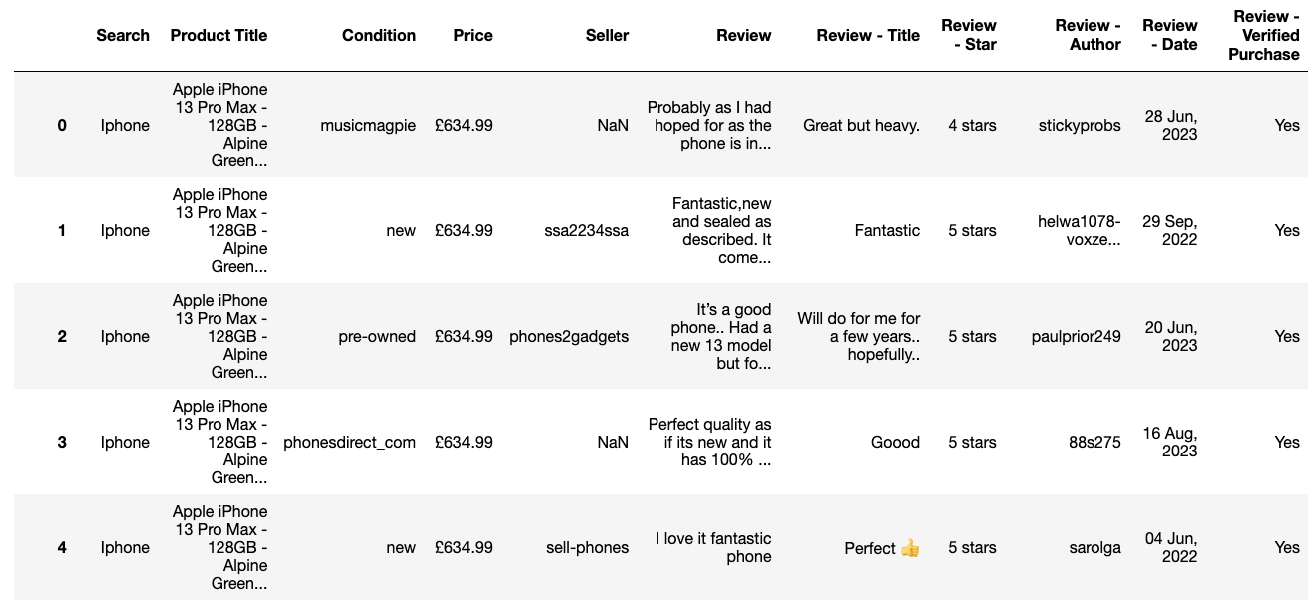

**Figure 1** This is a screenshot of Pandas data frame Apple products’ comments on eBay.

The subsequent phase involved the scraping of Amazon data. Initial attempts utilizing the BeautifulSoup and Selenium libraries proved unsuccessful, necessitating the exploration of an alternative approach. Leveraging the Playwright library, Amazon product URLs related to Apple products were systematically scraped (Appendix D), followed by the asynchronous extraction of intricate product details and reviews. The amassed information, inclusive of product titles, prices, ratings, and reviews, was meticulously organized into a Pandas data frame and archived as a CSV file. Implementation of error handling mechanisms and random delays was imperative to prevent potential impediments from Amazon. The resultant dataset comprised 135 variables and 21,906 rows (Figure 2).

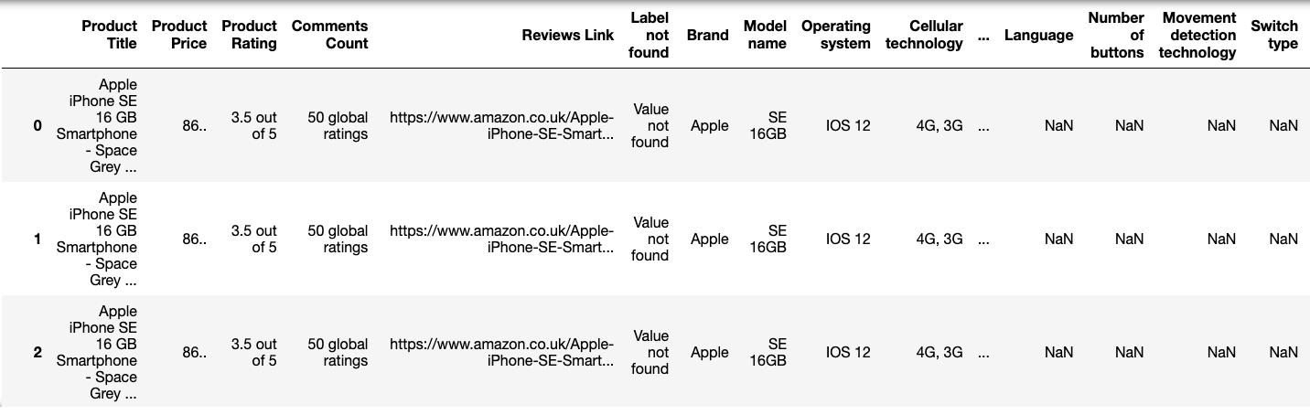

**Figure 2** This is a screenshot of Pandas data frame Apple products’ comments in Amazon.

The subsequent endeavour involved the extraction of Apple-related comments from Reddit, facilitated by the PRAW library in Python. Essential information, encompassing comment bodies, authors, upvotes, awards, and dates, was meticulously extracted, subsequently undergoing rigorous data cleaning and filtering processes (Appendix A). The final dataset was meticulously preserved in a CSV file ('reddit_comments.csv'), and the resulting Pandas dataframe was tailored to encompass comments aligning with specified criteria. This meticulous process yielded a dataset featuring 6 variables and 18,218 rows (Figure 3).

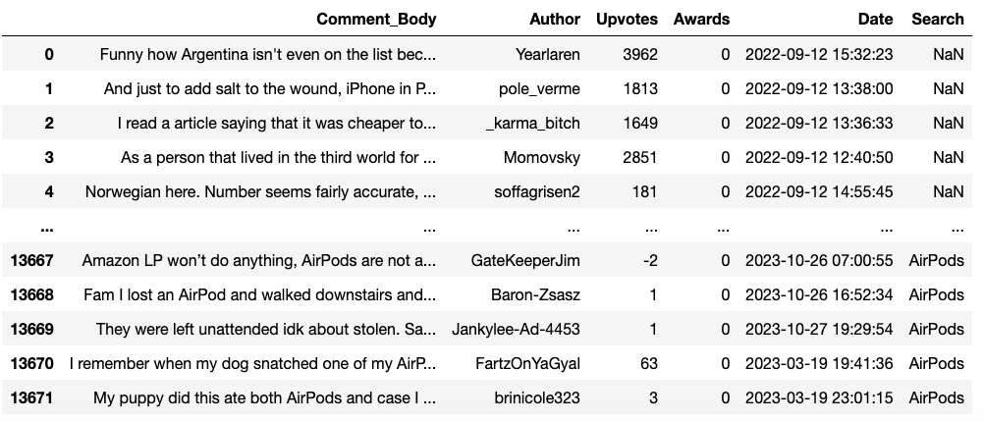

**Figure 3** This is a screenshot of Pandas dataframe Apple products’ comments on Reddit.

Conclusively, the YouTube data collection process was executed via the YouTube Data API (Appendix F). The process involved the systematic search for Apple product videos, subsequent retrieval of associated comments, and the meticulous curation of comments relevant to the respective product keywords. The API key was aptly configured, and functions for video searching and comment retrieval were meticulously defined. The iterative execution of these processes culminated in the creation of a final dataframe, encapsulating pertinent comments, which were systematically displayed and archived in ”youtube_comments.csv” after each iteration. The final dataset, resulting from this endeavour, comprised 43,356 rows and 8 variables (Figure 4).

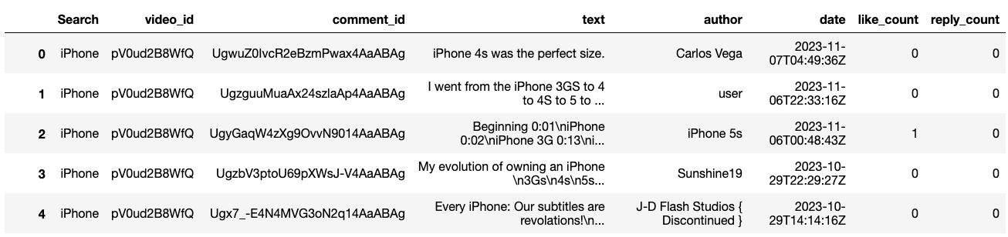

**Figure 4** This is a screenshot of Pandas dataframe Apple products’ comments on YouTube.

### Pre-processing and Cleaning

Within the initial phase, potential duplicates, arising from the scraping process, were addressed through the utilization of the “drop_duplicates” function in the Pandas library (Figure 5).

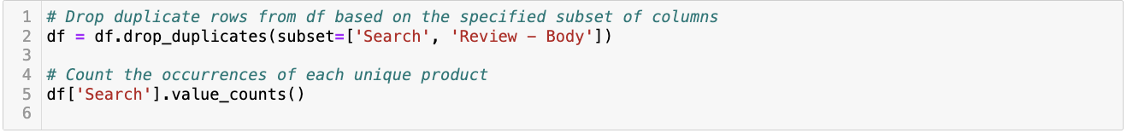

**Figure 5** This is a screenshot of a Python script to drop duplicates.

Given the diverse data types across columns, a careful conversion of column types was executed. Specifically, the “Date” column, signifying the timestamp of comments, transformed a date format using Pandas' “to_datetime” formula (Figure 6).

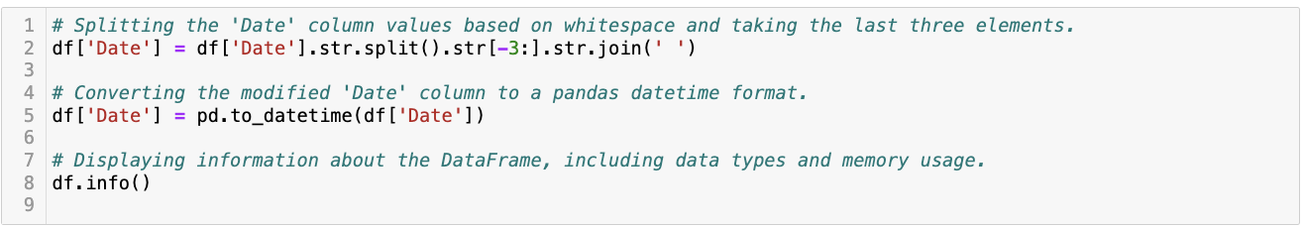

**Figure 6** This is a screenshot of the Python script to change the type of the column to datetime.

Concurrently, numerical columns like “Review – Rating” and “Product Price” were cast into integer format for consistency (Figure 7), while the textual content within the “Comment_Body” column was standardized to string format (Figure 8).

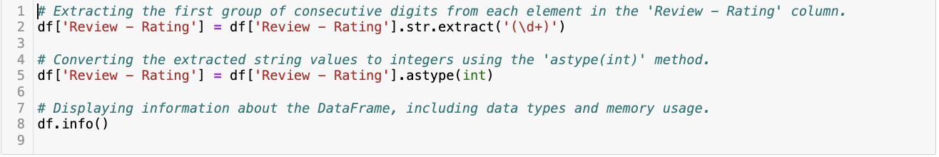

**Figure 7** This is a screenshot of a Python script to change the type of the column to integer.

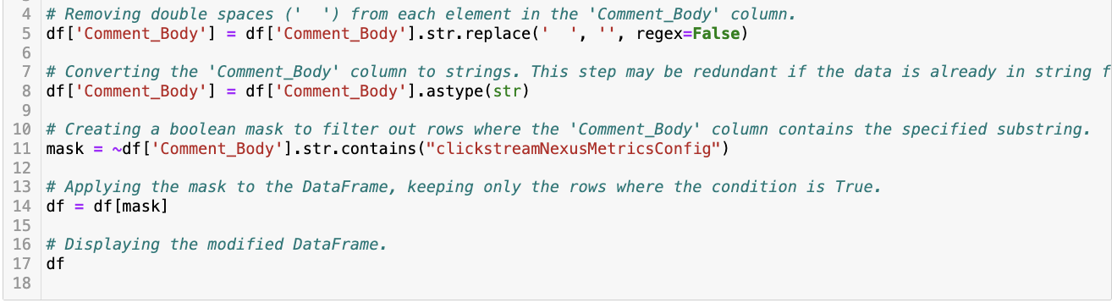

**Figure 8** This is a screenshot of a Python script to change the type of the column to a string.

To ensure homogeneity across products on distinct platforms, the top 1000 comments for each product on each platform were retained (Figure 9).

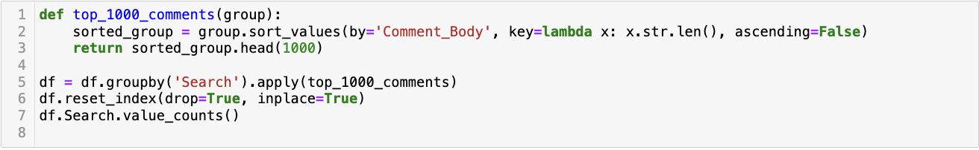

**Figure 9** This is a screenshot of the Python script to keep the longest comments in the dataset.

Employing the “langdetect” library's “detect” formula, only English comments were preserved, with non-English comments being meticulously reviewed and subsequently excluded from the dataset (Figure 10).

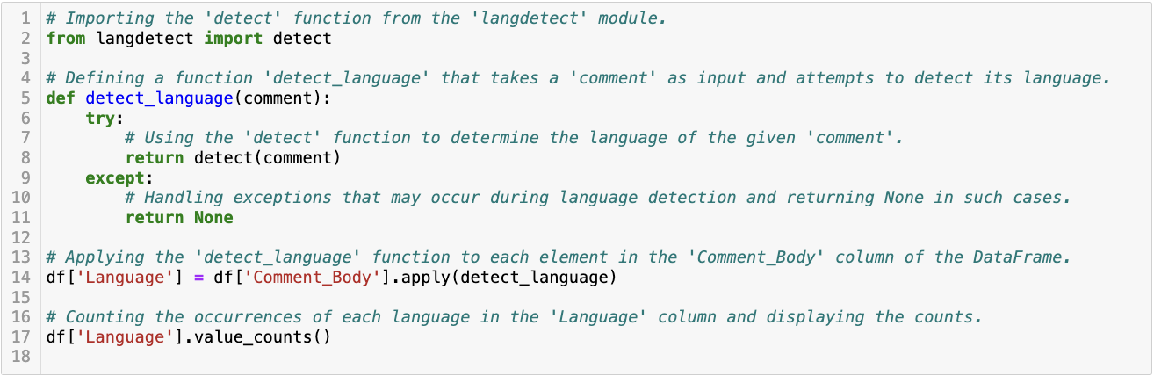

**Figure 10** This is a screenshot of the Python script to detect the languages.

Addressing linguistic nuances, the “contractions” library facilitated the expansion of contractions in the textual content (Figure 11).

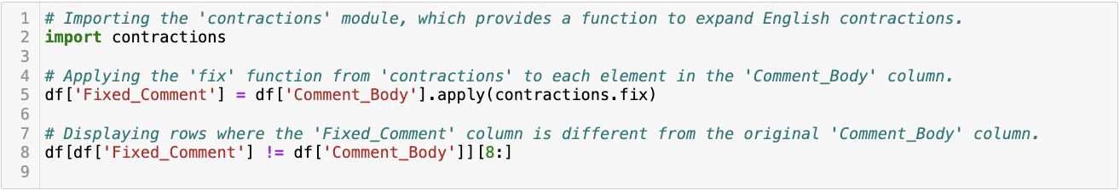

**Figure 11** This is a screenshot of the Python script to expand the contractions.

Further, leveraging the “re” library, patterns such as prices, sizes, volumes, and weights were detected and standardized (Figure 12).

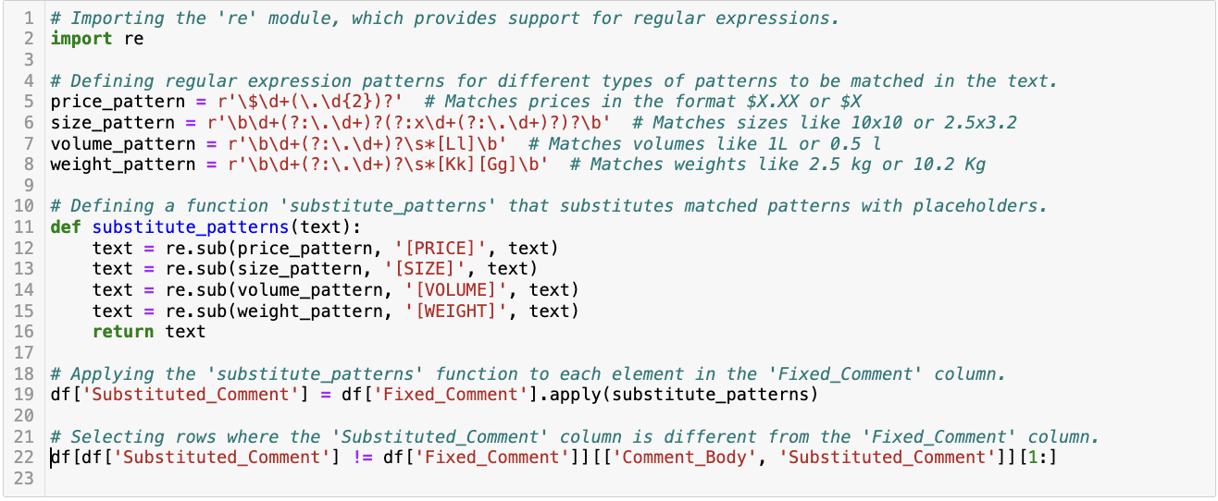

**Figure 12** This is a screenshot of a Python script to substitute patterns.

Hyperlinks embedded within comments were identified and marked using the same library (Figure 13).

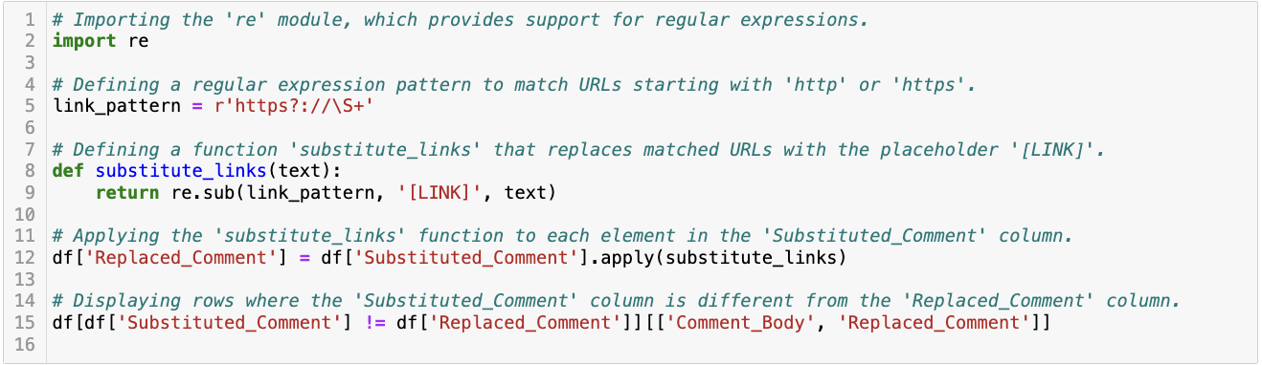

**Figure 13** This is a screenshot of a Python script to substitute website links.

Extraneous elements, such as line breaks represented by “\n”, were expunged via the “replace” formula (Figure 14).

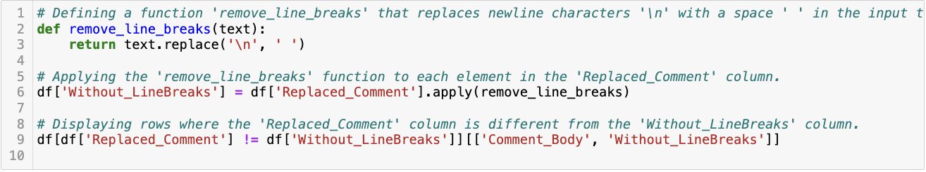

**Figure 14** This is a screenshot of the Python script to remove line breaks.

Spelling errors within words were rectified using the “textblob” library, mitigating the risk of inadvertent corrections (Figure 15).

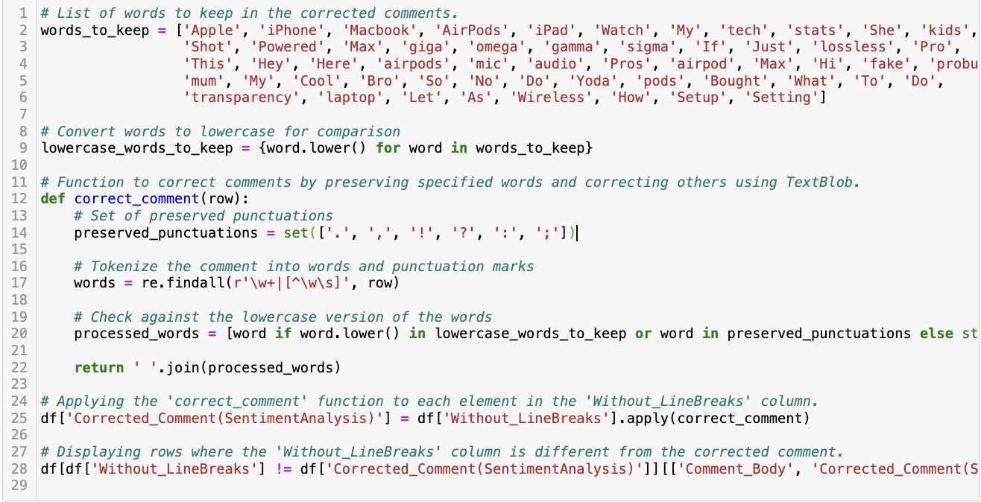

**Figure 15** This is a screenshot of a Python script to correct words with spelling errors.

After these initial steps, tokenization was executed using the “nltk” library (Figure 16).

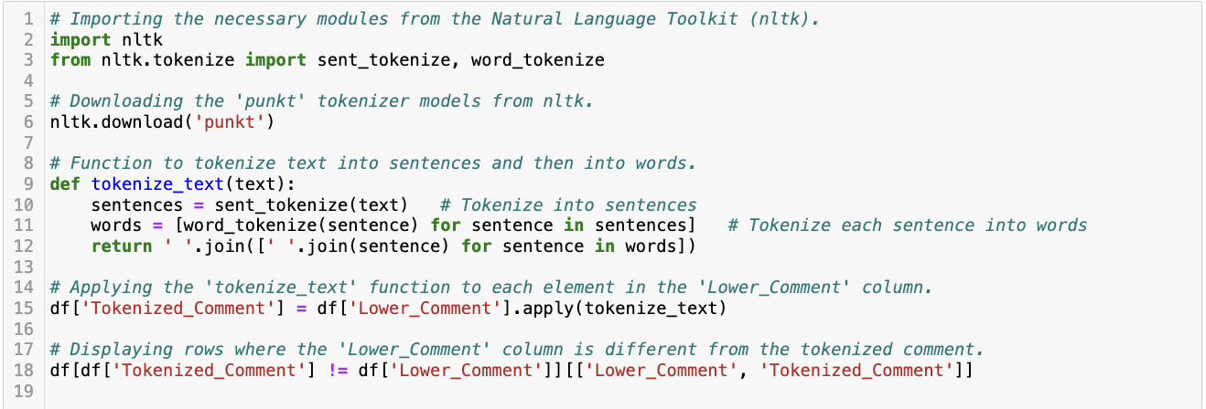

**Figure 16** This is a screenshot of the Python script for tokenization.

The removal of stopwords, facilitated by the “nltk” library (Figure 17), was particularly beneficial before sentiment analysis.

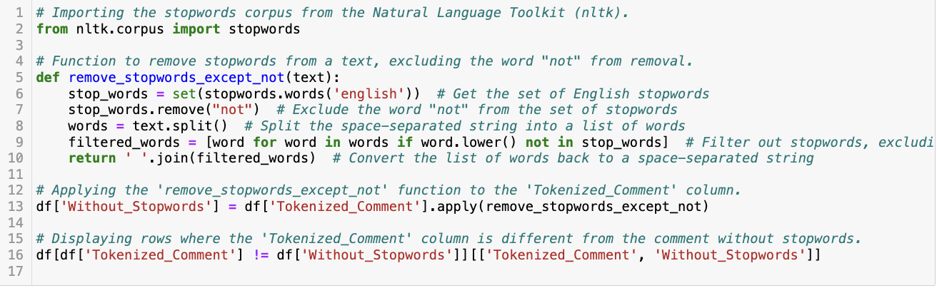

**Figure 17** This is a screenshot of a Python script to remove stopwords.

The elimination of emojis and punctuation, performed using the “re” and “string” libraries (Figure 18), preceded lemmatization executed via the “nltk” library (Figure 19).

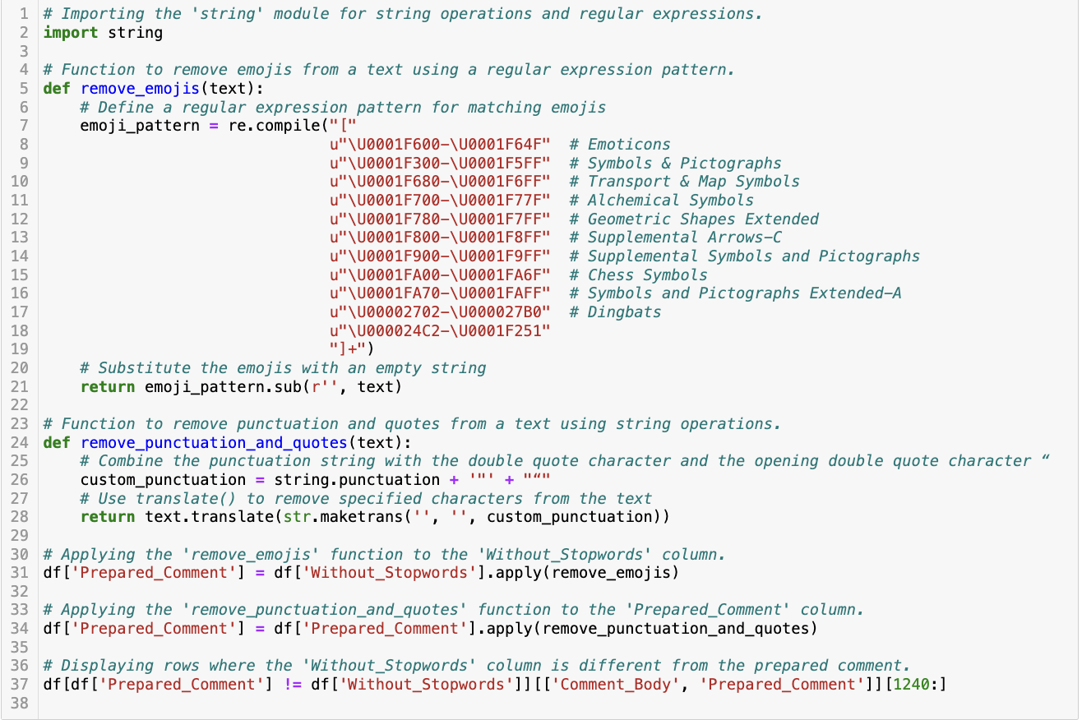

**Figure 18** This is a screenshot of a Python script to remove emojis and punctuation.

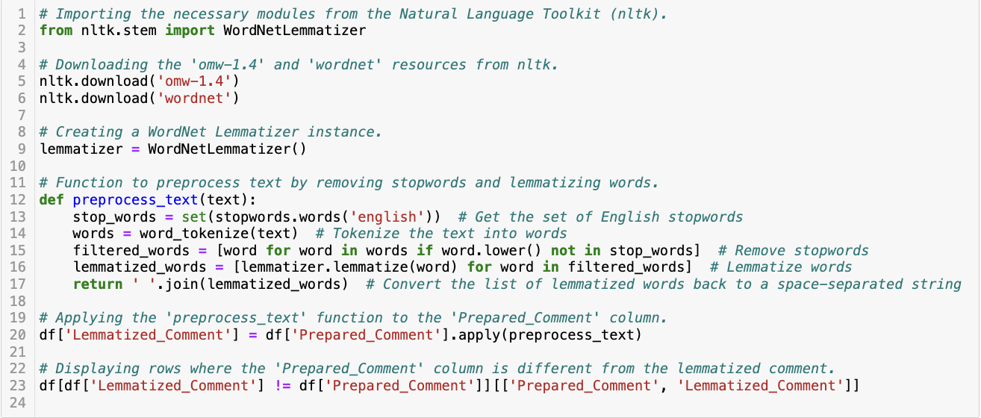

**Figure 19** This is a screenshot of the Python script for lemmatization.

Collectively, these rigorous preprocessing steps culminated in a meticulously curated dataset, poised for comprehensive analysis in alignment with the overarching objectives of this research.

### Summary

In the data formatting and cleansing phase, a meticulous approach was employed to create a comprehensive dataset for the sensitivity analysis comparing Apple products across e-commerce and social media platforms. The data underwent selective extraction and cleaning, resulting in refined datasets. The final dataset, prepared for comprehensive analysis, reflects key information from diverse sources, demonstrating a rigorous and streamlined data preparation process.

## Analysis and Findings

### Introduction

This section delves into the exploration based on user comments for each product on each platform, offering a holistic view of public perception and engagement. The upcoming sections systematically analyse each product on a platform-by-platform basis, revealing intricate patterns in consumer sentiment, emotional responses, and discussion themes. This comparative approach not only highlights the unique consumer-product relationship inherent to each platform but also provides a nuanced understanding of Apple's overall brand image as reflected in diverse digital ecosystems.

### eBay

To conduct a comprehensive analysis of the dataset, it is imperative to meticulously examine the data, make nuanced observations, and assess it from diverse perspectives (Figure 20).

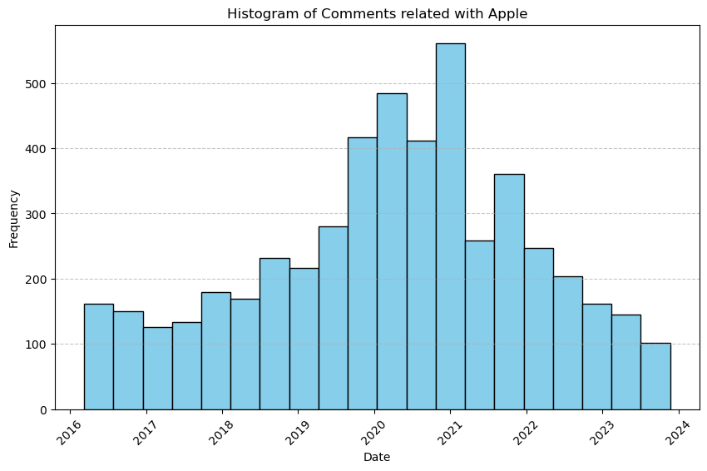

**Figure 20** This is a screenshot of the histogram showing the distribution of comments for Apple products on eBay over time.

#### iPhone

The subsequent product-based analysis serves to enhance the granularity of the overall examination, affording a nuanced perspective on Apple by scrutinizing individual products. The dataset, encompassing 1000 lines, was specifically curated for the iPhone, a primary component within Apple's product portfolio. A noteworthy thematic trend within the comments is the recurrent use of positive descriptors such as “good”, “well”, and “great” (Figure 21).

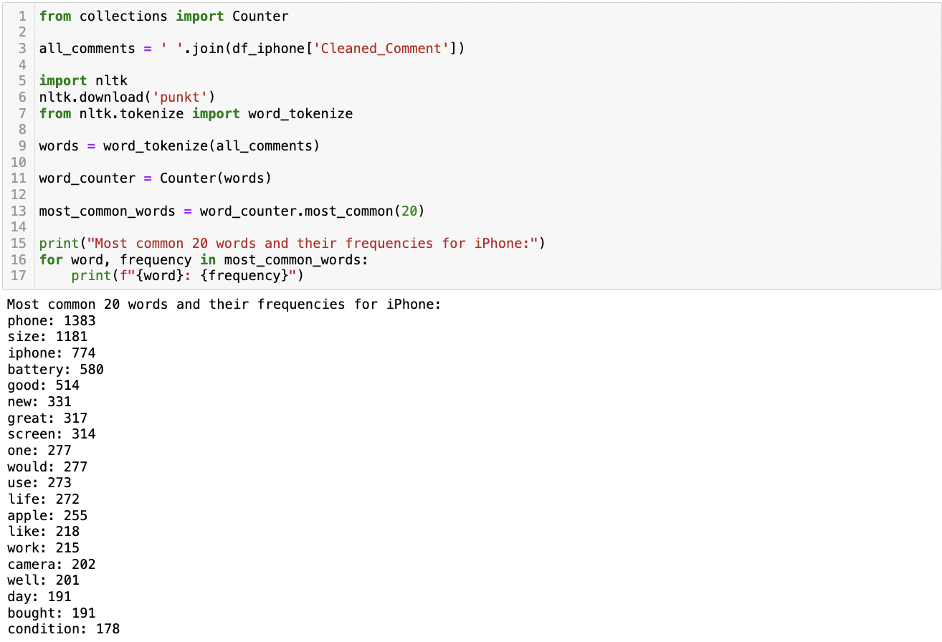

**Figure 21** This is a screenshot of the Python script and its result showing the most common words in the eBay iPhone comments dataframe.

Furthermore, a qualitative analysis reveals a pronounced emphasis on technical aspects, as evidenced by the frequent occurrence of terms like “battery”, “screen”, and “camera” in the comments. This suggests an inclination among users to delve into the specific technical features of the product.

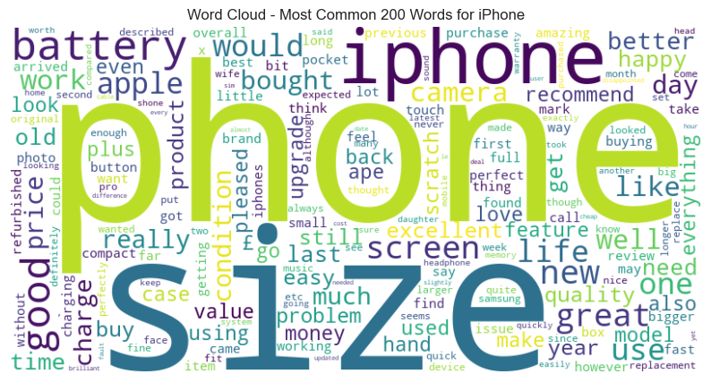

**Figure 22** This is a screenshot of the word cloud showing the most common words in the eBay iPhone comments dataframe.

A closer examination of the most frequently employed noun phrases sheds light on various themes within the dataset. These themes encompass expressions of product praise, commentary on pricing, technical specifications, and discussions about different iPhone models (Figure 23).

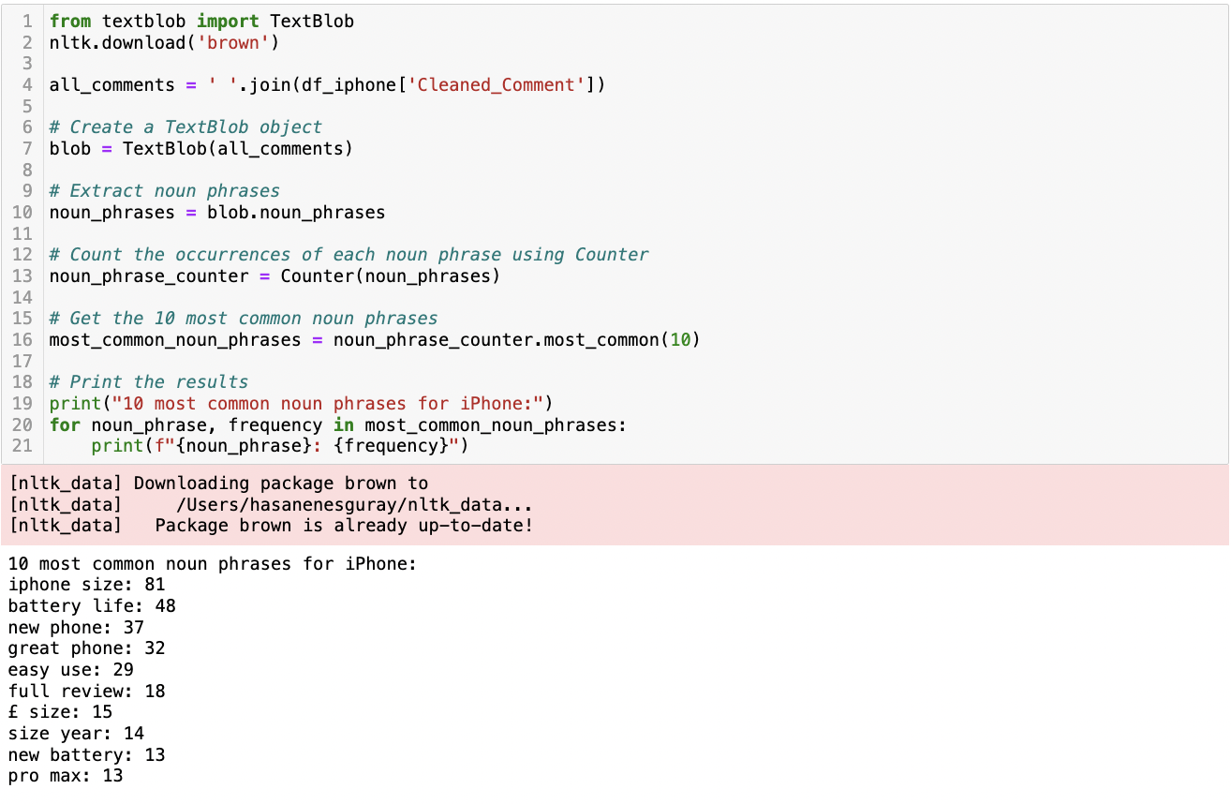



**Figure 23** This is a screenshot of the Python script and its result showing the most common noun phrases in the eBay iPhone comments dataframe.

##### Topic Modelling

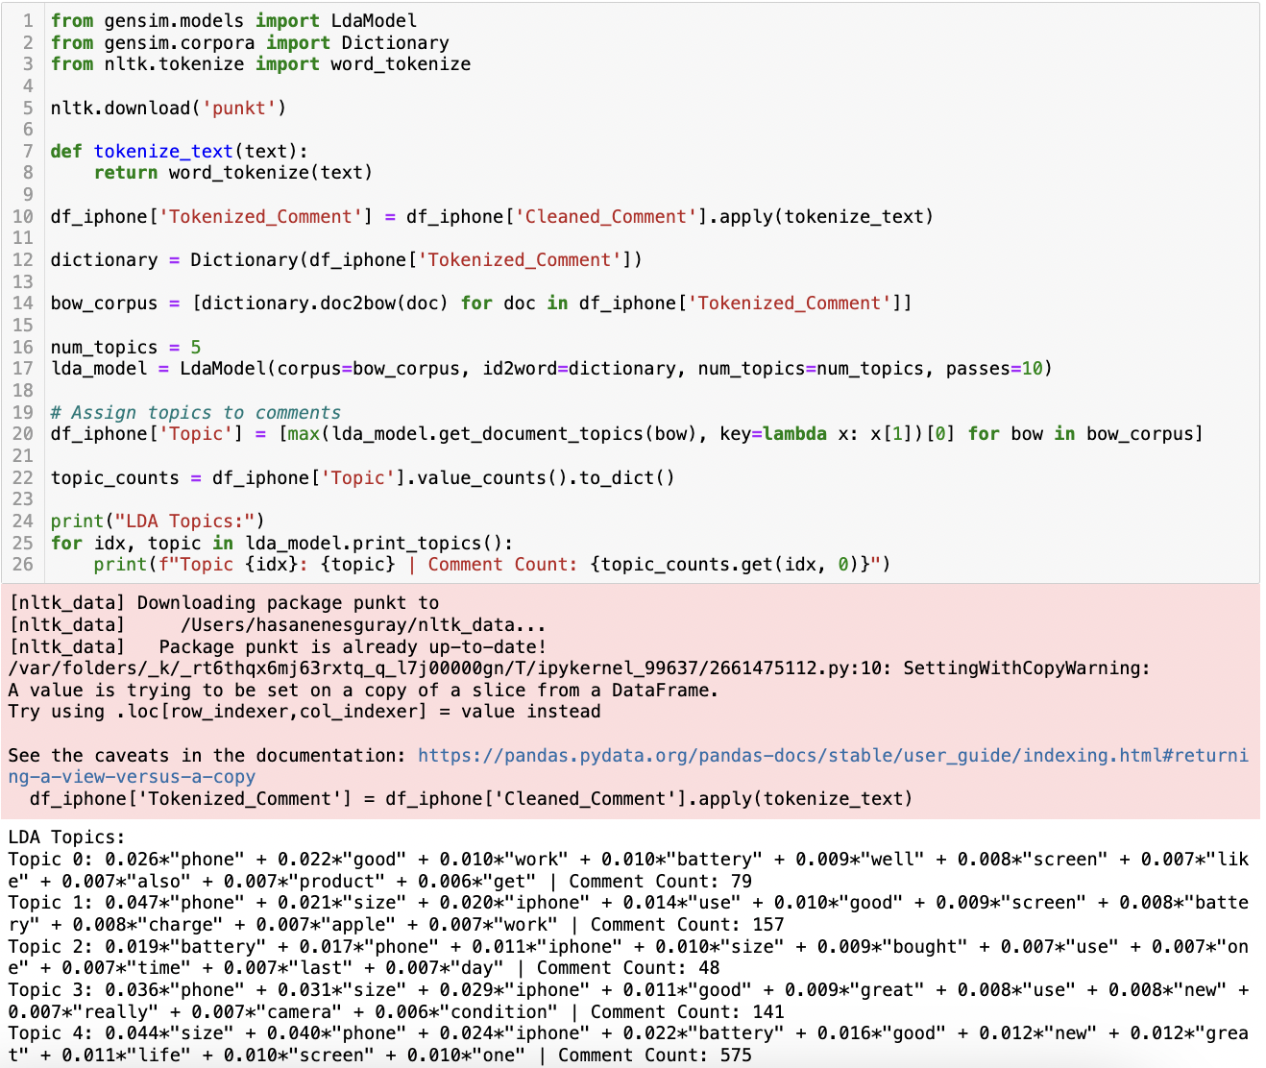

**Figure 24** This is a screenshot of the Python script and its result showing LDA Topic Modelling for eBay iPhone comments dataframe.

The LDA topic modelling of eBay comments related to iPhones reveals five distinct topics, each representing a set of concerns or features that users frequently discuss. Topic 0 seems to focus on the general functionality and quality of the phones, highlighting aspects like battery life and screen quality. Topic 1, with a higher emphasis on the word “phone” and mentions of “size” and “use”, suggests discussions centred around the physical attributes and usability of iPhones. Topic 2 appears to be more concerned with battery performance, purchase experience, and daily usage, indicating a user focus on practical, long-term aspects of iPhone use. Topic 3 and Topic 4, both with a high emphasis on “size”, “phone”, and “iphone”, possibly indicate a strong interest in the physical dimensions and model-specific features of iPhones. The large comment count in Topic 4 suggests that this is a major area of concern or interest for eBay users.

##### Sentiment Analysis

In the empirical analysis of sentiment associated with 1000 eBay comments on the iPhone, four distinct sentiment analysis algorithms were employed. The results indicate a variance in sentiment detection across algorithms, underscoring the inherent differences in methodological approaches and sentiment classification paradigms (Figure 25). The dominance of positive sentiment in all four different algorithms raises serious positivity.

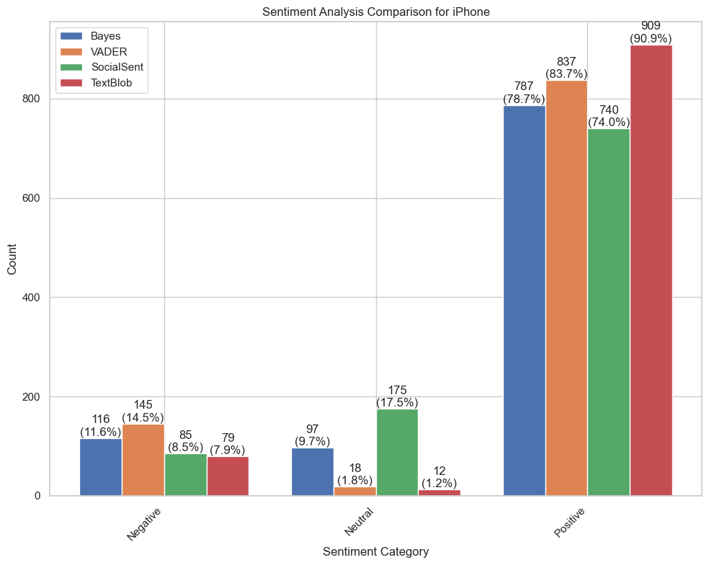

**Figure 25** This is a bar graph showing a sentiment analysis comparison for the eBay iPhone comments dataframe.

##### Emotion Analysis

In the course of the emotion analysis conducted using the LeXmo library, the examination revealed a prevailing occurrence of sentiments associated with trust, anticipation, and joy within the dataset (Figure 26). Conversely, emotions such as disgust, anger, and fear exhibited comparatively lower frequencies, indicating their lesser prevalence in the analysed comments. This situation supported the positive sentiment results.

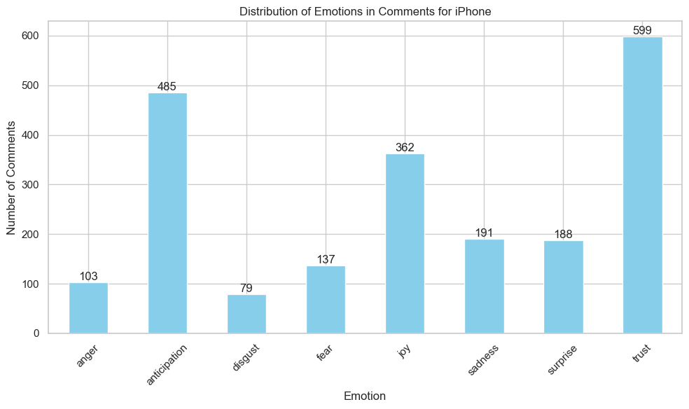

**Figure 26** This is a bar graph showing emotion analysis comparison for eBay iPhone comments dataframe.

#### iPad

In the analysis of iPad-related textual data, it was observed that words such as “good”, “great”, “happy”, “well”, and “excellent” prominently featured among the most frequently used terms (Figure 27). This prevalence of positive sentiment-associated terms may be interpreted as an indicative precursor to positive user sentiments.

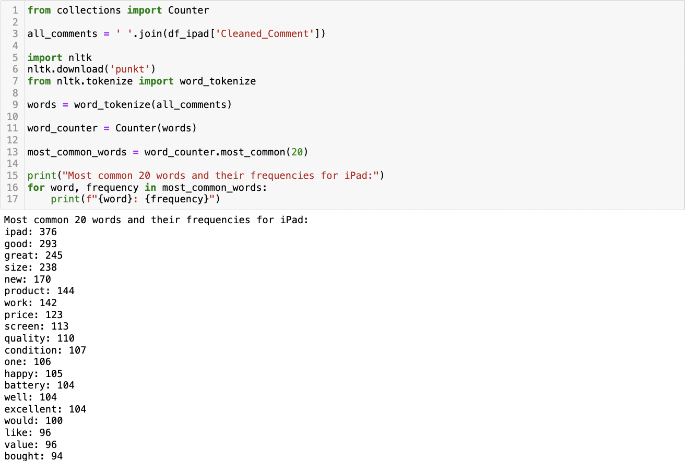

**Figure 27** This is a screenshot of the Python script and its result showing the most common words in the eBay iPad comments dataframe.

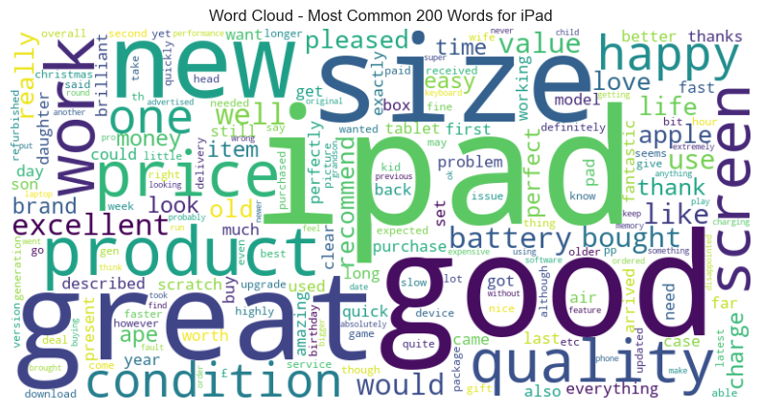

**Figure 28** This is a screenshot of the word cloud showing the most common words in the eBay iPad comments dataframe.

Furthermore, an examination of the predominant noun phrases revealed consistent support for positive evaluations, as evidenced by expressions such as “great product”, “excellent condition”, “good value”, “great price”, and “good quality” (Figure 29).

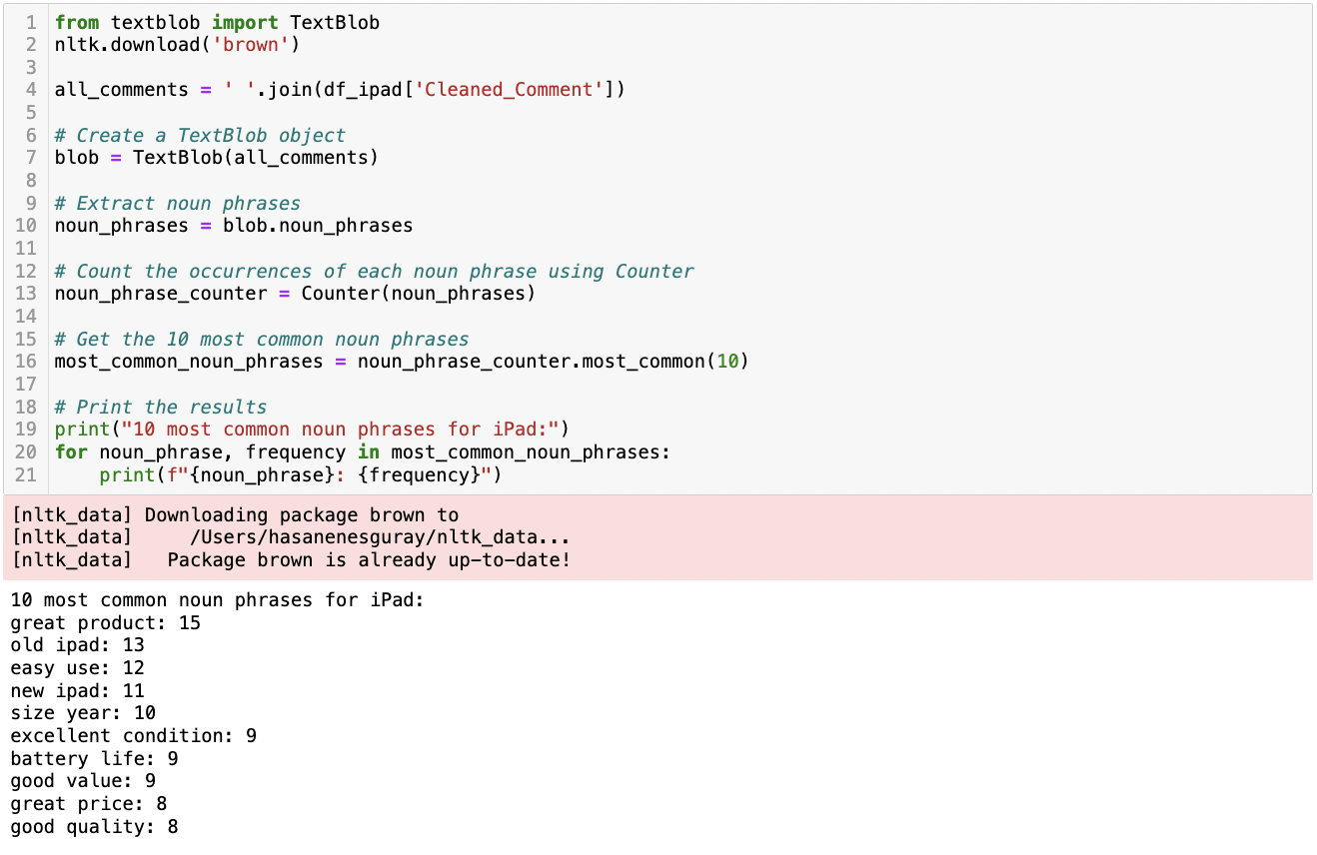

**Figure 29** This is a screenshot of the Python script and its result showing the most common noun phrases in the eBay iPad comments dataframe.

##### Topic Modelling Analysis

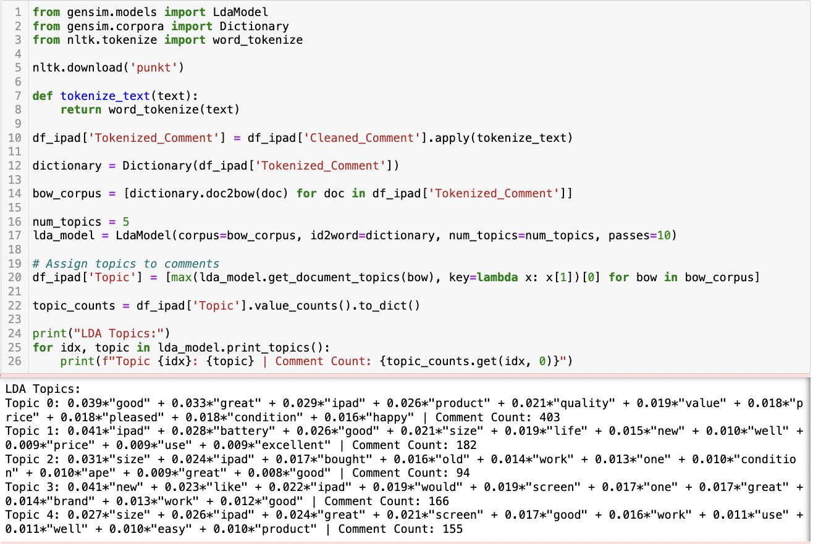

**Figure 30** This is a screenshot of the Python script and its result showing LDA Topic Modelling for eBay iPad comments dataframe.

For iPad, Topic 0, with the highest comment count, indicates a strong positive sentiment, emphasizing satisfaction with the iPad's quality, value, and condition. Topic 1 and 4 both focus on the iPad's size and battery life, suggesting that physical attributes and usability are significant factors for users. In contrast, Topic 2, which has the fewest comments, highlights practical concerns like the product's condition and purchase rationale, indicating interest in second-hand purchases or value deals. Topic 3 centres on comparisons with new products, focusing on the iPad's functionality and condition.

##### Sentiment Analysis

Each method employs unique mechanisms to discern sentiment, with Naïve Bayes using probabilistic models, VADER leveraging a lexicon curated for social media context, SocialSent employing historical and cultural metrics, and TextBlob utilizing pattern analysis. Despite the inherent methodological differences, each algorithm predominantly categorizes the sentiments as positive (Figure 31).

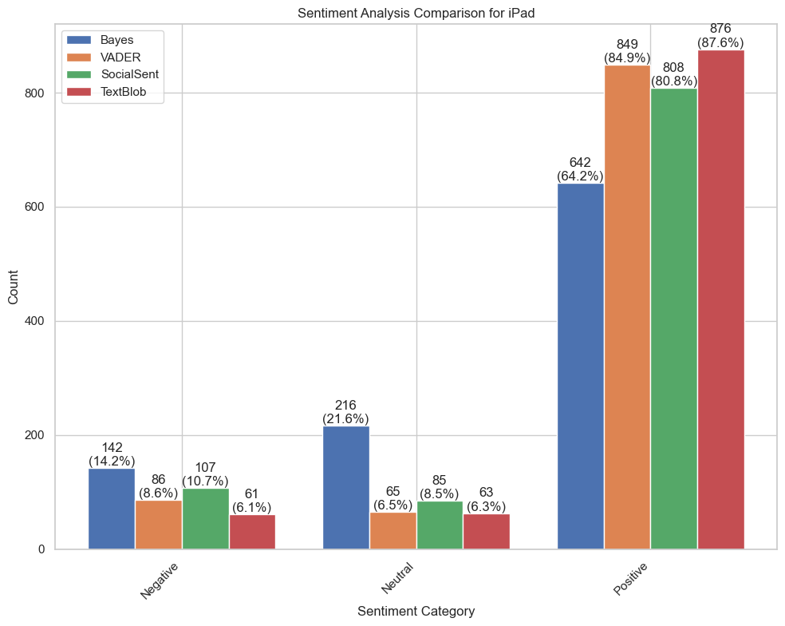

**Figure 31** This is a bar graph showing a sentiment analysis comparison for the eBay iPad comments dataframe.

##### Emotion Analysis

In the realm of emotional analysis, a discernible prevalence of emotions akin to those observed in the context of iPhones is evident in the case of iPads. Notably, an analysis of emotional responses revealed that the sentiments of anticipation, joy, and trust exhibited a relative equilibrium dominance on the emotional spectrum for iPad users (Figure 32). Furthermore, the fourth dominant emotion was surprise and the remaining emotional facets clustered in proximity to each other at the lower end of the spectrum.

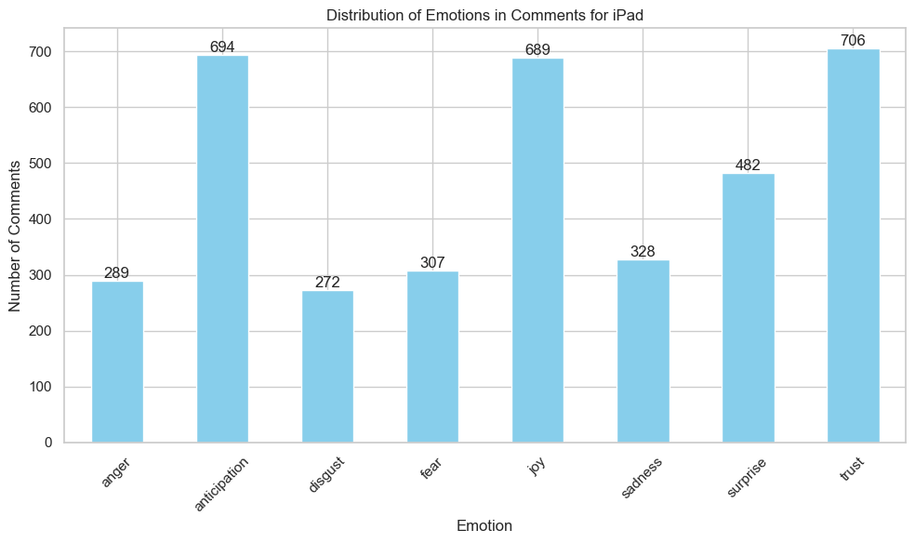

**Figure 32** This is a bar graph showing emotion analysis comparison for eBay iPad comments dataframe.

#### Macbook

In the examination of textual data related to the MacBook, a significant recurrence of words such as “great”, “good”, “love”, “new”, and “quality” was noted among the top 20 most frequent terms (Figure 33). The frequent appearance of these words, particularly those with positive connotations like “great” and “good”, suggests a strong positive sentiment in the discourse surrounding the MacBook. Terms like “new”, “quality”, and “fast” further underscore this positive narrative, hinting at user satisfaction with the product's features and performance.

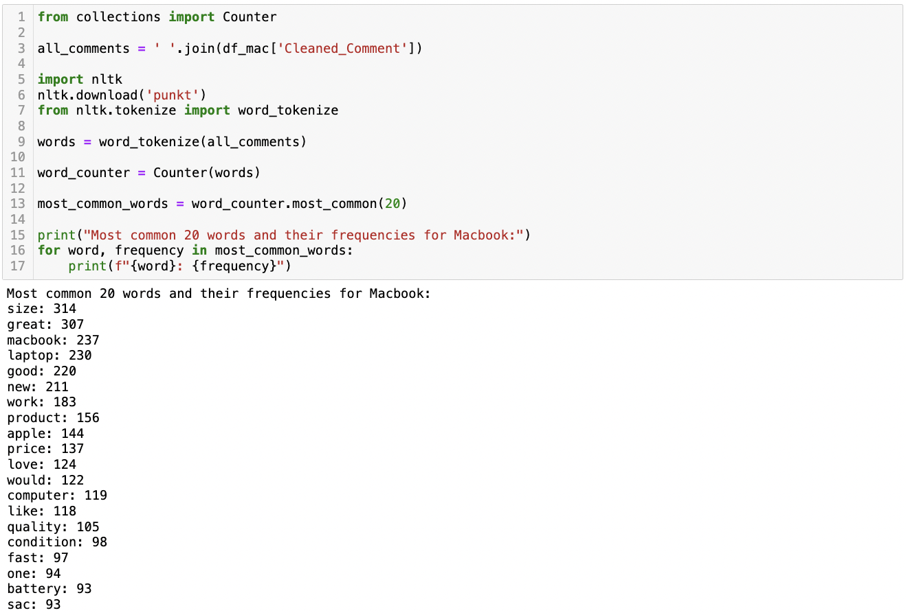

**Figure 33** This is a screenshot of the Python script and its result showing the most common words in the eBay Macbook comments dataframe.

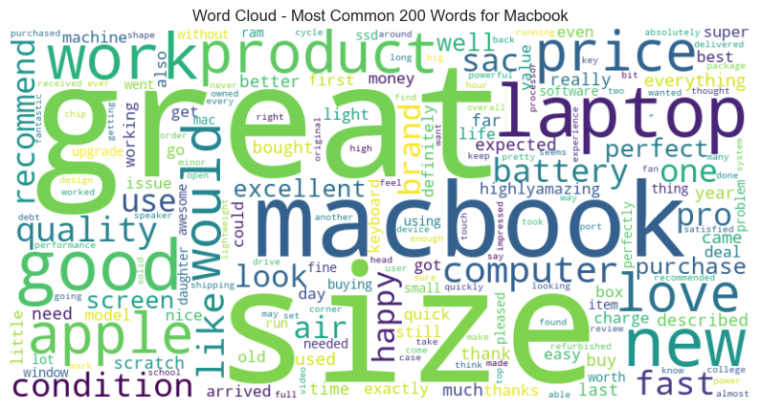

**Figure 34** This is a screenshot of the word cloud showing the most common words in the eBay Macbook comments dataframe.

Additionally, a detailed analysis of the most frequent noun phrases in discussions about the MacBook underscores a strong inclination towards positive assessments. Phrases like “great product”, “full review”, “great value”, “great laptop”, and “great price” frequently emerged (Figure 35). Notably, expressions such as “happy purchase”, “MacBook Air”, “new MacBook”, “great condition”, and “battery life” were also prevalent. These findings highlight a significant congruence between the positive sentiment expressed through individual terms and the overall positive sentiment embedded in more extended phrases.

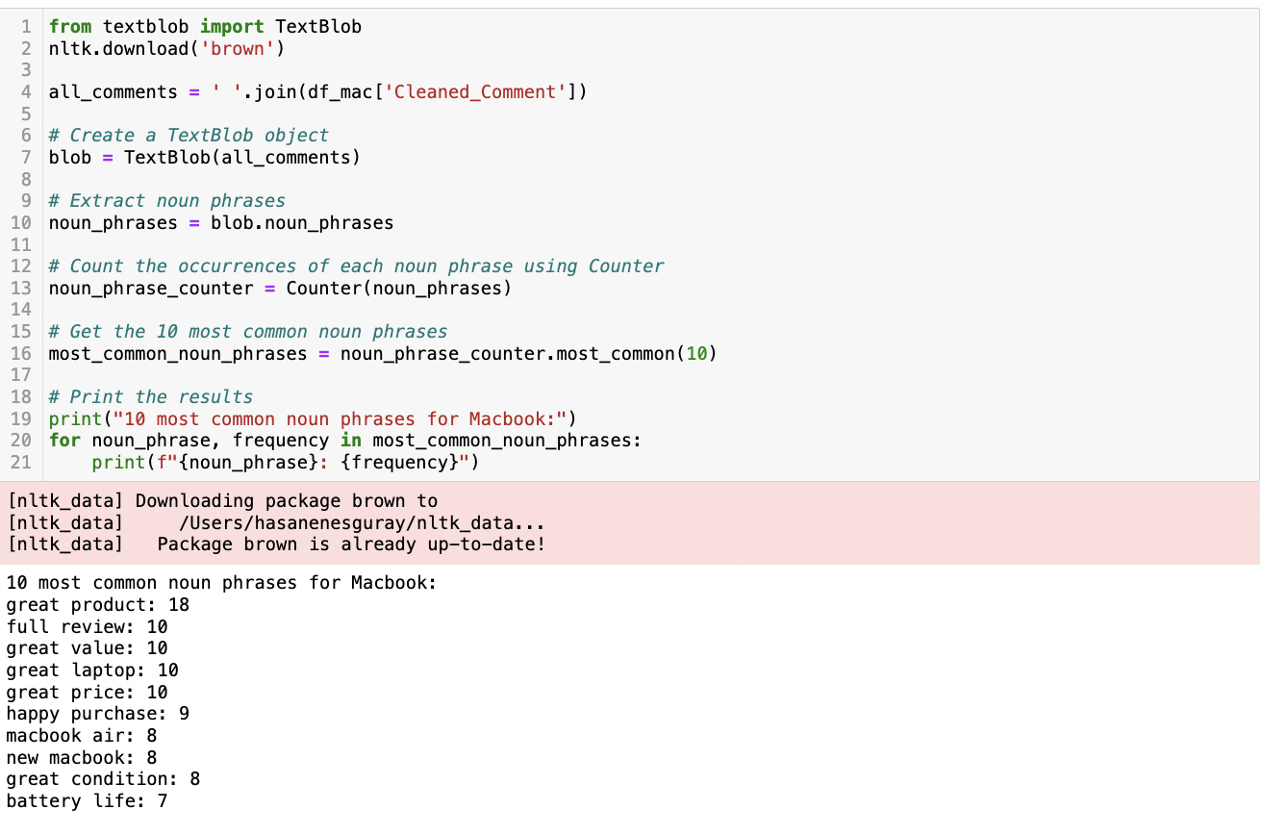

**Figure 35** This is a screenshot of the Python script and its result showing the most common noun phrases in the eBay Macbook comments dataframe.

##### Topic Modelling Analysis

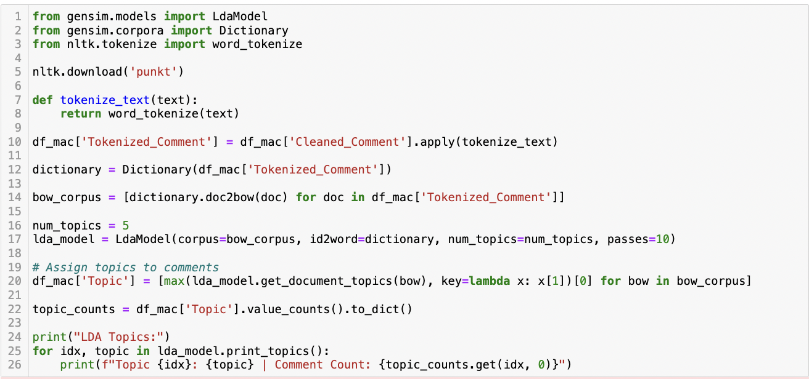 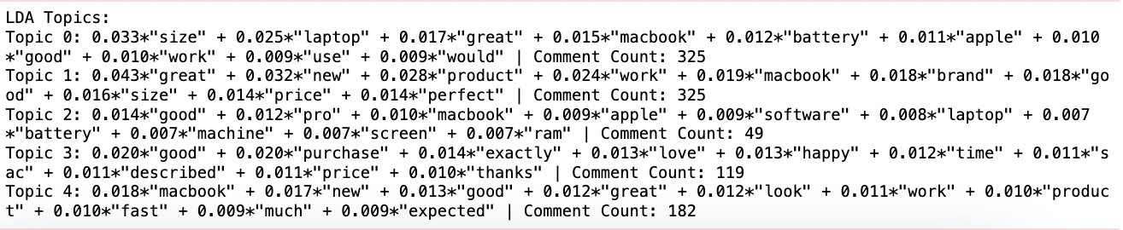

**Figure 36** This is a screenshot of the Python script and its result showing LDA Topic Modelling for eBay Macbook comments dataframe.

For Macbook, topic 0, emphasizes the physical attributes like ”size” and ”battery', along with performance aspects (“great”, ”good', ”work”) of MacBooks. Topic 1, highlights customer satisfaction with ”new” and ”brand” products, emphasizing ”great” condition and ”perfect” pricing. Topic 2, with the least comments, focuses on technical specifications such as ”pro”, ”software”, ”battery”, ”screen”, and ”ram”, indicating a more tech-savvy segment. Topic 3, encompassing, reflects on the purchasing experience, with emphasis on ”purchase”, ”exactly”, ”happy”, and ”thanks” suggesting a high level of satisfaction with the transaction process. Finally, Topic 4 combines attributes of the product (“macbook”, ”new”, ”good”, ”great”) with user experience (“work”, ”fast”, ”expected”), indicating overall positive feedback on both the product quality and its performance.

##### Sentiment Analysis

In the analysis of sentiment across a dataset of eBay MacBook comments, it was found that each of the four algorithms consistently classified the majority of comments as positive (Figure 37). Despite the lack of numerical uniformity in the classification of neutral and negative sentiments, the trend of positivity was a clear commonality.

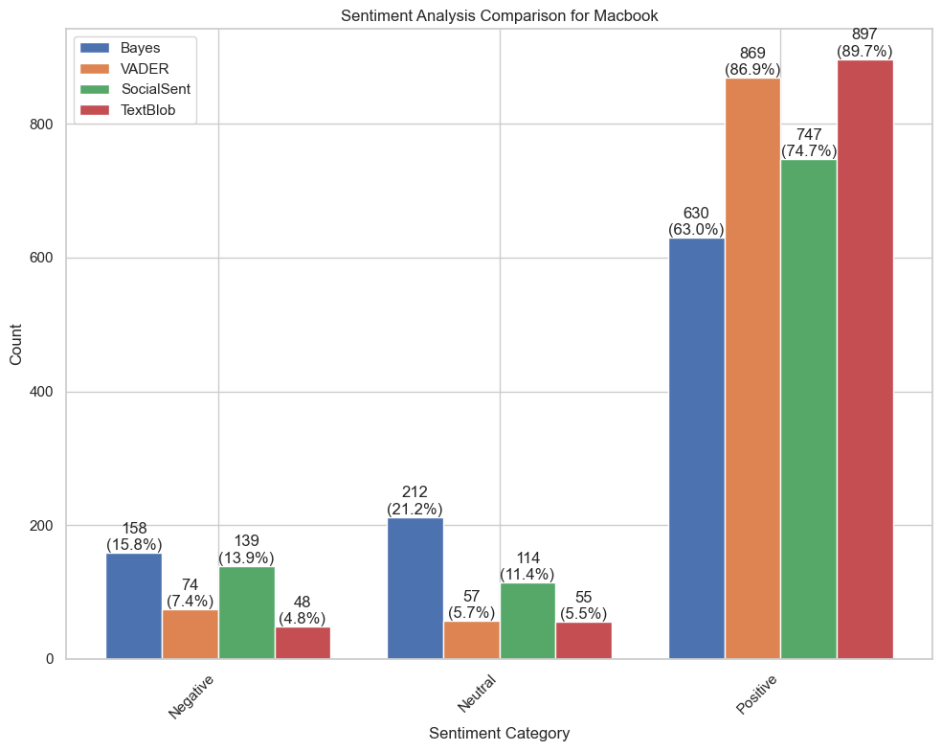

**Figure 37** This is a bar graph showing a sentiment analysis comparison for the eBay Macbook comments dataframe.

##### Emotion Analysis

For Macbook, the barometer of emotions revealed that the sentiments of anticipation, joy, and trust were the preeminent forces, each occupying a significant stratum within the overall affective composition (Figure 38). These three emotions collectively formed a triad of positivity that dominates the emotional milieu. In addition, surprise emerged as the fourth most prominent emotion, while the remaining affective states—anger, disgust, fear, and sadness—aggregated closely at a lesser magnitude, suggesting a lesser impact on the overall sentiment trend.

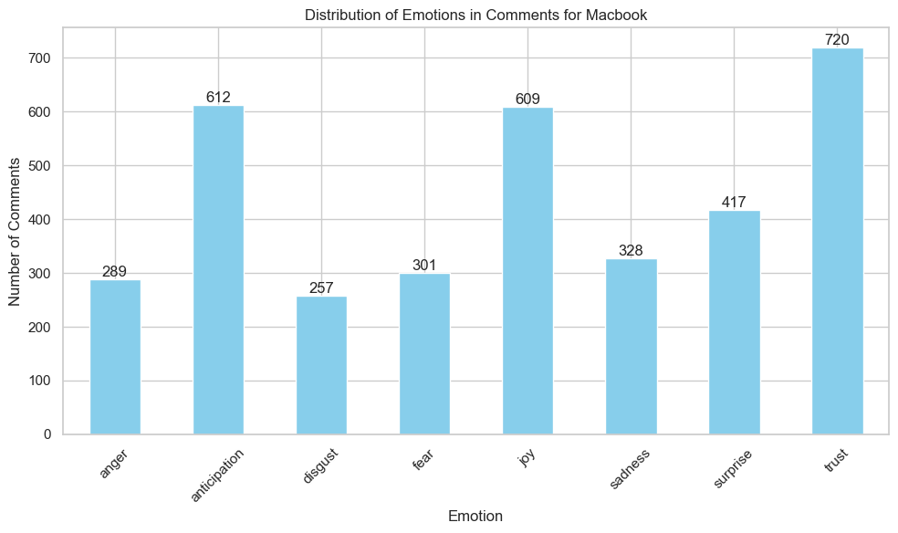

**Figure 38** This is a bar graph showing an emotion analysis comparison for the eBay Macbook comments dataframe.

#### AirPods

In the examination of textual data related to AirPods, significant emphasis was found on words like “good”, “great”, “quality”, “happy”, and “easy” among the top twenty most frequent terms (Figure 42). This pattern, marked by the recurrence of these positive connotations, suggests a strong lean towards favourable user sentiments regarding AirPods. The frequent mention of “sound” and “quality” in close association with AirPods also points to a high regard for their audio performance. This lexical landscape indicates that customer feedback is largely positive, focusing on satisfaction with product attributes such as sound quality, ease of use, and overall value.

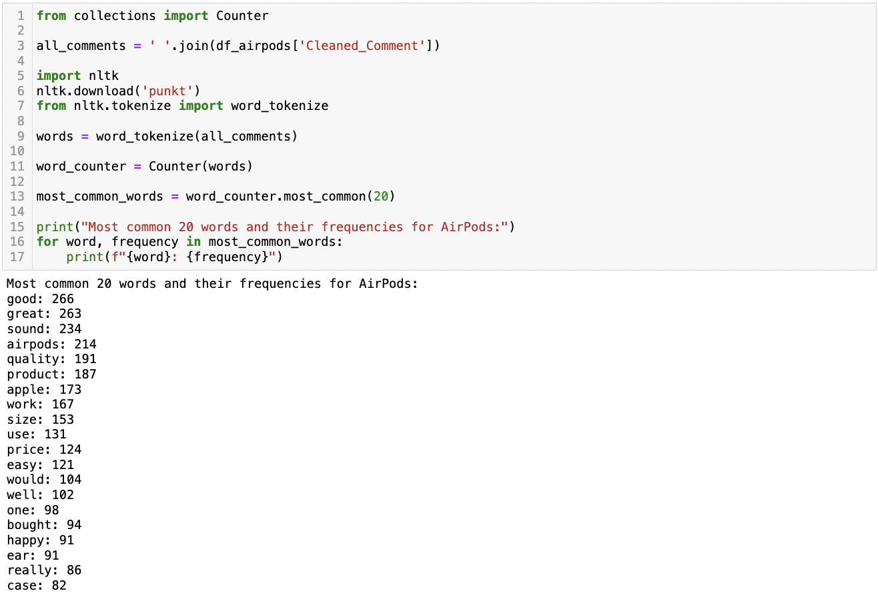

**Figure 39** This is a screenshot of the Python script and its result showing the most common words in eBay AirPods comments dataframe.

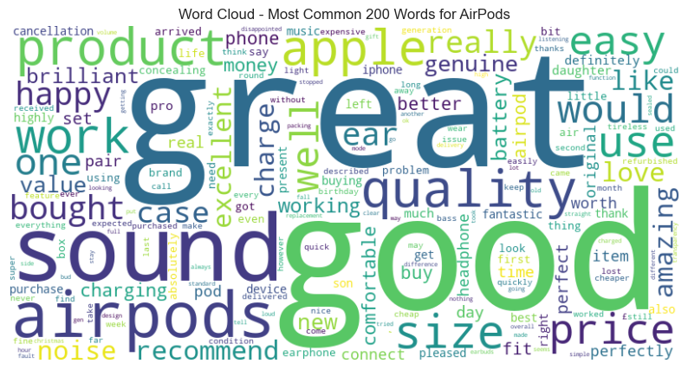

**Figure 40** This is a screenshot of the word cloud showing the most common words in eBay AirPods comments dataframe.

An in-depth analysis of the most prevalent noun phrases in discussions about AirPods underscores a strong positive sentiment, as highlighted by frequent terms like “easy use”, “sound quality”, “great product”, and “great quality” (Figure 41). Additionally, phrases such as “great price”, “happy purchase”, and “easy set” further reinforce this trend.

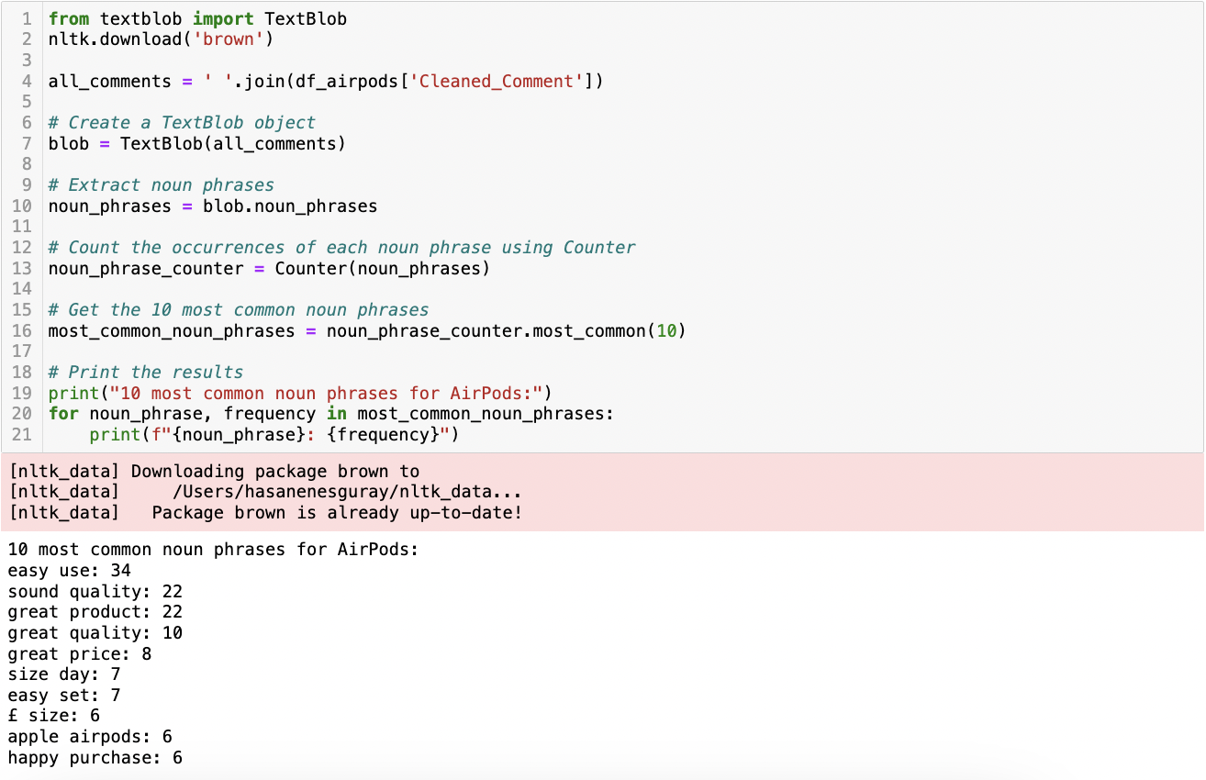

**Figure 41** This is a screenshot of the Python script and its result showing the most common noun phrases in eBay AirPods comments dataframe.

##### Topic Modelling Analysis

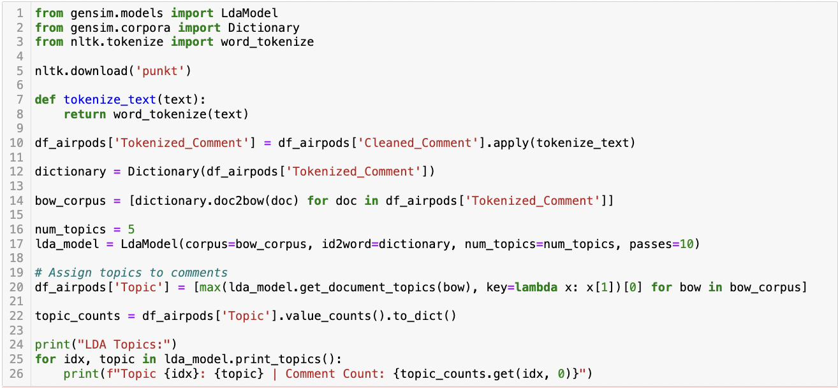

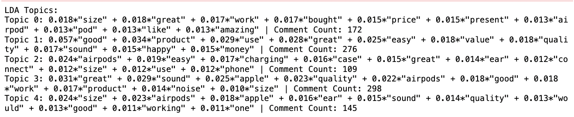

**Figure 42** This is a screenshot of the Python script and its result showing LDA Topic Modelling for eBay AirPods comments dataframe.

For AirPods Topic 0 primarily focuses on the practical aspects like size, price, and the suitability of AirPods as a present, and generally portrays a positive outlook with terms like “great”, “amazing”, and “like.” Topic 1 highlights overall satisfaction, emphasizing product quality (“good”, “great”), ease of use, and value for money. Topic 2 is more technical, discussing the ease of charging, the case, and connectivity aspects, indicating a user-focused perspective on functionality. Topic 3, the largest, seems to centre around product performance, particularly sound quality and Apple brand association, suggesting a high appreciation for technical excellence. Topic 4 appears to blend aspects of product design (size, fit in the ear) with performance (sound, quality) and includes some considerations about product durability and functionality (“working”).

##### Sentiment Analysis

The outcomes from the sentiment analysis methods provided a comprehensive view of public opinion, highlighting a predominantly positive reception towards the product (Figure 43). It was observed that each algorithm consistently classified the majority of comments as positive.

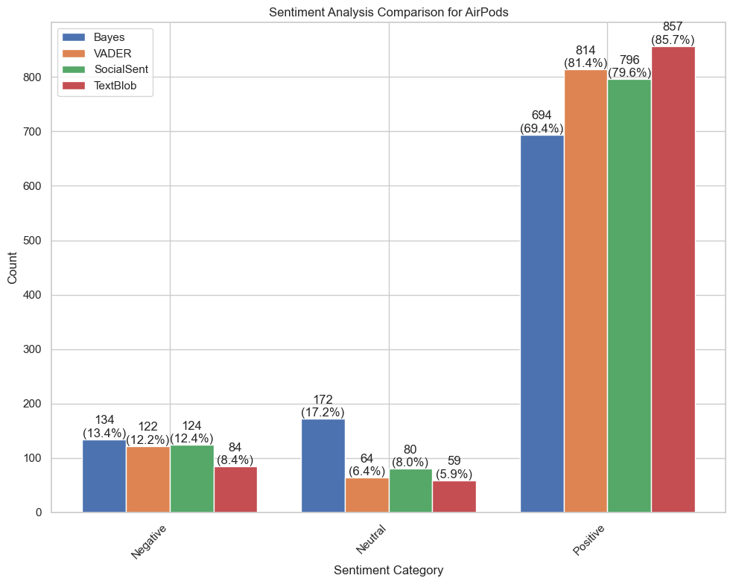

**Figure 43** This is a bar graph showing a sentiment analysis comparison for eBay AirPods comments dataframe.

##### Emotion Analysis

In the exploration of emotional dispositions towards AirPods, the representation delineated a dominant emotional triad of trust, joy, and anticipation, each commanding significant portions of the emotional dialogue within the AirPods user community (Figure 44). The occurrence of surprise noted as the fourth prevailing emotion, stood out distinctly above the remaining sentiments, which manifested in a more condensed cluster at the base of the emotional spectrum. Anger and disgust, notably, were the least expressed emotions.

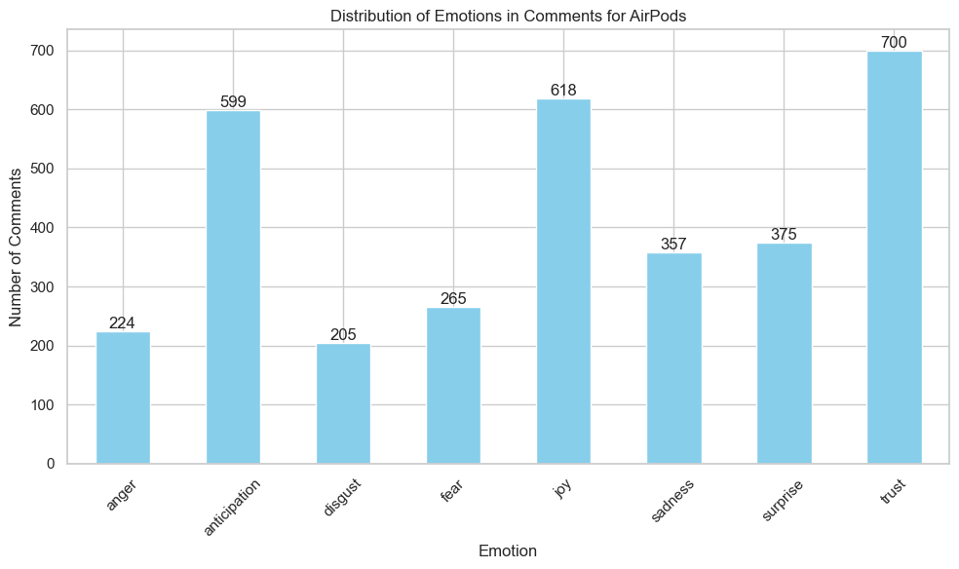

**Figure 44** This is a bar graph showing an emotion analysis comparison for eBay AirPods comments dataframe.

#### Apple Watch

Upon analysing the textual data about the Apple Watch, it is evident that phrases such as "watch", "great", "good", "love", and "quality" are the most commonly utilised words (Figure 45). The frequent occurrence of these terms, especially those with positive meanings indicates a significant favourable mood among users. The observed pattern in the data can be interpreted as an indication of user contentment and a positive evaluation of the Apple Watch. The presence of specific product-related terms like “watch”, “size”, and “battery” also indicates a focused discussion on the features and attributes of the product, reinforcing the overall positive sentiment.

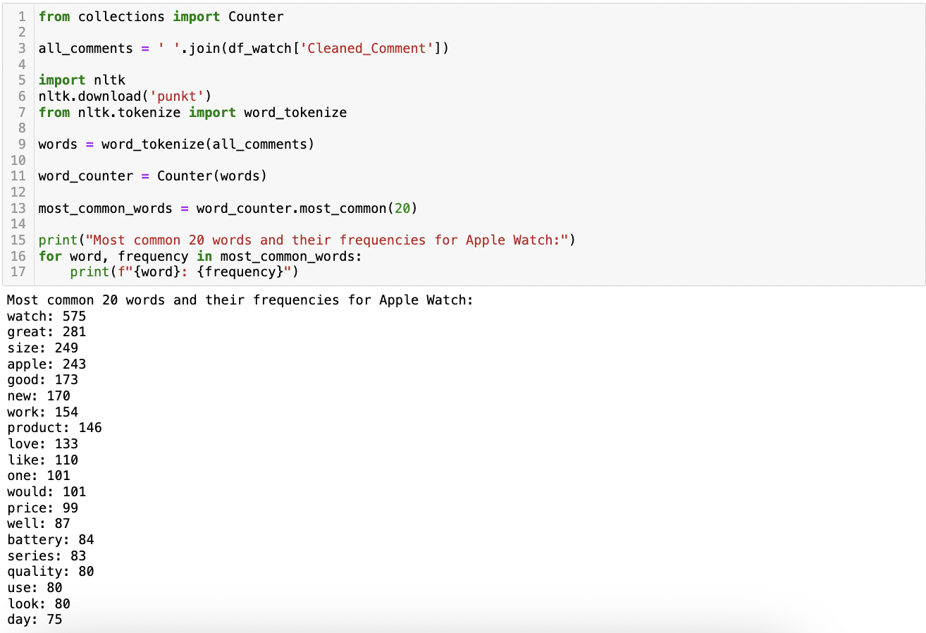

**Figure 45** This is a screenshot of the Python script and its result showing the most common words in the eBay Apple Watch comments dataframe.

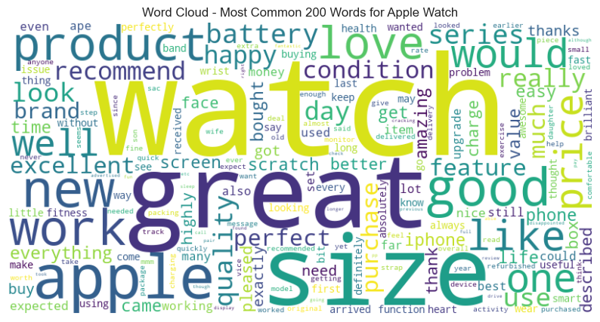

**Figure 46** This is a screenshot of the word cloud showing the most common words in the eBay Apple Watch comments dataframe.

Moreover, analysis of the most frequent noun phrases associated with Apple Watch discussions highlights a prevailing positive sentiment. Phrases such as “great product”, “series size”, “battery life”, “great price”, and “happy purchase” were prominently featured (Figure 47). Additionally, mentions of “perfect condition”, “easy use”, and “great condition” further underline this trend. These phrases not only reflect the favourable perception of the Apple Watch but also indicate a strong alignment between the individual word sentiments and the broader sentiment trends observed in these discussions, providing a holistic view of the public opinion surrounding the Apple Watch.

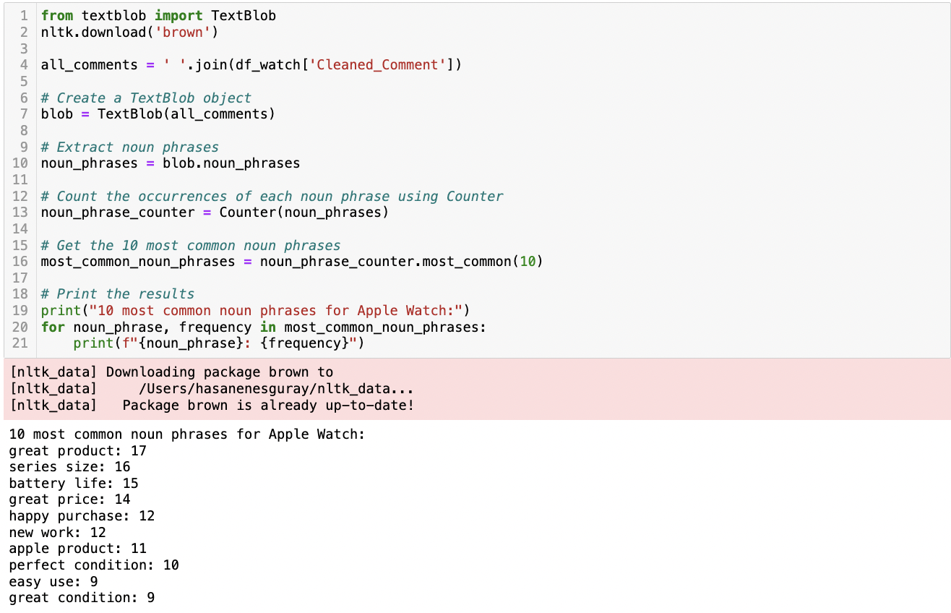

**Figure 47** This is a screenshot of the Python script and its result showing the most common noun phrases in the eBay Apple Watch comments dataframe.

##### Topic Modelling Analysis

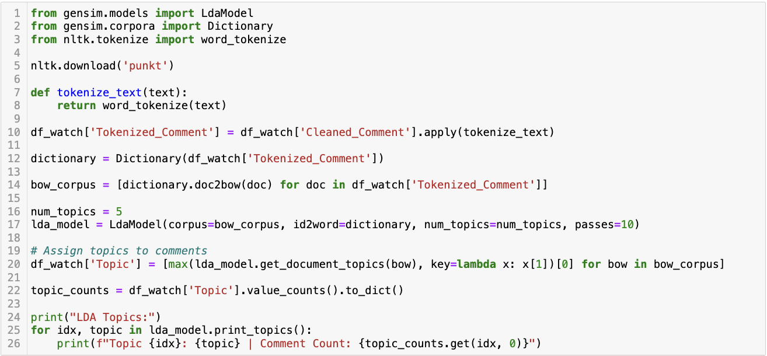

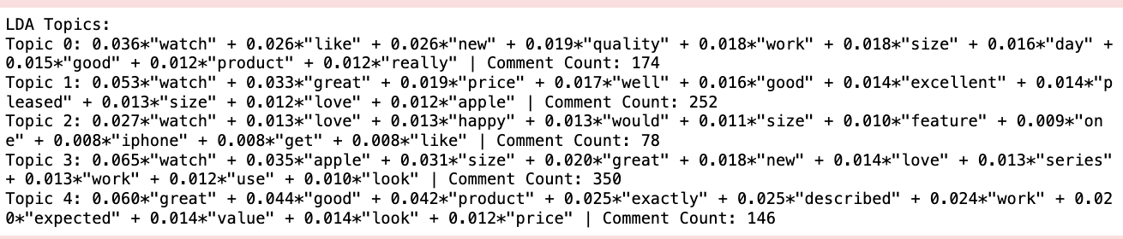

**Figure 48** This is a screenshot of the Python script and its result showing LDA Topic Modelling for eBay Apple Watch comments dataframe.

For Apple Watch, Topic 0 focuses on the general attributes of the watch like its quality, size, and functionality, highlighting its newness and day-to-day utility. Topic 1 emphasizes the watch's value for money, praising its great quality, pleasing size, and compatibility with Apple products. In Topic 2, the emphasis shifts to personal satisfaction and the watch's features, indicating a strong emotional connection (“love”, ”happy”) with the product. Topic 3, with the highest comment count, centres around the brand ('Apple'), the watch's aesthetic appeal ('look'), and its utility in various series, suggesting a blend of brand loyalty and appreciation for its functionality. Topic 4 focuses on the product's reliability and value, with terms like ”great”, ”good”, “exactly”, “described”, and ”expected” indicating customer satisfaction with the product meeting or exceeding expectations.

##### Sentiment Analysis

The analysis demonstrated a marked tendency towards classifying the majority of comments as positive, indicating a generally favourable reception of the product among eBay users (Figure 49). The consistency observed in positive sentiment classification across multiple algorithms reinforces the reliability of the findings and underscores the predominance of satisfaction within customer feedback.

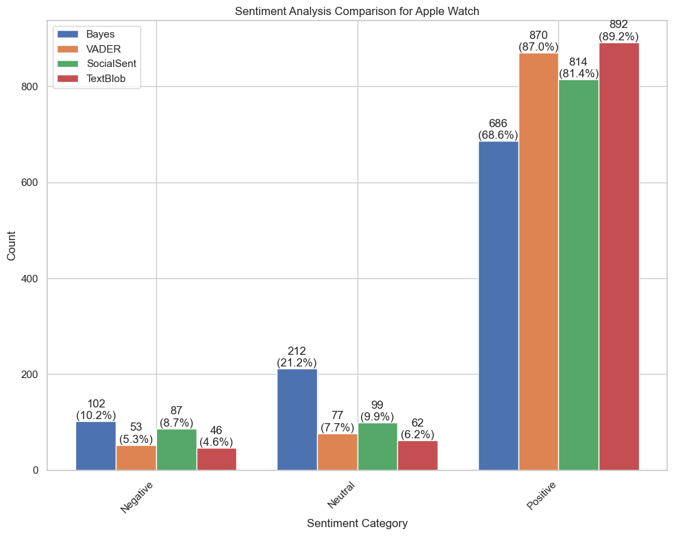

**Figure 49** This is a bar graph showing the sentiment analysis comparison for eBay Apple Watch comments dataframe.

##### Emotion Analysis

Consumer feedback on the Apple Watch shows high anticipation with 820 comments, followed by joy and trust (Figure 50). Fear is noted less, while anger, disgust, and sadness are minimal, highlighting a largely positive sentiment towards the product, with a distinctive emphasis on forward-looking expectations.

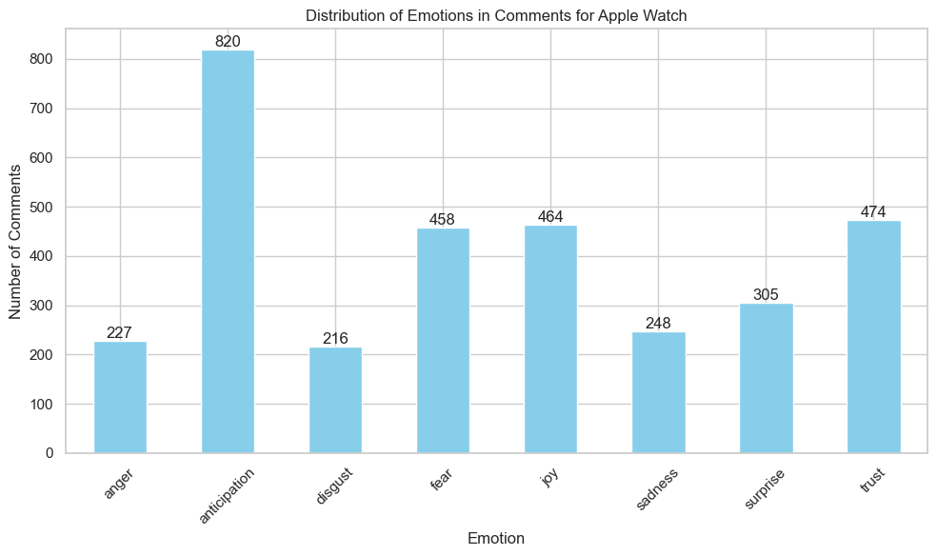

**Figure 50** This is a bar graph showing emotion analysis comparison for eBay Apple Watch comments dataframe.

### Amazon

The chronological analysis of the Amazon dataset uncovers a timeline extending from 2012 through to the current year, as visualized in the provided histogram (Figure 51).

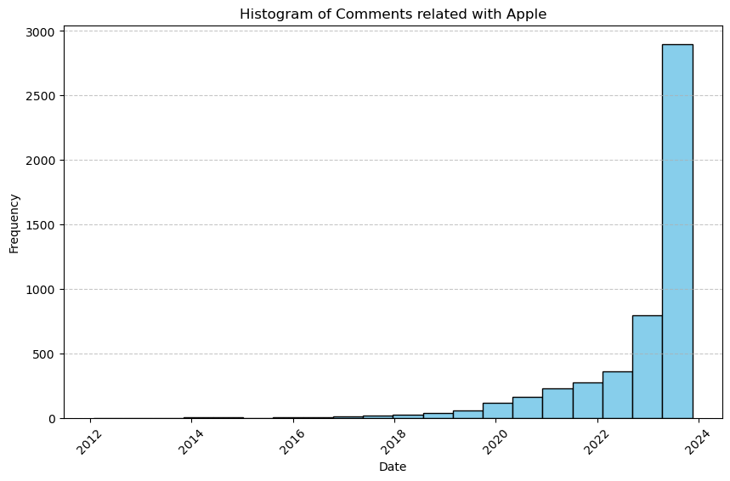

**Figure 51** This is a screenshot of the histogram showing the distribution of comments for Apple products on Amazon over time.

#### iPhone

A striking pattern emerges from the word frequency analysis for iPhone, highlighting the prominence of terms like ”phone”, ”size”, and ”case”, which collectively signal a strong consumer interest in the physical attributes of the device. Additionally, the frequent mention of ”screen”, ”battery”, and ”camera” underscores the importance of these features in user evaluations. The language used is overwhelmingly positive, with words such as ”good', ”great', and ”like” appearing frequently, reflecting a favourable consumer sentiment towards the iPhone (Figure 52).

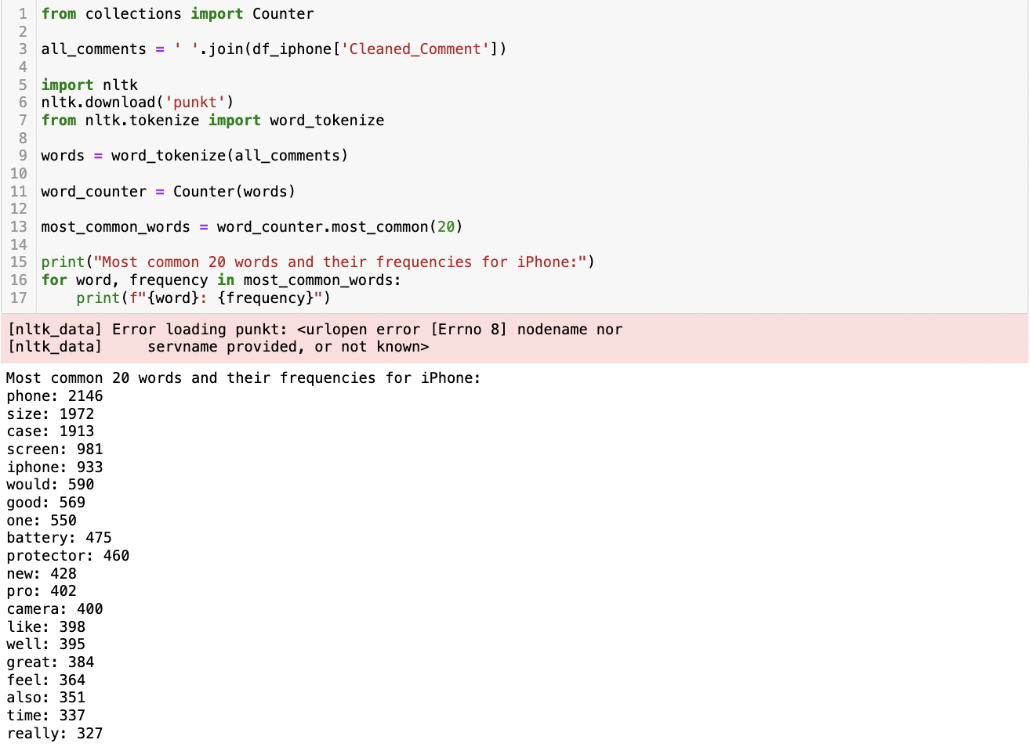

**Figure 52** This is a screenshot of the Python script and its result showing the most common words in the Amazon iPhone comments dataframe.

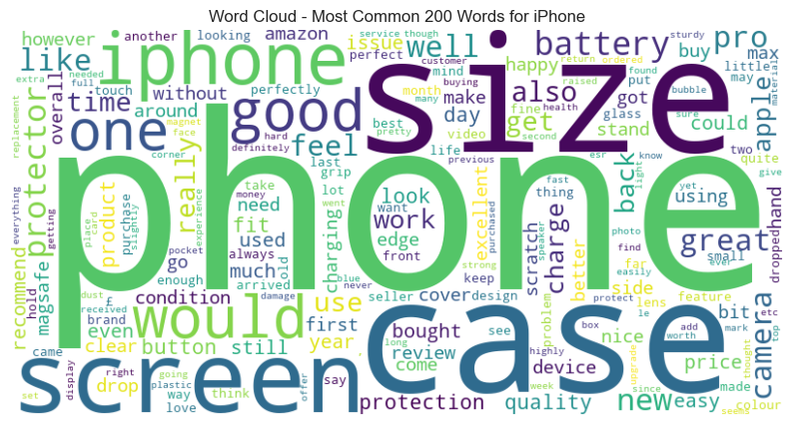

**Figure 53** This is a screenshot of the word cloud showing the most common words in the Amazon iPhone comments dataframe.

The analysis of the predominant noun phrases in this dataset reveals several underlying motifs related to iPhone-related discussions (Figure 54). These motifs include conversations about the physical aspects of the phone, protective accessories, the lifecycle of the device, and the overall user experience. The phrases “iPhone size” and “pro max” suggest a focus on the physical dimensions and model variations of the iPhone. Terms like “screen protector” and “phone case” indicate a significant interest in accessory-related topics, whereas “new phone” and “old phone” reflect the lifecycle stages of the device. “Battery life” and “excellent condition” are indicative of the quality and performance discussions among users.

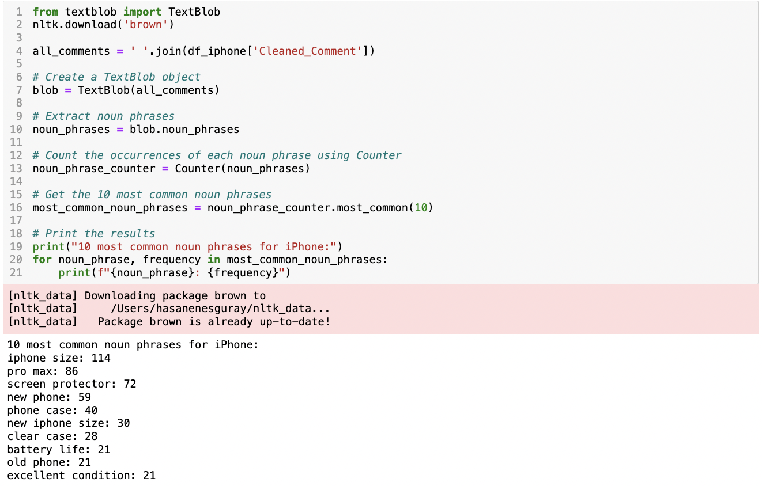

**Figure 54** This is a screenshot of the Python script and its result showing the most common noun phrases in the Amazon iPhone comments dataframe.

##### Topic Modelling

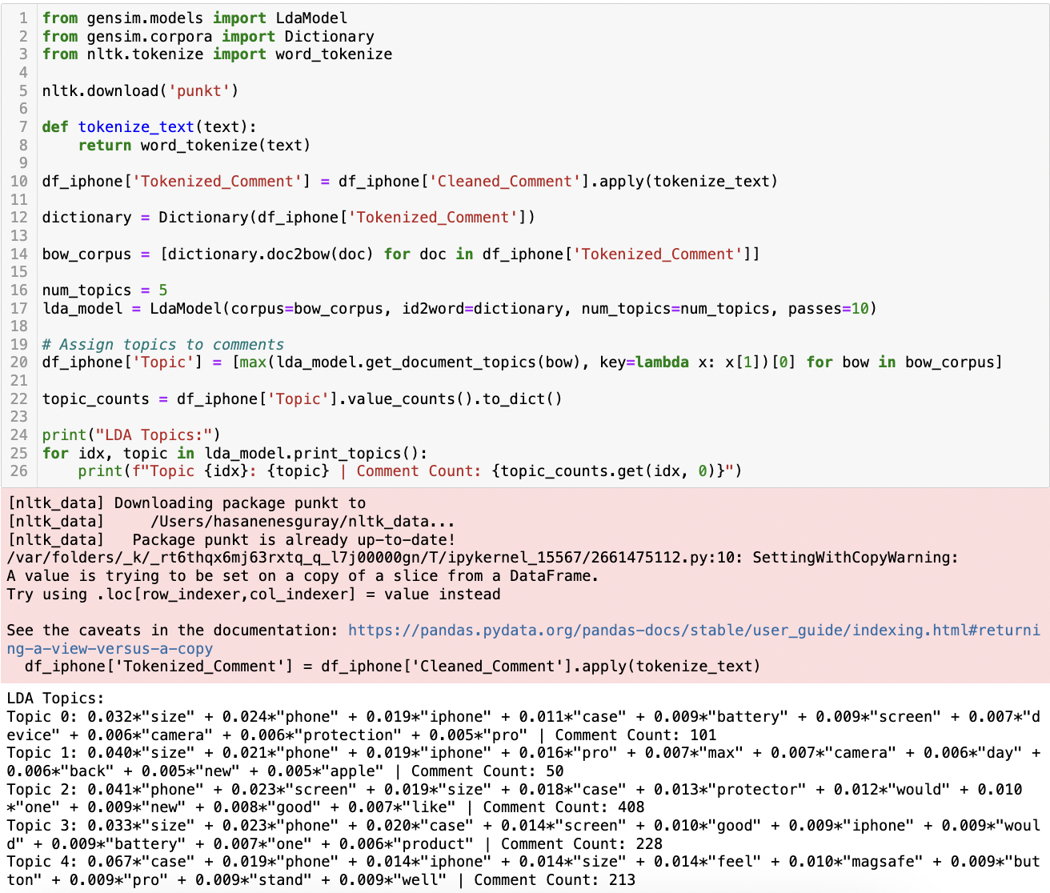

**Figure 54** This is a screenshot of the Python script and its result showing LDA Topic Modelling for the Amazon iPhone comments dataframe.

The LDA Topic Modelling of 1000 Amazon comments related to iPhones reveals several distinct themes. Topic 0 focuses primarily on the iPhone's size, phone features, and aspects like battery, screen, and camera, indicating concerns about usability and technical specifications. Topic 1 also emphasizes size but leans more towards the “pro” versions, hinting at a niche interested in advanced features. The most prominent Topic 2 discusses the phone in general, with a strong emphasis on screen and size, suggesting a widespread interest in the iPhone's display and form factor. Topic 3, mirrors Topic 0 but with more emphasis on the case and screen, indicating a concern for protection and usability. Finally, Topic 4 is heavily focused on cases, particularly their feel and compatibility with features like MagSafe, highlighting a significant interest in accessories.

##### Sentiment Analysis

Although variations in the classification of sentiments as negative, neutral, or positive were observed, the sentiment analysis of Amazon comments for the iPhone revealed a significant inclination towards positive sentiment across all algorithms (Figure 55).

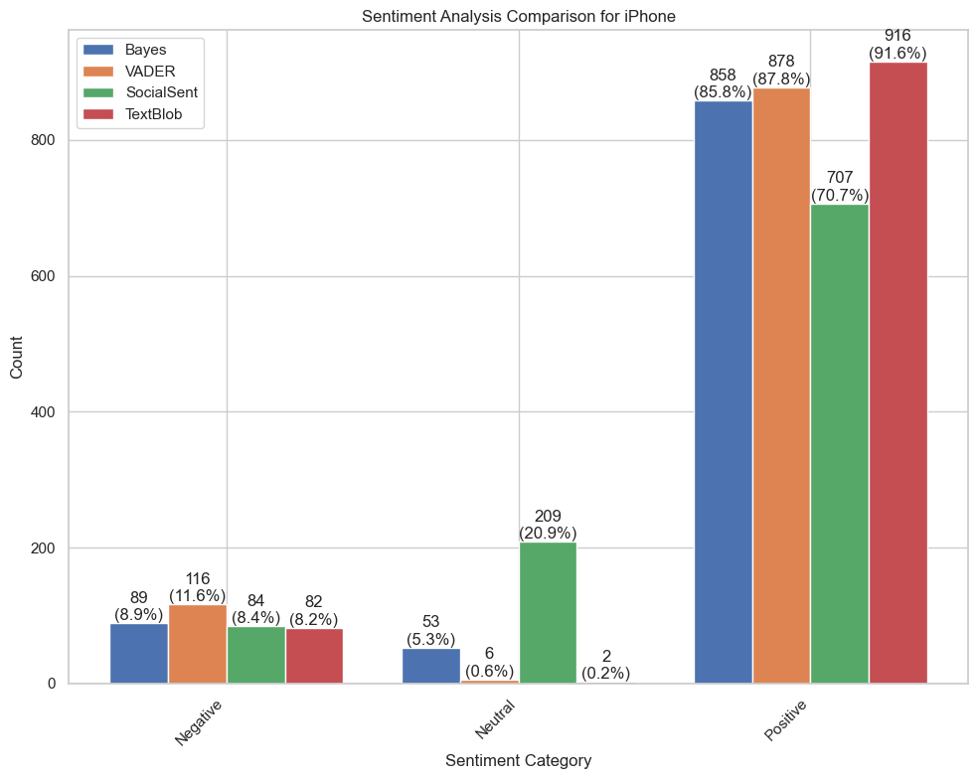

**Figure 55** This is a bar graph showing a sentiment analysis comparison for the Amazon iPhone comments dataframe.

##### Emotion Analysis

The emotional analysis of iPhone comments shows users mainly trust the brand, interspersed with feelings of sadness and anticipation (Figure 56). Fear suggests product apprehensions, while joy indicates positive reactions. Surprise points to unexpected user experiences. Anger and disgust are minimal, highlighting overall positive reception but with varied emotional undercurrents, meriting deeper product evaluation to improve user satisfaction.

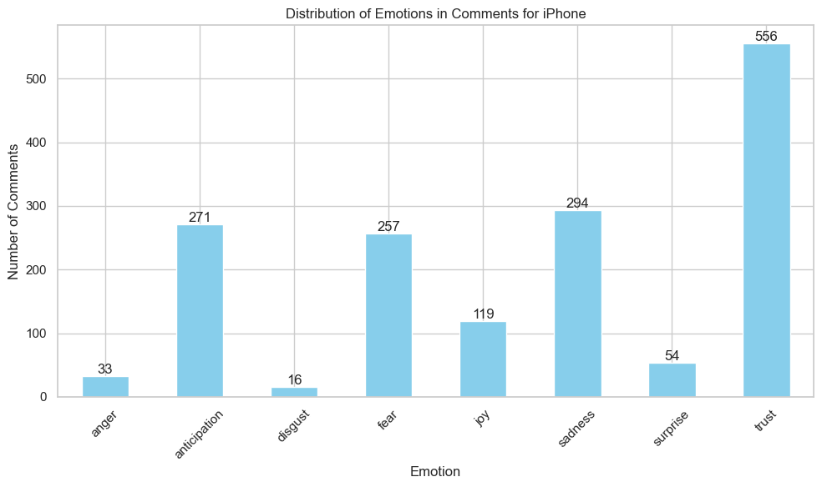

**Figure 56** This is a bar graph showing an emotion analysis comparison for the Amazon iPhone comments dataframe.

#### iPad

In the examination of discourse surrounding the iPad, a pattern emerged showing frequent mentions of practical aspects like “case”, “keyboard”, “screen”, and “protector”, alongside more subjective evaluations like “good”, “great”, and “really” (Figure 57). The high occurrence of these terms suggests a dual focus in discussions about the iPad on one hand, there's a clear emphasis on functional and hardware features; on the other hand, there's a significant expression of positive sentiment.

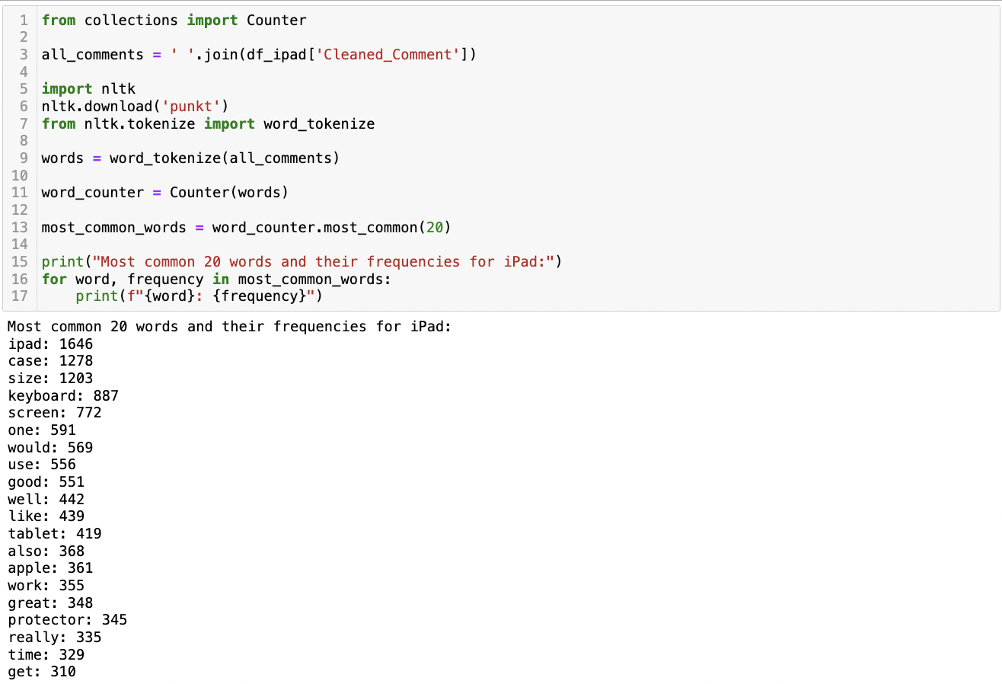

**Figure 57** This is a screenshot of the Python script and its result showing the most common words in the Amazon iPad comments dataframe.

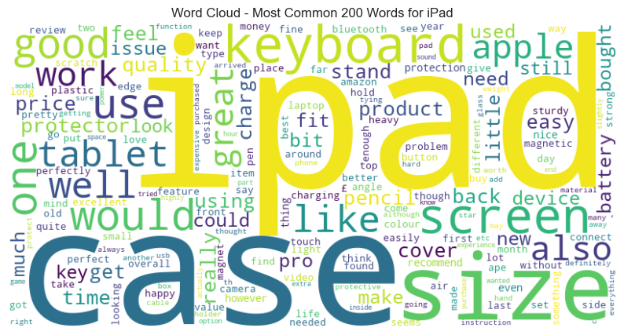

**Figure 58** This is a screenshot of the word cloud showing the most common words in the Amazon iPad comments dataframe.

The study of common noun phrases in iPad discussions reveals key themes: accessory protection (“screen protector”, “iPad case”), model details (“new iPad”, “pro size”), cost sensitivity (“£ size”), tool compatibility (“Apple Pencil”, “fit iPad”), and ease of use (“easy use”, “size year”) (Figure 63). iPad conversations focus on practical usage and accessory compatibility rather than device lifecycle, emphasizing functionality, protection, and affordability.

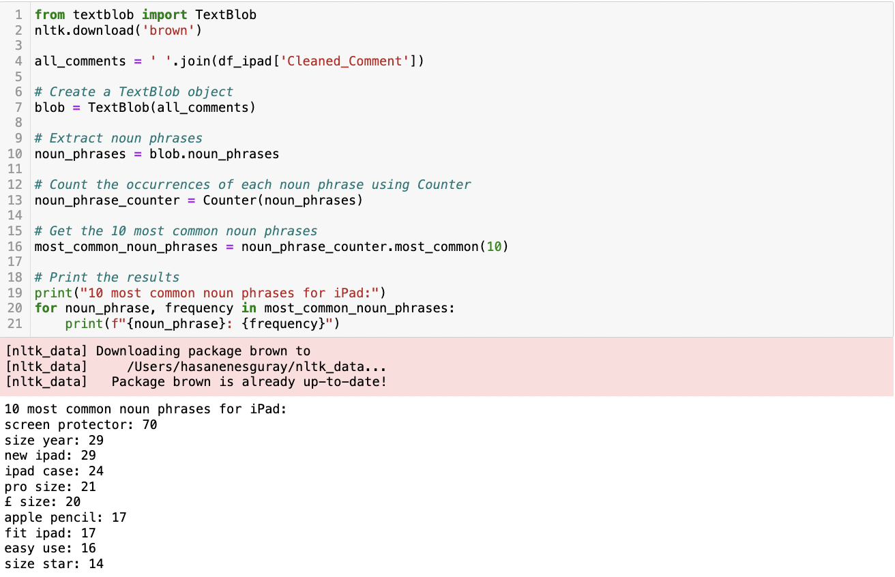

**Figure 59** This is a screenshot of the Python script and its result showing the most common noun phrases in the Amazon iPad comments dataframe.

##### Topic Modelling Analysis

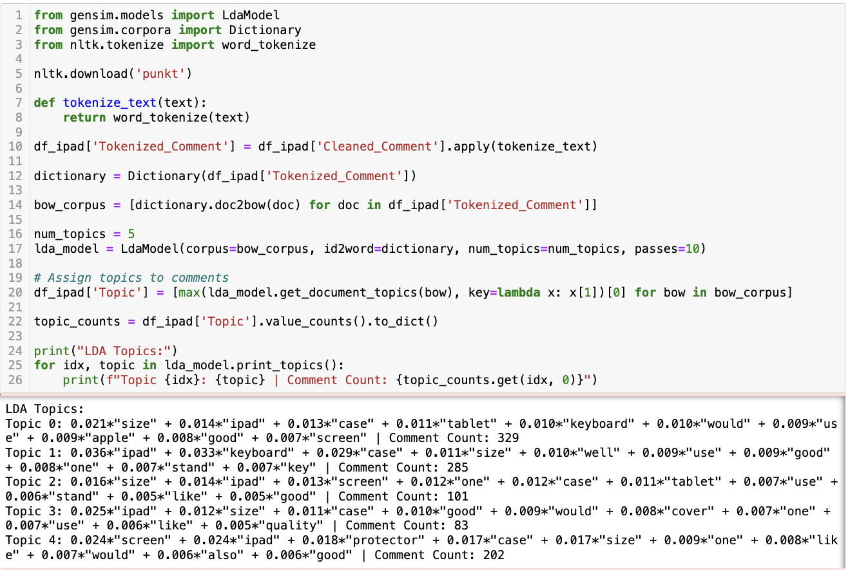

**Figure 60** This is a screenshot of the Python script and its result showing LDA Topic Modelling for the Amazon iPad comments dataframe.

For iPad, topic 0 emphasizes practicality, focusing on size, usability with keyboards, and overall functionality, indicating a consumer interest in the iPad as a versatile device. Topic 1 also highlights the keyboard and case, suggesting a significant interest in accessories that enhance the iPad's functionality. Topic 2, while smaller, continues the trend with a focus on screen size and case design, implying that visual and protective aspects are key considerations for a subset of users. Topic 3 shifts slightly, emphasizing quality and cover, indicating a concern for durability and protection. Finally, Topic 4 stands out by concentrating on the screen and protector, highlighting a specific concern for screen integrity and protection.

##### Sentiment Analysis

The sentiment analysis conducted on a sample of iPad comments from Amazon demonstrates a consistent trend of positivity according to four distinct algorithms (Figure 61).

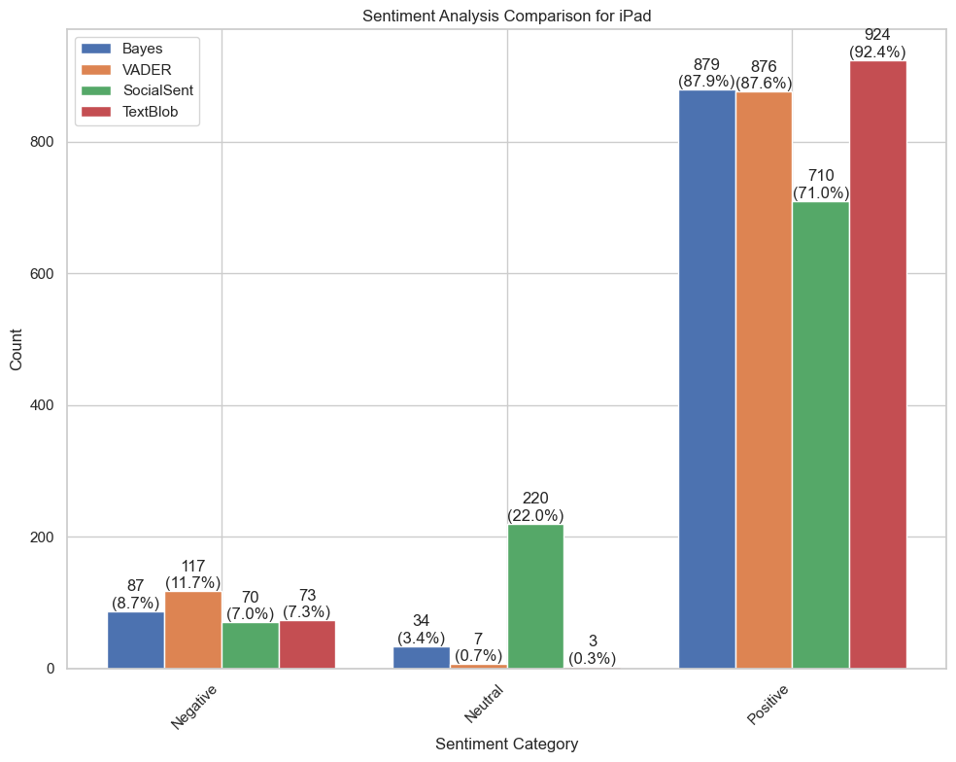

**Figure 61** This is a bar graph showing a sentiment analysis comparison for the Amazon iPad comments dataframe.

##### Emotion Analysis

In the investigation of emotional responses to the iPad, the data visualization elucidates a distinct pattern of affective reactions among users (Figure 62). Analysing 1000 comments, the most prevalent emotion expressed was trust illustrating a strong foundation of reliability and confidence in the iPad. This was followed by anticipation and sadness, indicating a complex emotional landscape where users express not only their expectations but also moments of discontent or longing. Joy, as the next significant emotion, reflects positive user experiences, albeit to a lesser extent compared to trust. The occurrence of surprise was relatively modest, suggesting that the iPad experience aligns closely with user expectations. Notably, negative emotions such as fear, anger, and disgust were present but in significantly lower frequencies.

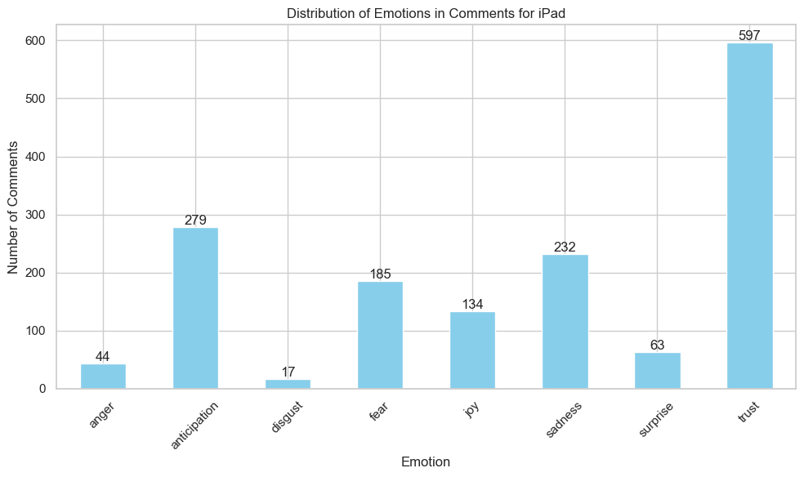

**Figure 62** This is a bar graph showing an emotion analysis comparison for the Amazon iPad comments dataframe.

#### Macbook

In analysing MacBook-related texts, frequent words like “size”, “laptop”, and “battery” emphasize hardware aspects (Figure 63). Positive terms like “good” and “great” show user satisfaction. Words “use”, “work”, and “price” highlight its practicality and cost considerations, indicating a balanced discourse on the MacBook's quality, utility, and value.

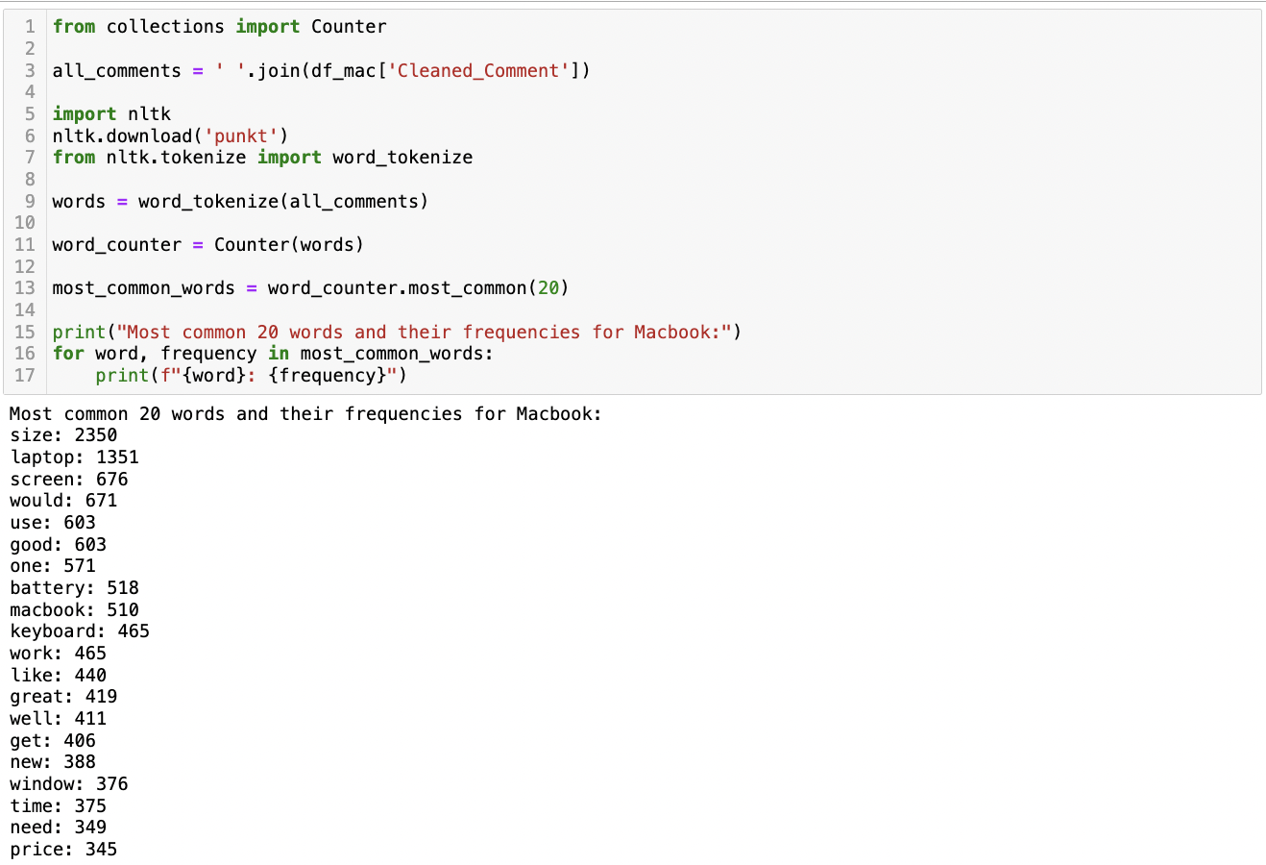

**Figure 63** This is a screenshot of the Python script and its result showing the most common words in the Amazon Macbook comments dataframe.

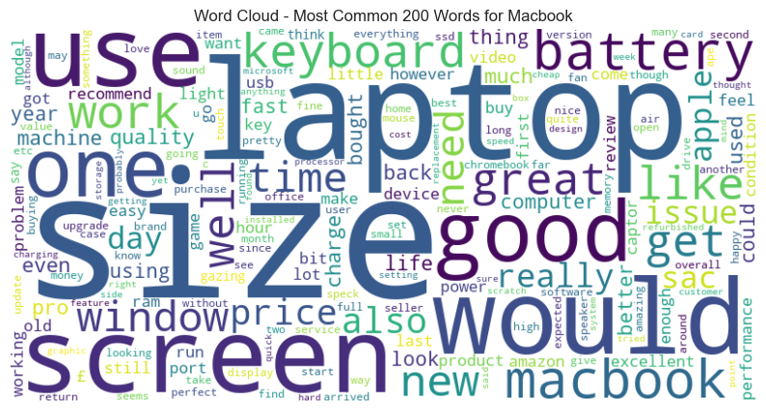

**Figure 64** This is a screenshot of the word cloud showing the most common words in the Amazon Macbook comments dataframe.

The analysis of MacBook discussions (Figure 65) shows varied interests, focusing on performance, models, cost, and condition. Key phrases include “battery life”, “macbook air”, and “window size”, highlighting concerns about endurance, specific models, display dimensions, and novelty. “£ size” indicates price sensitivity, “excellent condition” emphasizes the device's physical state, and “size month” suggests warranty or usage duration interests.

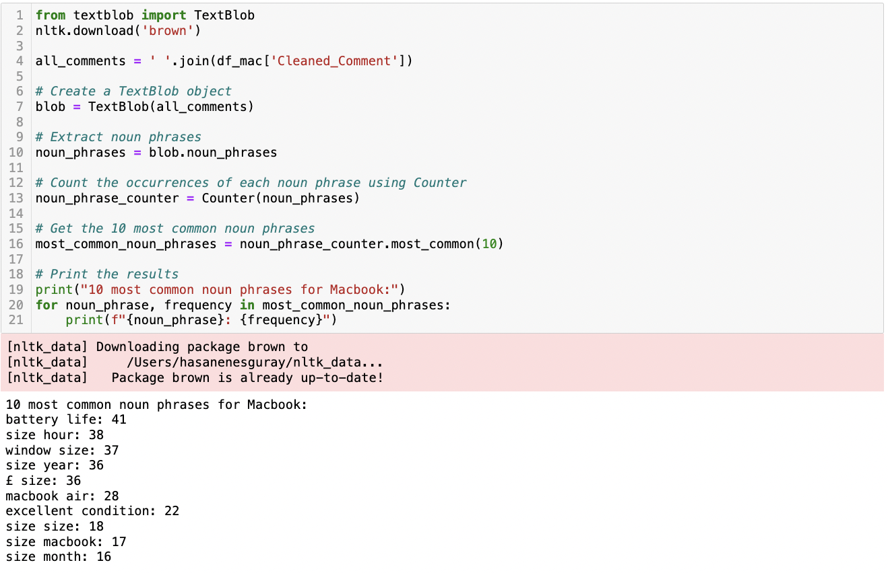

**Figure 65** This is a screenshot of the Python script and its result showing the most common noun phrases in the Amazon Macbook comments dataframe.

##### Topic Modelling Analysis

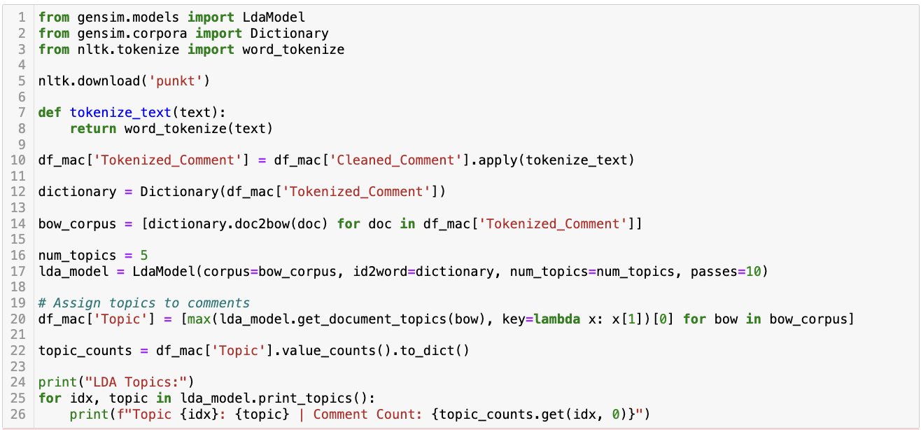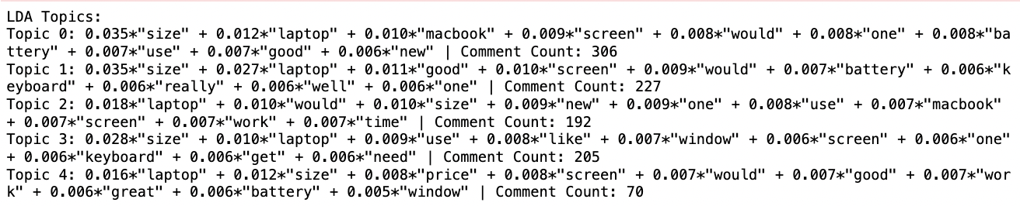

**Figure 66** This is a screenshot of the Python script and its result showing LDA Topic Modelling for the Amazon Macbook comments dataframe.

For Macbook, topic 0, with the highest comment count, and Topic 1 predominantly focus on the size, laptop functionality, screen, and battery life, indicating a general concern for overall usability and features. Topic 2 shifts slightly to include the newness of the product, suggesting interest in the latest models and their functional improvements. Topic 3 introduces elements like software compatibility (“window”), pointing to a segment concerned with software and interface aspects. Lastly, Topic 4 emphasizes cost-value considerations (“price”) and qualitative attributes (“great”), indicating a cost-conscious consumer group interested in overall value.

##### Sentiment Analysis

The sentiment analysis conducted on Amazon reviews for Macbook demonstrated a pronounced trend toward positive sentiment when processed through a suite of sentiment analysis algorithms (Figure 67). Despite the methodological variances, the overarching conclusion drawn from the data was a clear predominance of positive feedback.

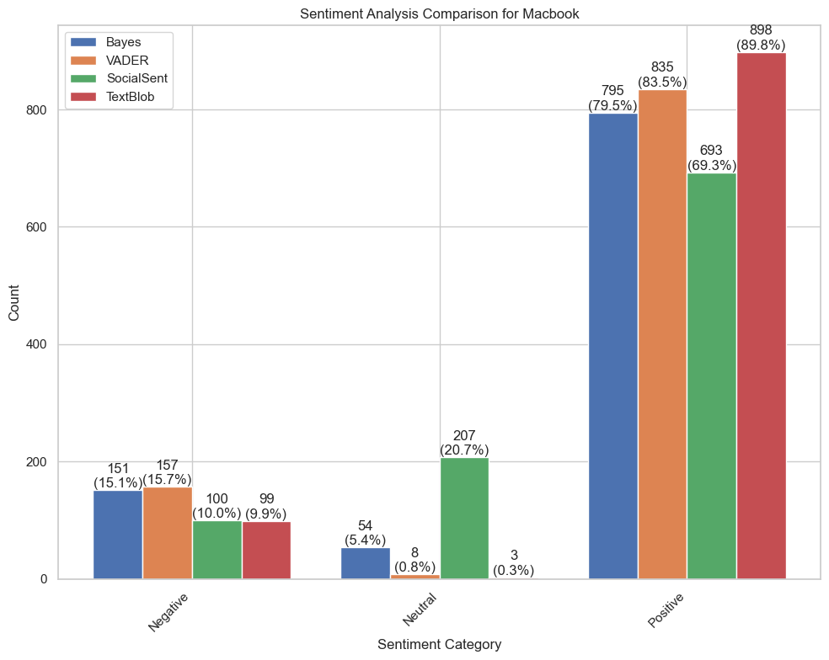

**Figure 67** This is a bar graph showing a sentiment analysis comparison for the Amazon Macbook comments dataframe.

##### Emotion Analysis

The data visualization highlighted a predominant inclination towards trust, signifying strong consumer confidence in the product (Figure 68). This was closely followed by anticipation, suggesting an eager expectation or positive outlook regarding the MacBook's use or future developments. The presence of joy, though less dominant, still played a significant role in the emotional landscape, indicating overall satisfaction and pleasure among users. Notably, the occurrence of surprise and fear was relatively balanced, pointing to a mixture of unexpected reactions and apprehensions among consumers. This emotional configuration underscores a predominantly positive engagement with the MacBook, with trust and anticipation being the most salient emotions. The presence of negative emotions, albeit in smaller proportions, reflects the diverse and complex nature of consumer relationships with technology products.

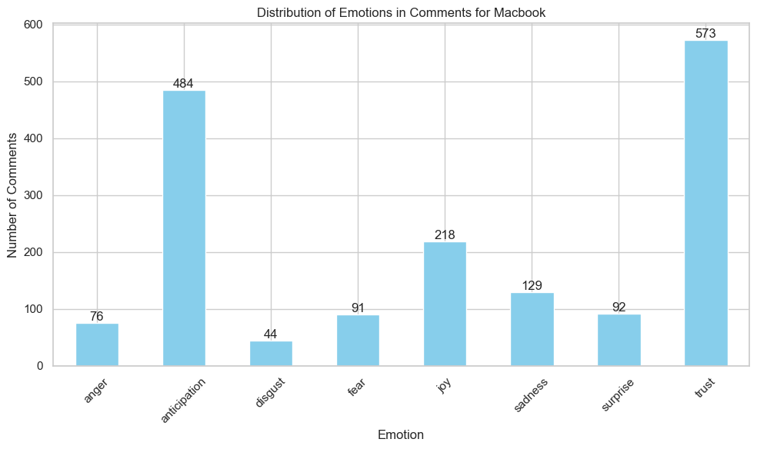

**Figure 68** This is a bar graph showing an emotion analysis comparison for the Amazon Macbook comments dataframe.

#### AirPods

In the analysis of textual data about AirPods, a noteworthy pattern emerged with words such as “size”, “sound”, “ear”, and “quality” ranking among the top 20 most frequently used terms (Figure 69). The predominant occurrence of these words, especially those related to product features like “size”, “sound”, and “quality”, indicates a strong focus on the technical and experiential aspects of AirPods. Words like “good” and “quality” also reflect positive sentiment, suggesting user appreciation for their auditory experience and design. Additionally, terms such as “case”, “bud”, and “battery” highlight specific areas of interest or concern for users.

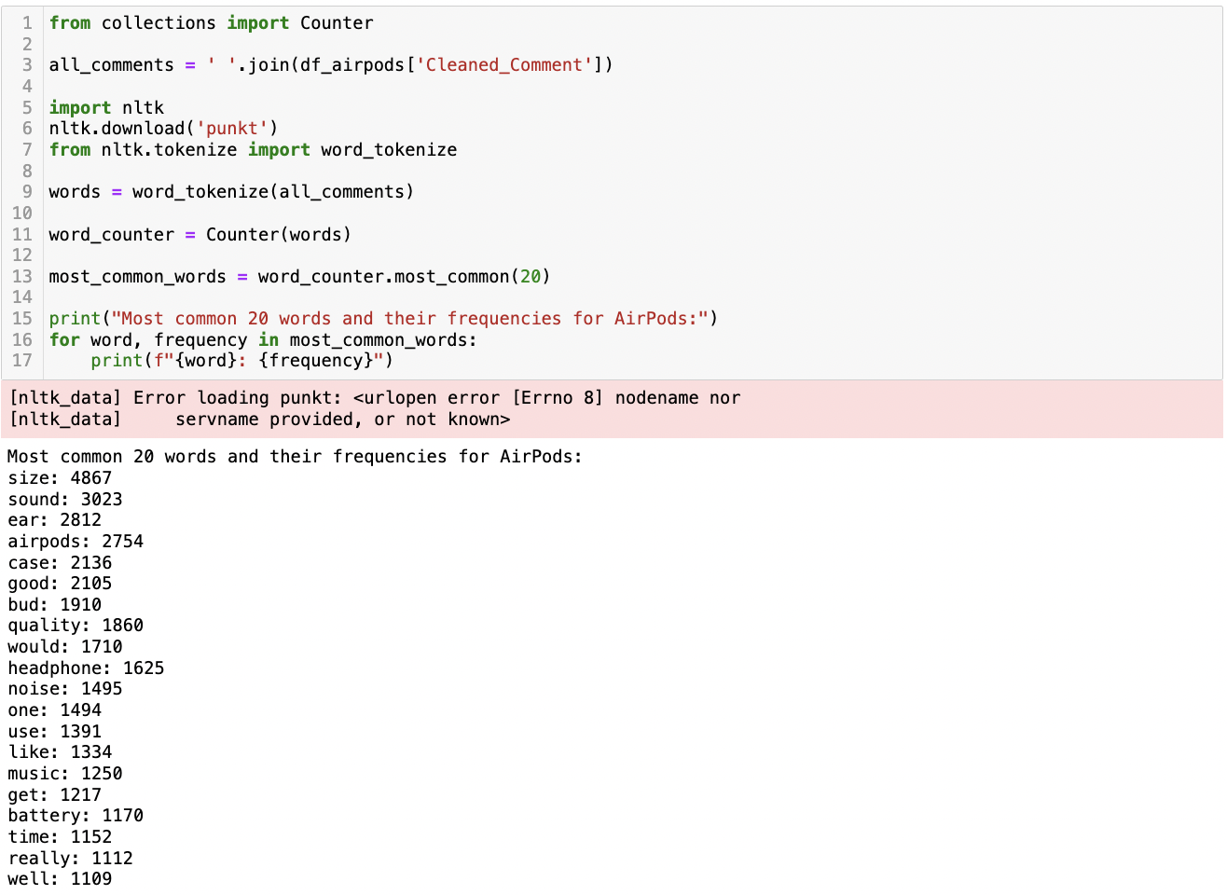

**Figure 69** This is a screenshot of the Python script and its result showing the most common words in the Amazon AirPods comments dataframe.

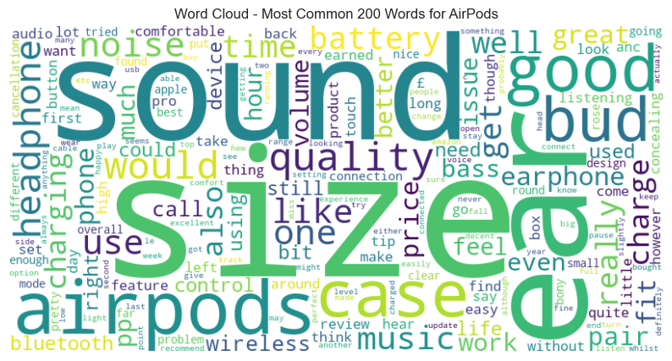

**Figure 70** This is a screenshot of the word cloud showing the most common words in the Amazon AirPods comments dataframe.

Analysing common phrases in AirPods discussions (Figure 71) reveals a focus on user experience and functionality. Dominant terms like “sound quality”, “battery life”, and “noise cancellation” highlight priorities in audio performance, longevity, and immersive listening. “Ear bud” and “fit ear” emphasize comfort, while “touch control” suggests the importance of intuitive interaction, reflecting a discourse centred on sensory experiences and practical use.

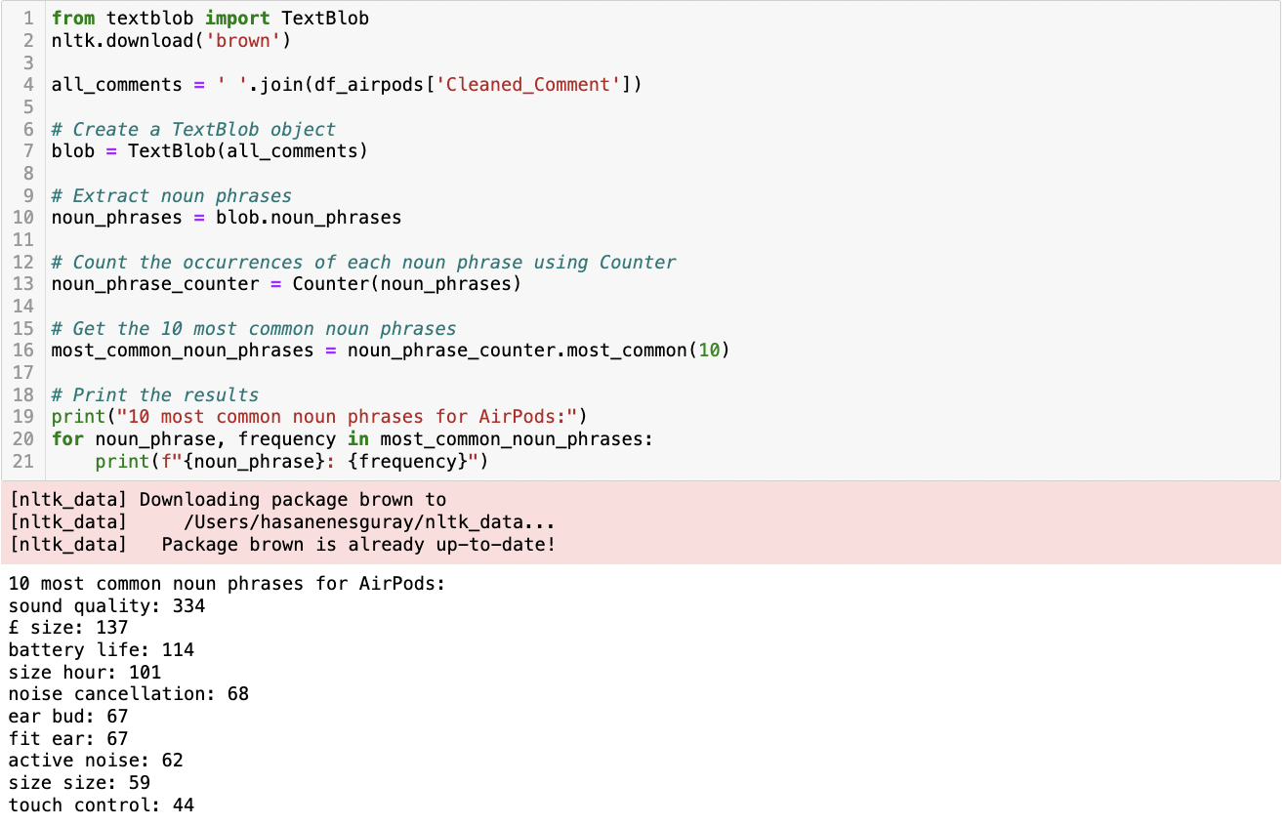

**Figure 71** This is a screenshot of the Python script and its result showing the most common noun phrases in the Amazon AirPods comments dataframe.

##### Topic Modelling Analysis

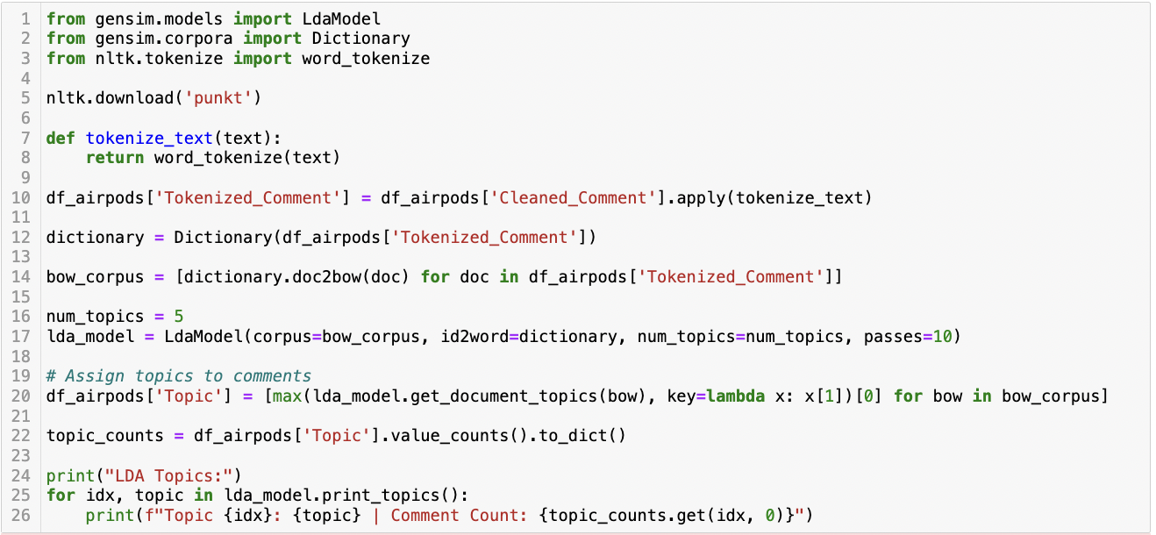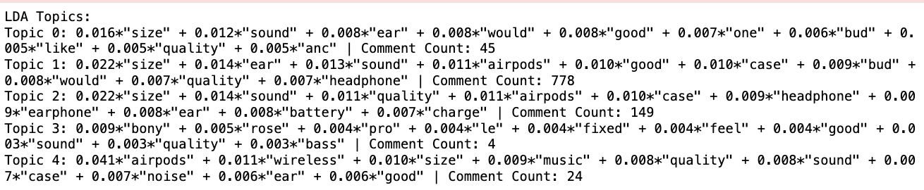

**Figure 72** This is a screenshot of the Python script and its result showing LDA Topic Modelling for Amazon AirPods comments dataframe.

For AirPods, topic 1, with the highest comment count, emphasizes ”size” and ”ear” comfort, indicating a significant interest in the physical fit of AirPods. Sound quality is a recurring theme across all topics, highlighting its importance to consumers. Topic 0 and Topic 2 also focus on ”size”, ”sound”, and ”quality”, suggesting that these are key factors in customer satisfaction or dissatisfaction. The prominence of ”airpods”, ”case”, and ”bud” in Topics 1 and 2 indicates a focus on the product's design and accessories. Interestingly, Topic 3, though it has the least comments, introduces unique terms like ”bony”, ”rose”, and ”pro”, which could indicate specific product variants or features. Topic 4, with a moderate comment count, brings ”wireless” and ”music” into focus, suggesting user interest in the functionality and performance of AirPods in music listening.

##### Sentiment Analysis

The sentiment analysis conducted on Amazon reviews for AirPods demonstrates a predominant trend of positivity as discerned by all applied algorithms (Figure 73). The findings suggest that while the algorithms concur on the overall positive reception of AirPods among consumers, the nuances of sentiment interpretation remain algorithm-specific.

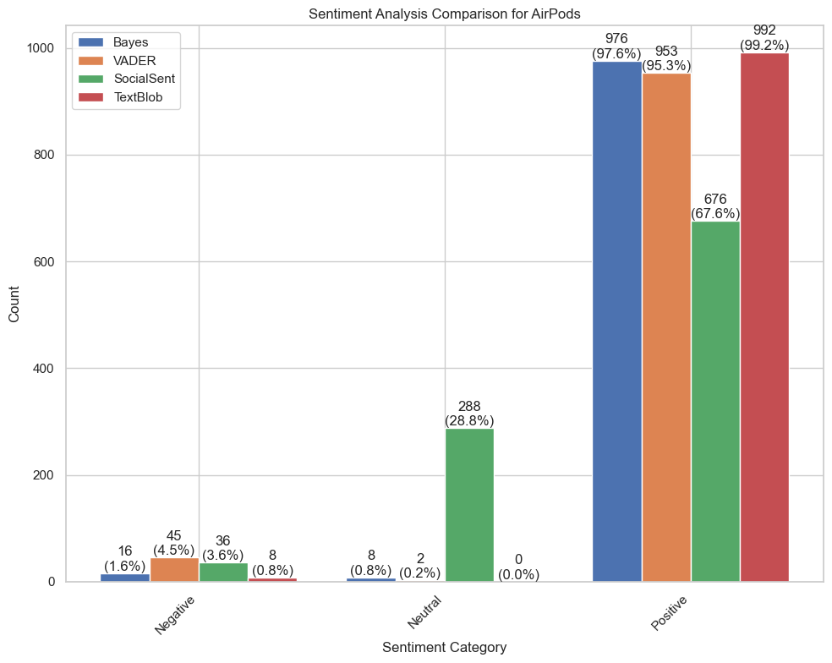

**Figure 73** This is a bar graph showing a sentiment analysis comparison for Amazon AirPods comments dataframe.

##### Emotion Analysis

Notably, trust emerged as the most prevalent emotion underscoring a significant level of consumer confidence in the product (Figure 74). This was followed by anticipation and sadness, illustrating a complex interplay of forward-looking expectations and elements of discontent or unmet expectations among users. Interestingly, joy, though less predominant, still reflected a notable degree of positive engagement. Disgust was absent from the dataset, further reinforcing the predominantly positive emotional disposition towards the AirPods.

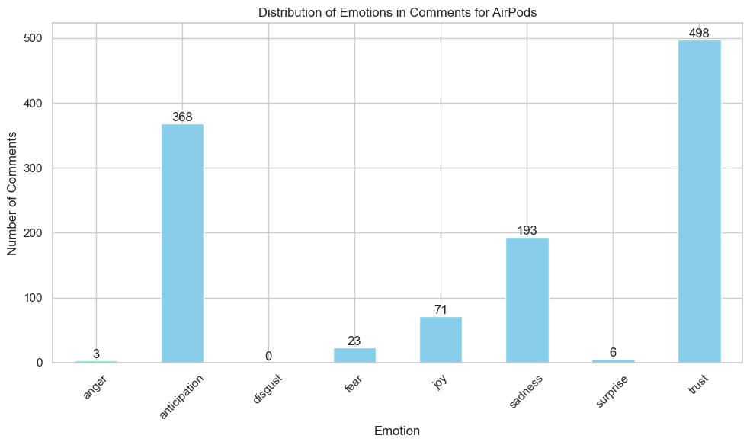

**Figure 74** This is a bar graph showing an emotion analysis comparison for Amazon AirPods comments dataframe.

#### Apple Watch

Analysing the top 20 words in Apple Watch discussions (Figure 75) reveals key focuses: “watch”, “size”, “strap”, and “quality” indicate user interest in features and design. Positive terms like “good”, “great”, and “easy” reflect favourable sentiment. “Fit”, “charge”, and “use” suggest practical engagement, emphasizing functionality and user experience.

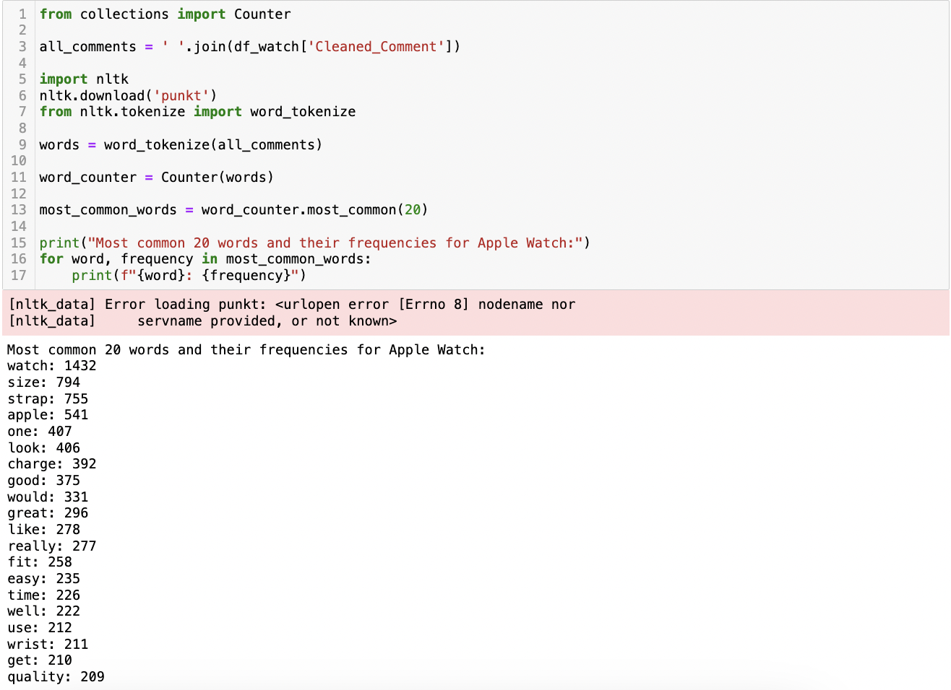

**Figure 75** This is a screenshot of the Python script and its result showing the most common words in the Amazon Apple Watch comments dataframe.

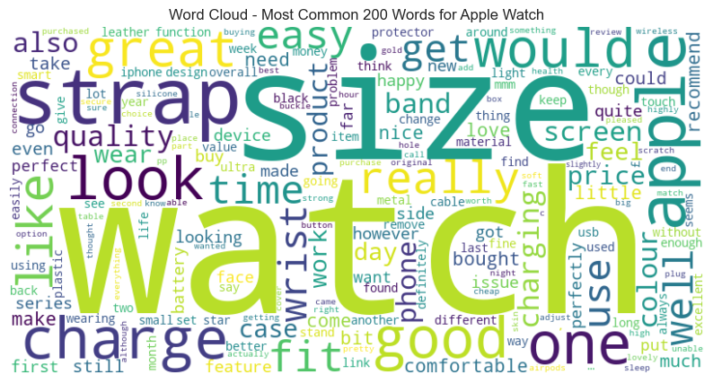

**Figure 76** This is a screenshot of the word cloud showing the most common words in the Amazon Apple Watch comments dataframe.

The analysis of common noun phrases in Apple Watch discussions highlights a focus on practicality, comfort, and quality. Key terms like “series size” and “small wrist” emphasize model variety and personal fit, reflecting a preference for customization. “Battery life” and “screen protector” suggest concerns about durability and longevity, vital for wearable tech. Positive phrases like “good quality” and “great product” indicate overall user satisfaction. The recurrence of “fit apple” points to interest in the watch's integration with other Apple products, showing that discussions prioritize physical attributes and user-friendly design within the Apple ecosystem.

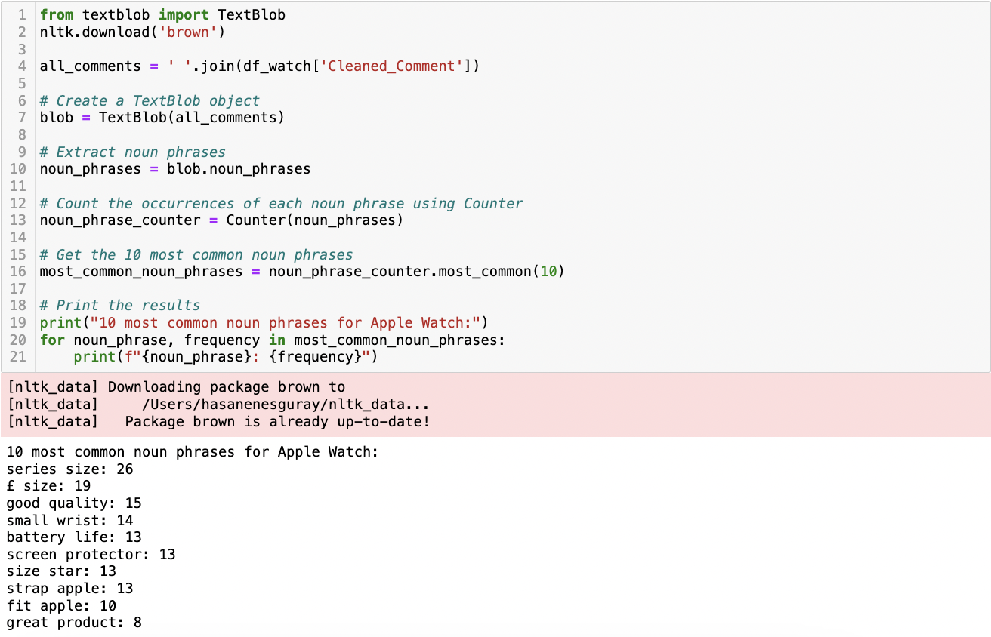

**Figure 77** This is a screenshot of the Python script and its result showing the most common noun phrases in the Amazon Apple Watch comments dataframe.

##### Topic Modelling Analysis

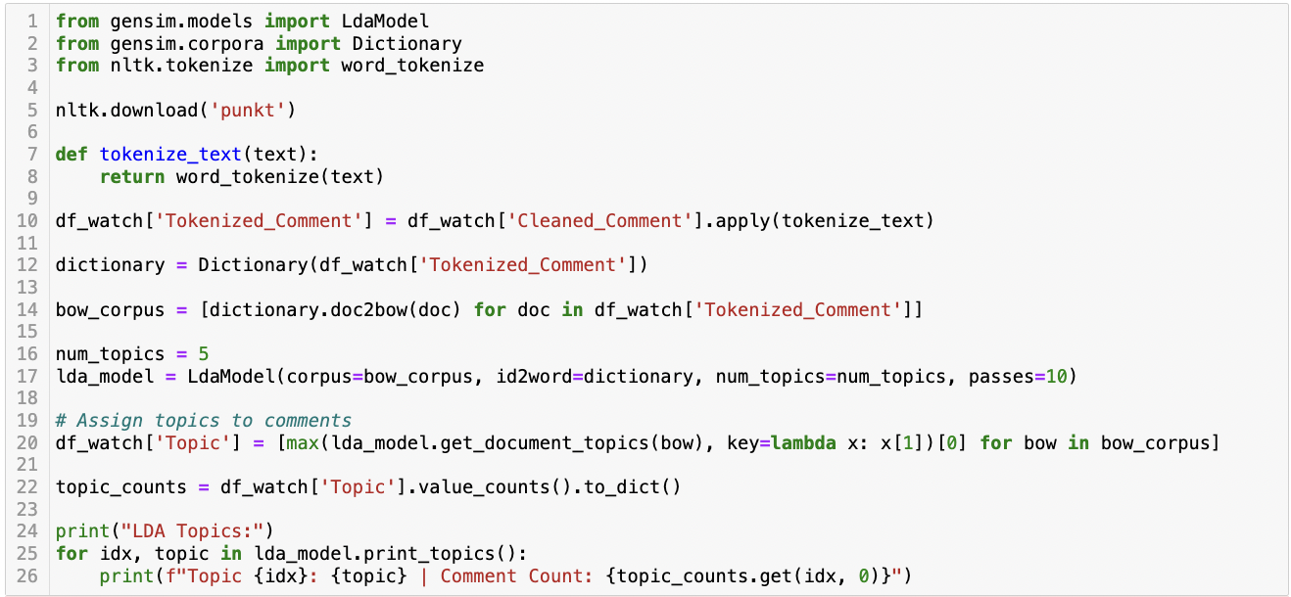

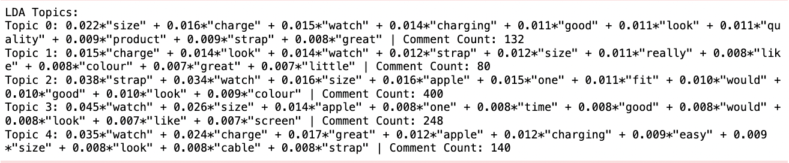

**Figure 78** This is a screenshot of the Python script and its result showing LDA Topic Modelling for Amazon Apple Watch comments dataframe.

For Apple Watch, topic 0 focuses on the physical aspects of the watch like size, charging capabilities, and strap quality, indicating an interest in practicality and aesthetics. Topic 1 also discusses charge and look, but with a slightly different emphasis, suggesting a concern for the watch's appearance and functionality. The largest group, Topic 2, heavily emphasizes the strap and size, highlighting user interest in customization and fit. Topic 3 brings in a broader perspective, discussing the Apple brand and functionality like screen and time-keeping, indicating an interest in the watch's core features and brand value. Lastly, Topic 4 centres around ease of use in charging and overall satisfaction with the product, suggesting that user experience, particularly in terms of convenience and utility, is a significant factor for customers.

##### Sentiment Analysis

In the sentiment analysis conducted on a corpus of comments regarding the Apple Watch, a pronounced trend towards positive sentiment was discerned across all utilized algorithms (Figure 79). The analysis demonstrated a consistent pattern of positive sentiment, despite the nuanced interpretations of each algorithm.

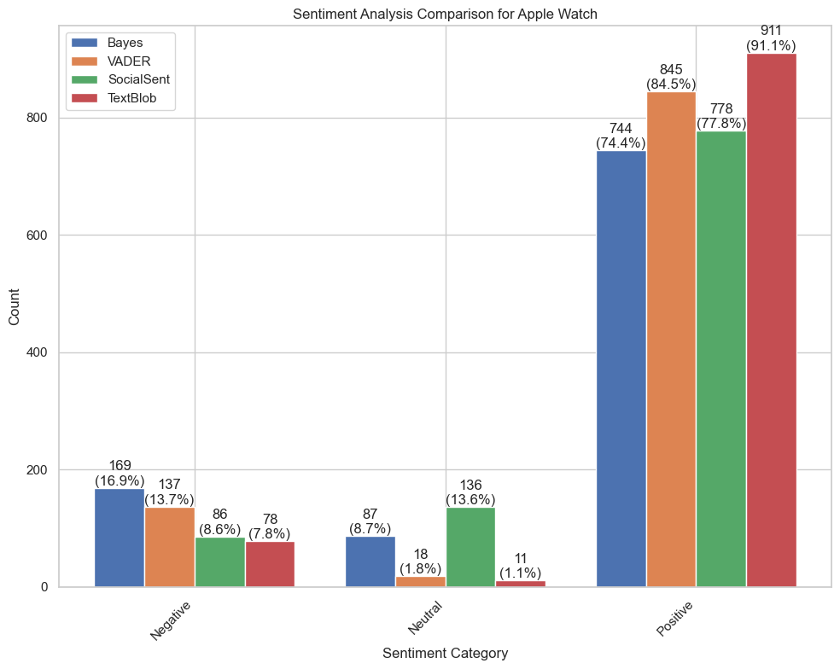

**Figure 79** This is a bar graph showing sentiment analysis comparison for Amazon Apple Watch comments dataframe.

##### Emotion Analysis

In the emotional analysis of consumer comments about the Apple Watch, the data revealed anticipation and trust as the predominant emotions, indicating strong consumer expectations and confidence in the product (Figure 80). Joy also contributed to the overall positive sentiment, while a notable presence of fear suggested concerns related to aspects like product reliability or privacy. Other emotions such as sadness, surprise, anger, and disgust were present as well, reflecting a broader spectrum of consumer experiences.

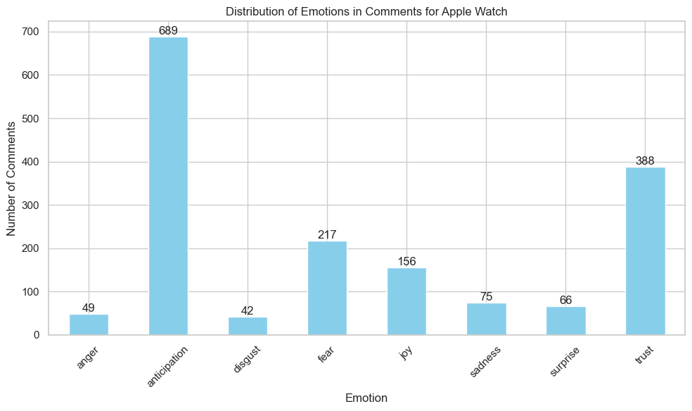

**Figure 80** This is a bar graph showing the emotion analysis comparison for Amazon Apple Watch comments dataframe.

### Reddit

The chronological examination of the Reddit comments dataset reveals a timeframe spanning from January 2022 through today (Figure 81).

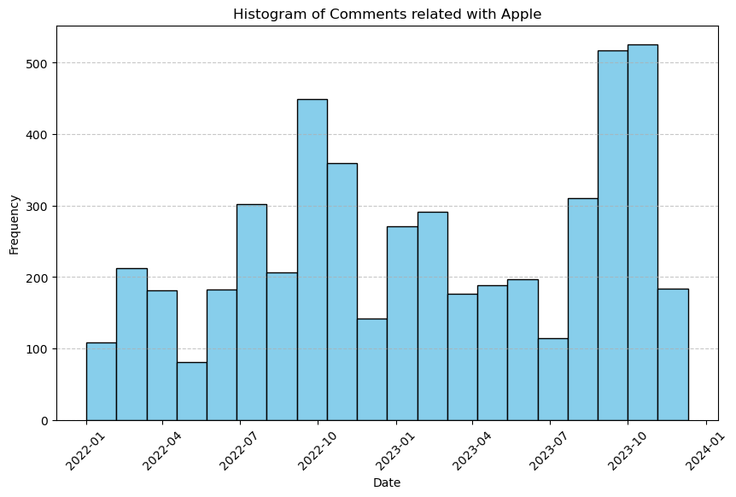

**Figure 81** This is a screenshot of the histogram showing the distribution of comments for Apple products on Reddit over time.

#### iPhone

Analysing iPhone-related Reddit comments (Figure 82), the data shows a focus on physical and functional features. Words like “iPhone”, “size”, and “phone” emphasize interest in the device's dimensions and brand. “Year” suggests discussions on model releases or longevity, while “pro”, “camera”, and “screen” highlight interest in specific features. Terms like “new” and “price” indicate discussions on future models and cost concerns, reflecting user preferences and sensitivity to pricing.

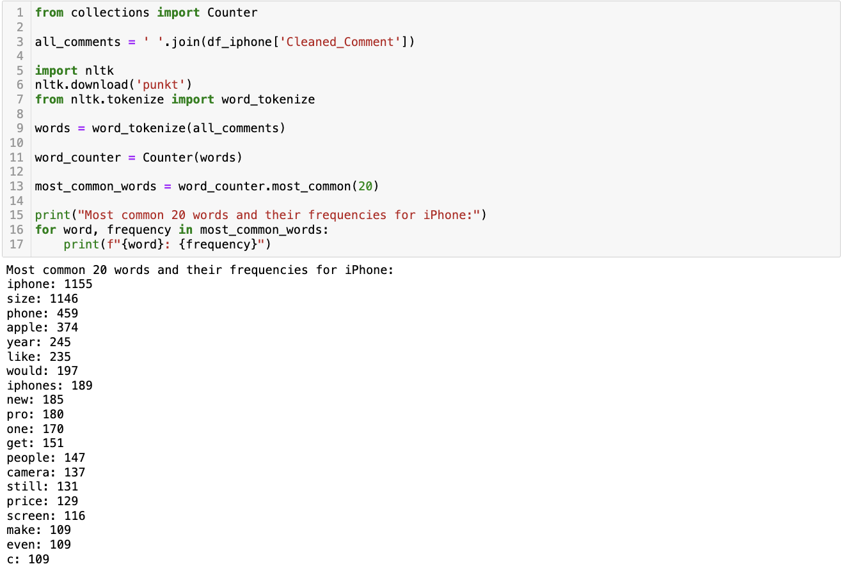

**Figure 82** This is a screenshot of the Python script and its result showing the most common words in the Reddit iPhone comments dataframe.

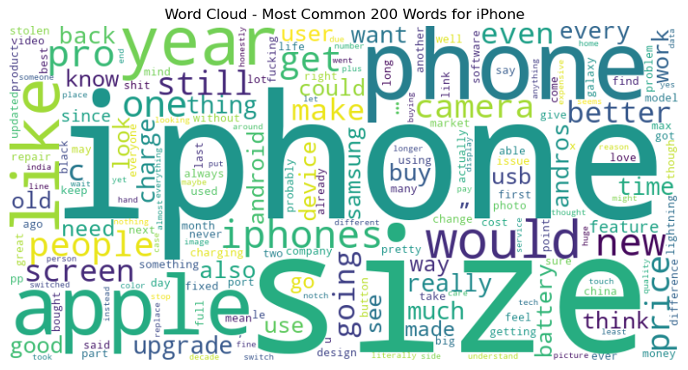

**Figure 83** This is a screenshot of the word cloud showing the most common words in the Reddit iPhone comments dataframe.

Analysing iPhone-related Reddit comments (Figure 84) reveals key consumer interests. The focus on “iPhone size” suggests the importance of ergonomics and display characteristics. Frequent mentions of “new iPhone” and “new phone” highlight interest in the latest models and technological updates. Terms like “Pro Max” and “Pro size” point to a preference for larger, feature-rich models. “USB C” reflects discussions on connectivity standards, while “iPhone user” hints at user experience considerations. Overall, the discourse emphasizes physical attributes, technological progression, and user experience in the smartphone market.

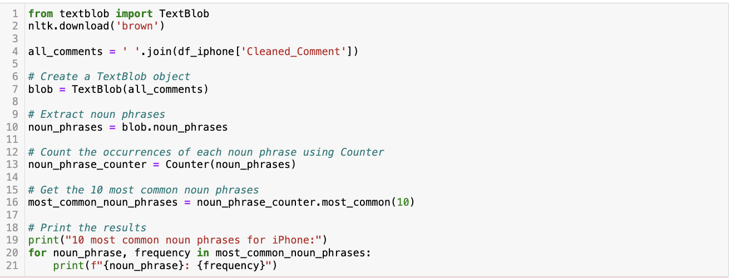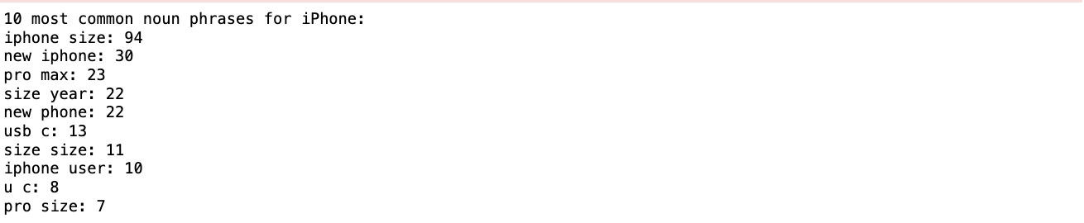

**Figure 84** This is a screenshot of the Python script and its result showing the most common noun phrases in the Reddit iPhone comments dataframe.

##### Topic Modelling

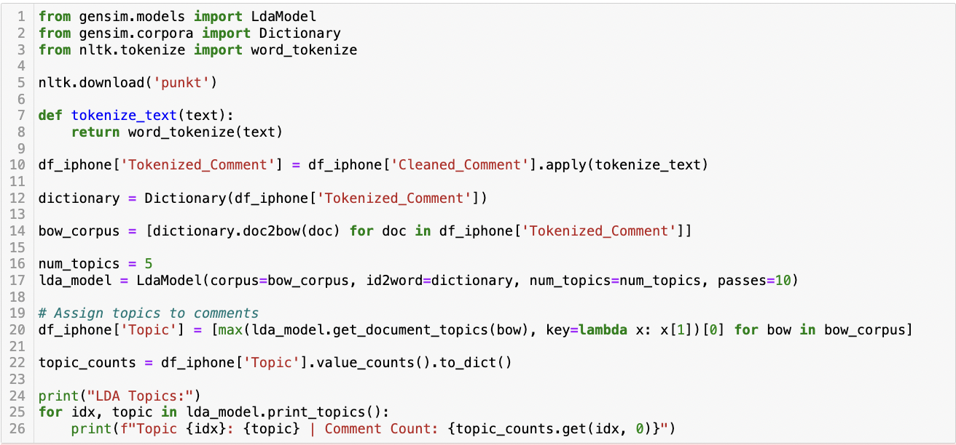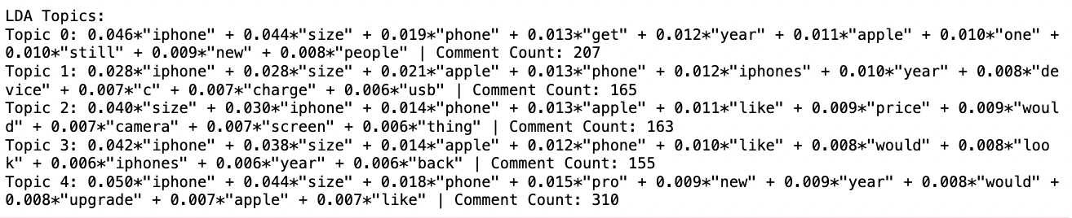

**Figure 85** This is a screenshot of the Python script and its result showing LDA Topic Modelling for the Reddit iPhone comments dataframe.

Common across all topics are the terms “iphone”, “size”, and “phone”, indicating a general focus on the physical aspects and branding of iPhones. Topic 0 seems to revolve around the longevity and updates of iPhones, with keywords like “year”, “still”, and “new.” Topic 1 highlights technical aspects, possibly related to charging and connectivity, as indicated by words like “charge” and “usb.” Topic 2 with words like “price”, “camera”, and “screen”, suggests discussions centred around iPhone features and value for money. Topic 3 appears to focus on the design and aesthetic appeal of iPhones, inferred from keywords like “look” and “back.” Finally, Topic 4, with the highest comment count, includes “pro” and “upgrade”, indicating discussions possibly related to higher-end iPhone models and decisions around upgrading to newer versions.

##### Sentiment Analysis

Despite the varied computational techniques and sentiment dictionaries inherent to each algorithm, the analysis consistently indicated a predominant skew towards positive sentiment (Figure 86). This consistency underscores the general optimism in public opinion regarding the iPhone, as captured in the online discussions.

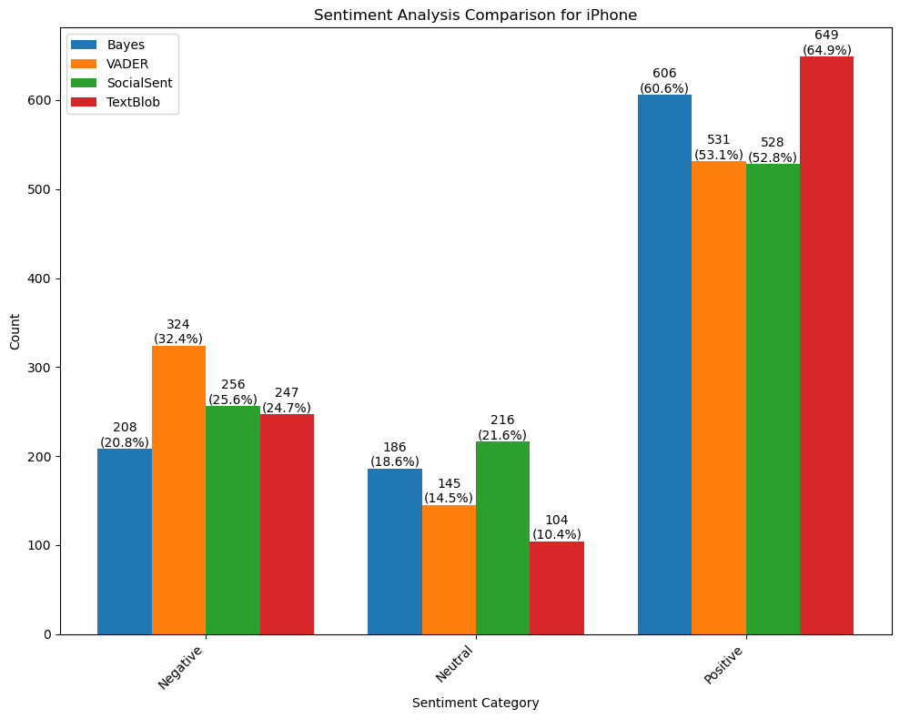

**Figure 86** This is a bar graph showing a sentiment analysis comparison for the Reddit iPhone comments dataframe.

##### Emotion Analysis

In the “Emotion Analysis” section of the dissertation, the sentiment distribution across 1000 Reddit comments related to the iPhone was examined using LexMo emotion analysis (Figure 87). Emotions such as anticipation and trust surfaced as predominant, reflecting a generally positive outlook and confidence in the product. However, significant expressions of anger, fear, and sadness were also noted, highlighting critical or concerned perspectives among users. The presence of disgust and surprise, albeit less frequent, added to the multifaceted nature of public opinion. Joy, as an indicator of satisfaction and happiness, was also notably present in the discourse.

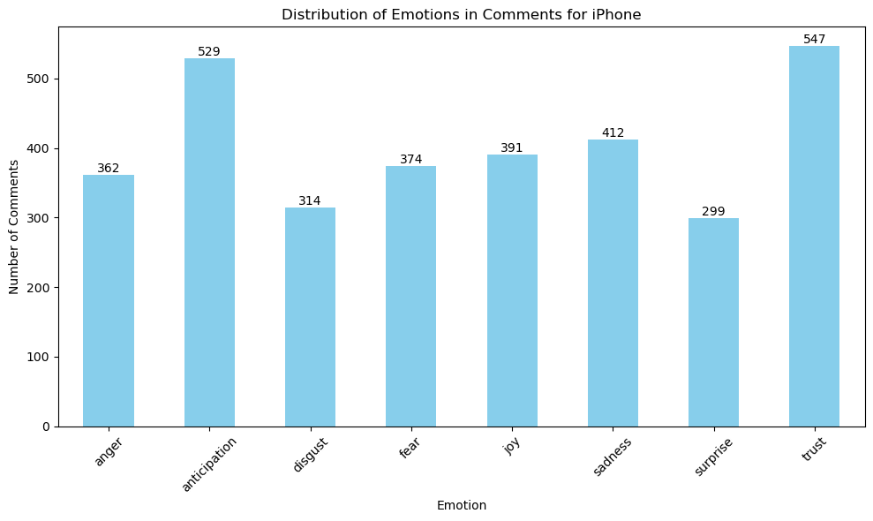

**Figure 87** This is a bar graph showing an emotion analysis comparison for the Reddit iPhone comments dataframe.

#### iPad

Analysing Reddit comments on the iPad (Figure 88) shows focus areas in consumer discussions. Dominant terms “iPad”, “Pro”, and “Apple” highlight brand and model interest, especially in the iPad Pro series. “Size” indicates interest in device versions, dimensions or storage. Words like “use”, “work”, and “need” suggest practical use in professional and daily life, while “price” and “new” point to considerations of cost and updates.

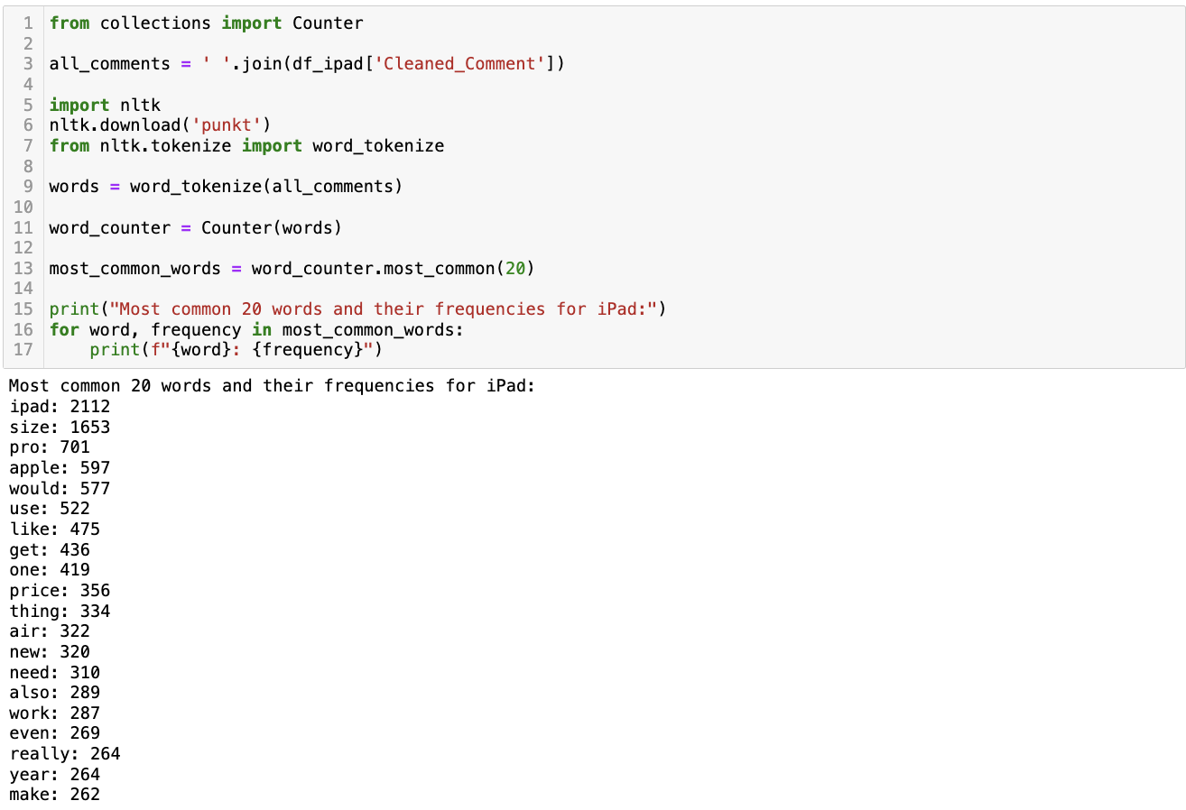

**Figure 88** This is a screenshot of the Python script and its result showing the most common words in the Reddit iPad comments dataframe.

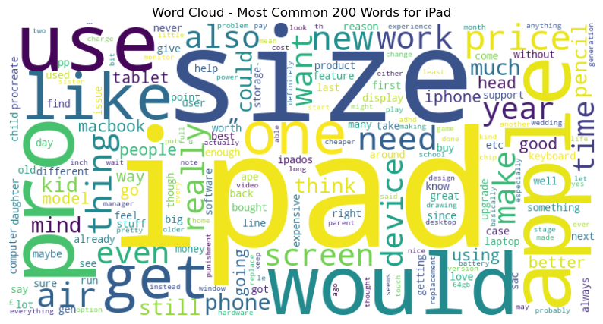

**Figure 89** This is a screenshot of the word cloud showing the most common words in the Reddit iPad comments dataframe.

Analysing common iPad-related noun phrases from Reddit (Figure 90), key themes include interest in the latest models like “new iPad” and “iPad Air”, showing consumer focus on current technology. “Pro size” and “iPad size” highlight concerns about device dimensions, linked to usability and portability. “Stage manager” suggests interest in specific features, while “Apple Pencil” and “iPad Procreate” point to the iPad's use in creative and artistic applications, reflecting its diverse functionality.

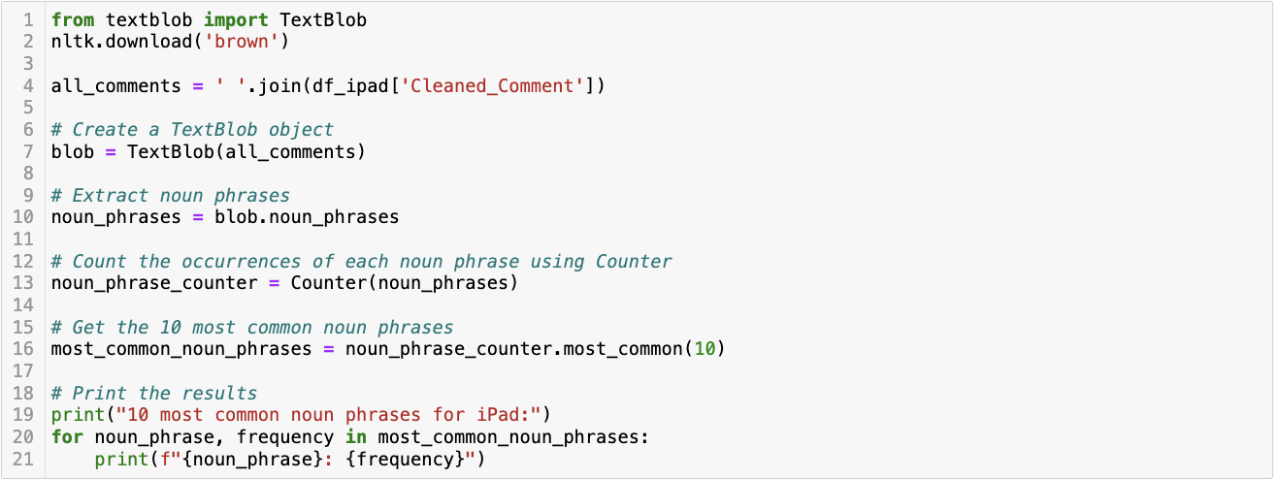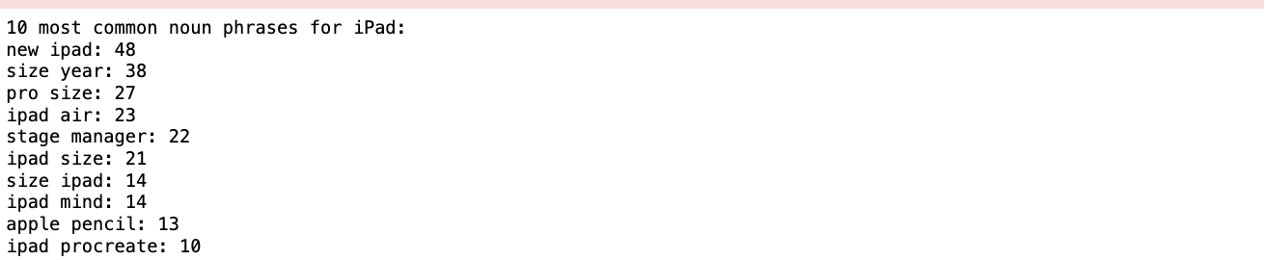

**Figure 90** This is a screenshot of the Python script and its result showing the most common noun phrases in the Reddit iPad comments dataframe.

##### Topic Modelling Analysis

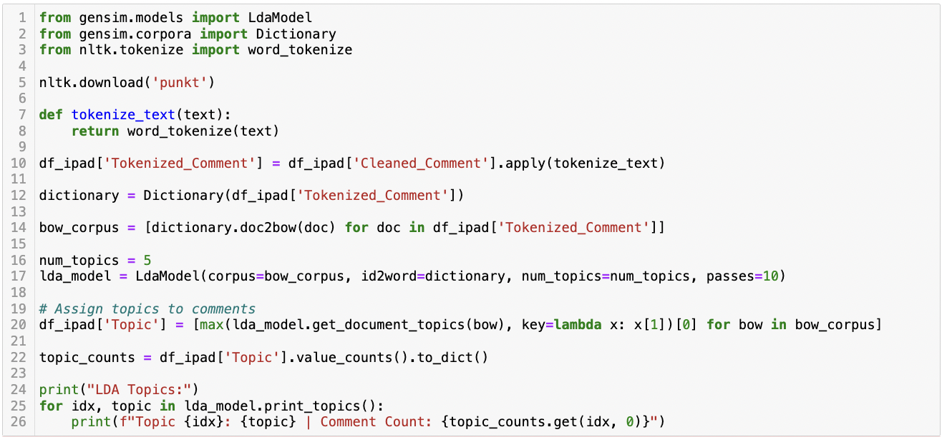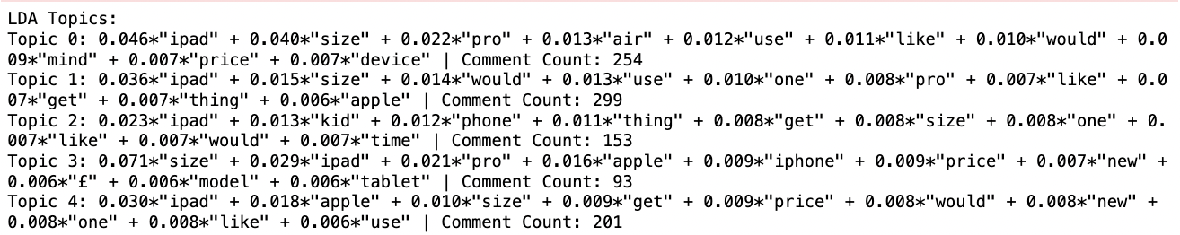

**Figure 91** This is a screenshot of the Python script and its result showing LDA Topic Modelling for the Reddit iPad comments dataframe.

For iPad, topic 0 focuses on the iPad's size, Pro and Air models, usability, and price, indicating a general interest in comparing different iPad models and their features. Topic 1, the most discussed, mirrors similar themes but with less emphasis on specific models, suggesting a broader discussion about the iPad's utility and appeal. Topic 2 introduces a unique angle by mentioning kids and phones, hinting at discussions about the iPad's role in family settings or as a phone alternative. Topic 3, though less frequent, is notable for its high emphasis on the size and inclusion of the iPhone, indicating comparative discussions between Apple products. Finally, Topic 4 also highlights the iPad's price and new models, reflecting ongoing interest in the latest Apple releases and value assessments.

##### Sentiment Analysis

The sentiment analysis conducted on Reddit comments about the iPad demonstrated a pronounced skew towards positive sentiment among all utilized algorithms (Figure 92). The collective findings suggest a favourable public perception of the iPad on the Reddit platform, as indicated by the predominant positive sentiment classifications.

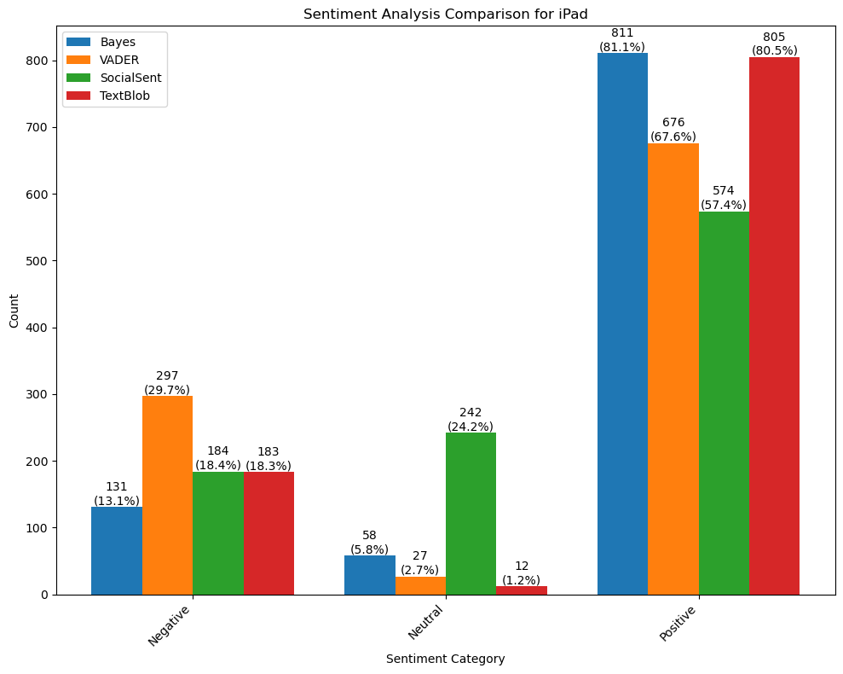

**Figure 92** This is a bar graph showing a sentiment analysis comparison for the Reddit iPad comments dataframe.

##### Emotion Analysis

The analysis for iPad on Reddit revealed a predominance of anticipation and trust, indicating a generally positive outlook among commenters towards the iPad (Figure 93). Following these feelings was joy, which in the context of the discussions represented satisfaction or happiness. On the other side of the spectrum, emotions such as fear, sadness, and anger were also noted, albeit to a lesser extent. These negative emotions might be indicative of concerns or negative experiences associated with the iPad. Interestingly, levels of disgust and surprise were relatively low, suggesting that the comments were more oriented towards expected or typical aspects of the product rather than unexpected or particularly negative attributes.

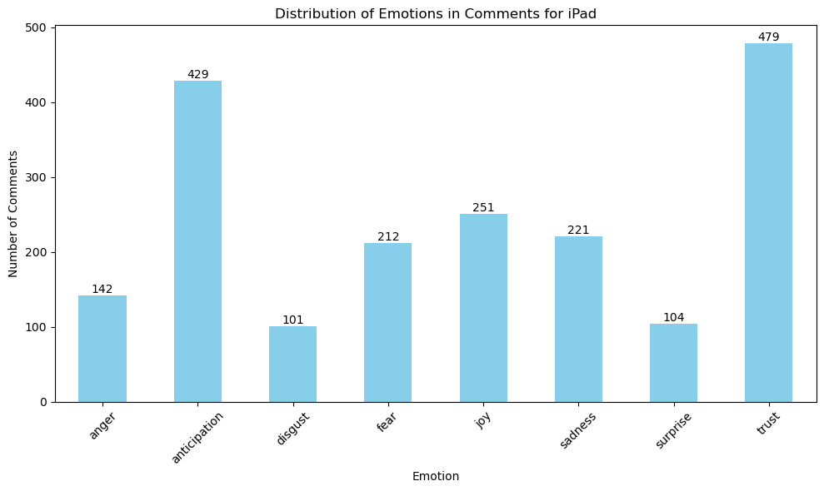

**Figure 93** This is a bar graph showing an emotion analysis comparison for the Reddit iPad comments dataframe.

#### Macbook

Analysing MacBook-related Reddit comments (Figure 94) reveals consumer behaviour and preferences. High frequency of “MacBook”, “Pro”, “Air”, and “Apple” shows focus on specific models, indicating product awareness and brand recognition. “Price” and “laptop” underscore cost importance and product categorization. Speculative terms like “would”, “like”, and “get” suggest discussions are opinion-based, with a focus on preferences and purchase intentions. “New”, “year”, and “still” reflect ongoing dialogues on updates and product longevity. “Work” and “need” highlight practical considerations, emphasizing the MacBook's role in professional and personal settings. The most frequent term “size” likely signifies the extensive nature of these discussions.

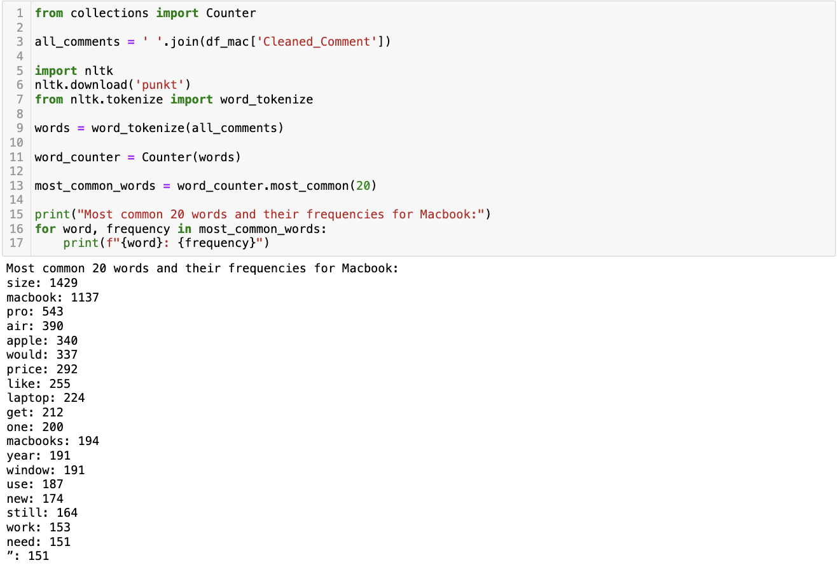

**Figure 94** This is a screenshot of the Python script and its result showing the most common words in the Reddit Macbook comments dataframe.

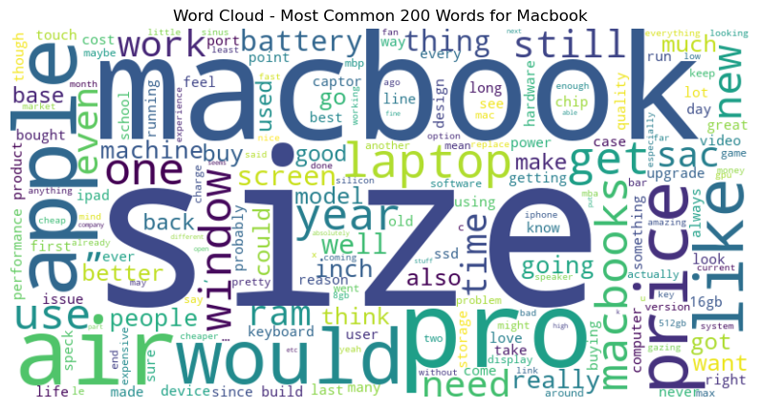

**Figure 95** This is a screenshot of the word cloud showing the most common words in the Reddit Macbook comments dataframe.

Analysing MacBook-related Reddit comments (Figure 96), a trend emerges emphasizing interest in the MacBook's physical dimensions and models. Terms like “size macbook”, “macbook air”, and “pro size” show consumer focus on size comparisons across models, indicating size as a key purchasing factor. Mentions of “new macbook” and “pro macbook” reflect interest in the latest models and upgrades, suggesting a tech-savvy consumer base attentive to Apple's product advancements. “Apple product” suggests broader, less specific Apple discussions.

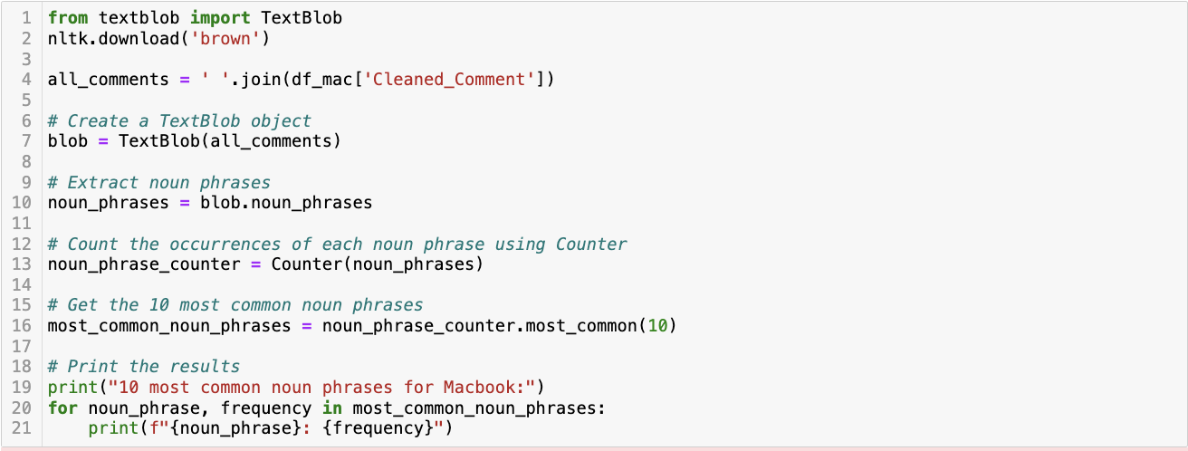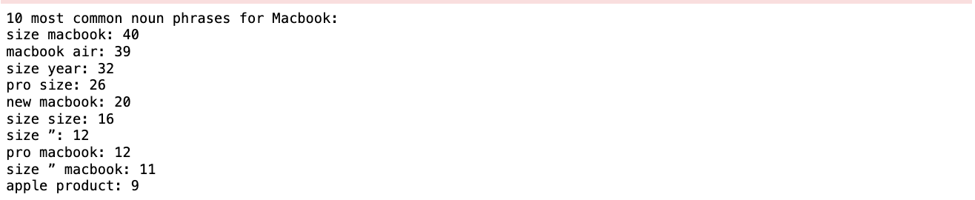

**Figure 96** This is a screenshot of the Python script and its result showing the most common noun phrases in the Reddit Macbook comments dataframe.

##### Topic Modelling Analysis

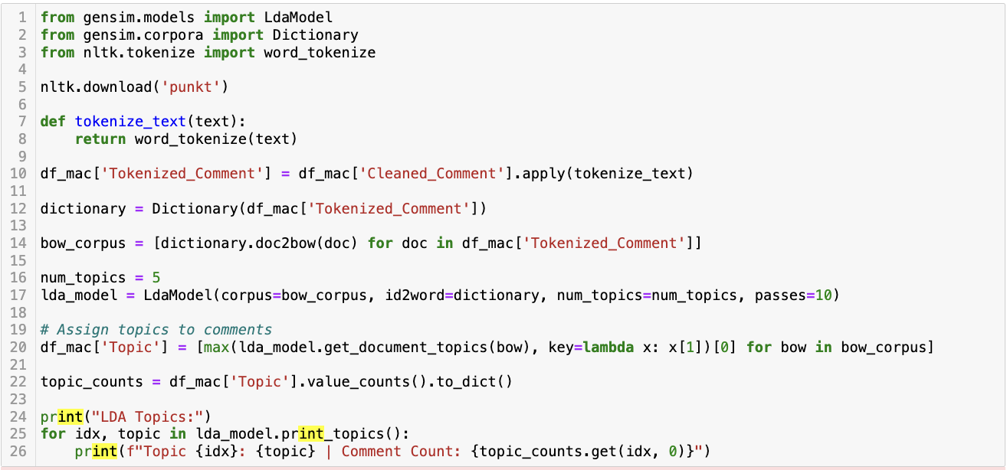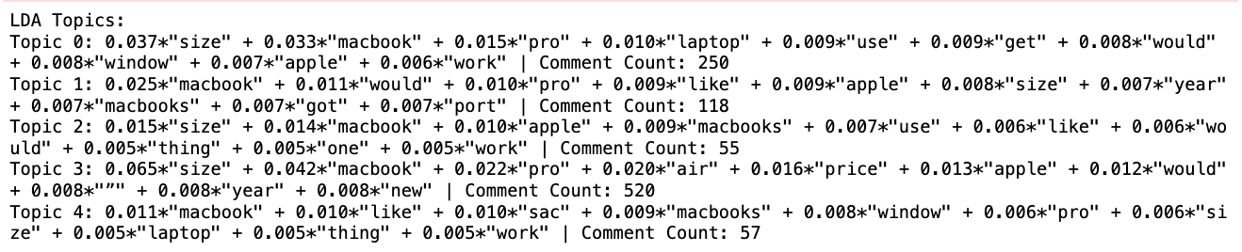

**Figure 97** This is a screenshot of the Python script and its result showing LDA Topic Modelling for the Reddit Macbook comments dataframe.

For Macbook, topic 0 focuses on practical aspects such as size, usability, and compatibility with Windows, indicating a significant interest in the physical attributes and cross-platform functionality of MacBooks. Topic 1 seems to discuss preferences and experiences with different models, including considerations like ports and annual updates. Topic 2, with fewer comments, continues the trend of discussing size and usability but also includes some comparisons with other Apple products. Topic 3, the most prominent, heavily emphasizes size again but also introduces price and newer models like the MacBook Air, suggesting a keen interest in the value proposition of different MacBook models. Finally, Topic 4 appears to touch on similar themes as the other topics but with less frequency.

##### Sentiment Analysis

The sentiment analysis conducted on a collection of Reddit comments about the MacBook demonstrated a predominant trend of positive sentiment when assessed by four distinct algorithms (Figure 98). Each algorithm's methodological framework and sentiment lexicon resulted in a diverse classification of comments, yet despite these differences, a collective propensity towards positive sentiment was consistently noted.

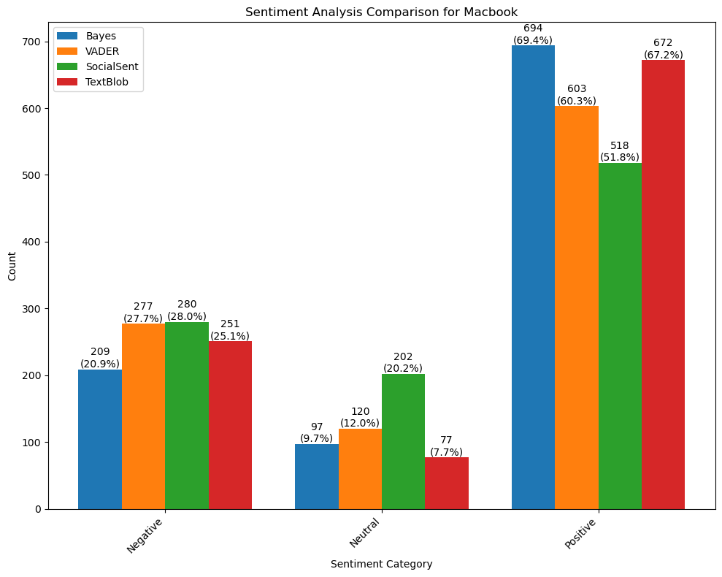

**Figure 98** This is a bar graph showing a sentiment analysis comparison for the Reddit Macbook comments dataframe.

##### Emotion Analysis

The findings from Macbook comments revealed a diverse range of emotional expressions among Reddit users (Figure 99). A notable inclination towards emotions of anticipation and trust was observed, indicating a predominant sense of expectation and reliability associated with the MacBook brand. Contrarily, emotions of anger and disgust were also prominently featured in the comments, reflecting critical perspectives or negative experiences. Furthermore, a significant presence of emotions like fear, sadness, and joy suggested a complex emotional landscape, where users shared apprehensive, sorrowful, as well as joyful experiences with their devices. The presence of surprise, though less dominant, indicated instances of unexpected outcomes or revelations among the users.

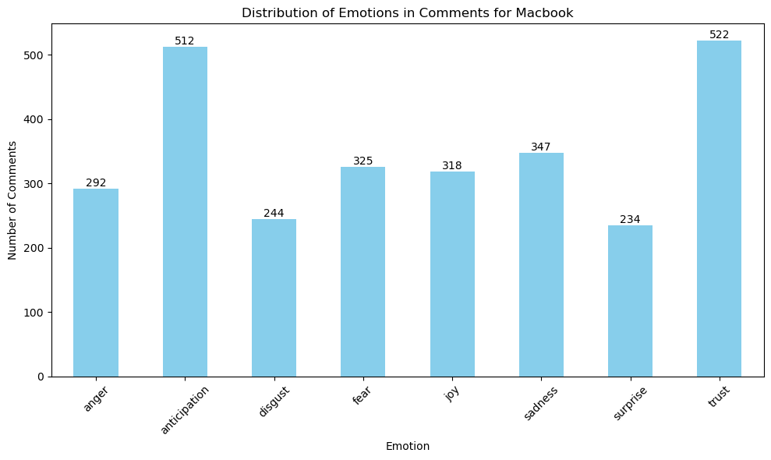

**Figure 99** This is a bar graph showing an emotion analysis comparison for the Reddit Macbook comments dataframe.

#### AirPods

Analysing common words in Reddit's AirPods discussions (Figure 100) reveals a focus on product features, user preferences, and brand connection. Frequent terms “AirPods”, “Pro”, “Max”, and “Gen” show keen interest in various models and generations, reflecting a well-informed consumer base. “Apple” indicates a strong brand association, suggesting brand loyalty or influence. Words like “size”, “sound”, “ear”, and “noise” highlight key product attributes, impacting purchase decisions and user satisfaction. Terms such as “like”, “would”, and “get” imply aspirational discussions about future purchases or features, illustrating a multifaceted conversation encompassing product specifics, user experiences, and brand context.

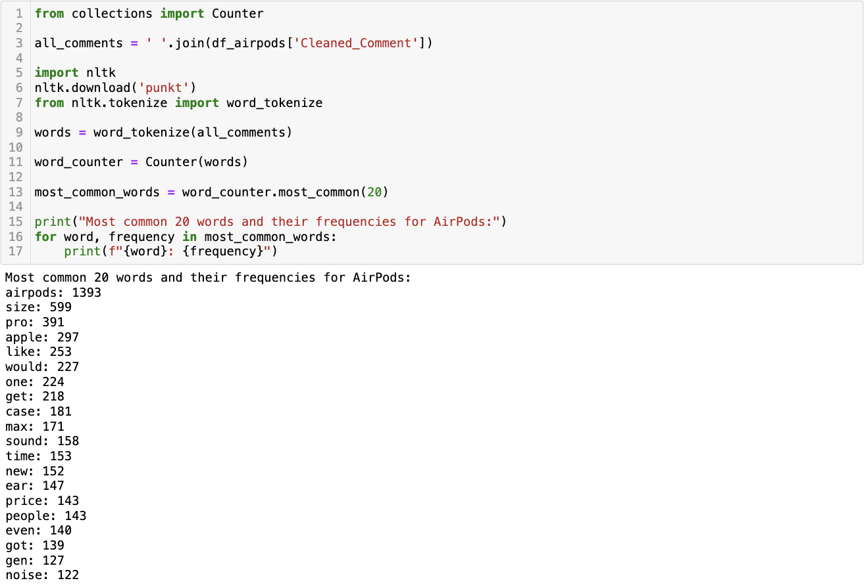

**Figure 100** This is a screenshot of the Python script and its result showing the most common words in the Reddit AirPods comments dataframe.

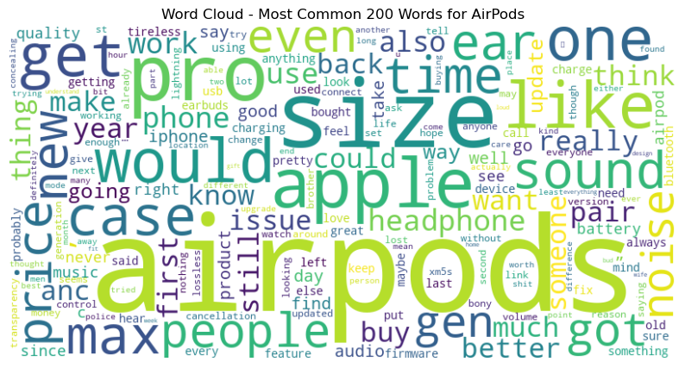

**Figure 101** This is a screenshot of the word cloud showing the most common words in the Reddit AirPods comments dataframe.

Analysing common noun phrases in Reddit's AirPods comments (Figure 102) reveals trends in consumer interests. Terms like “pro size”, “new airpods”, and “airpods max” show strong interest in the latest models and updates, highlighting a focus on new releases. “Sound quality” and “gen airpods” emphasize the importance of technical improvements and generational updates. Phrases “pro size” and “airpods size” suggest specific interest in dimensions and fit, key for wearable tech. “USB C” reflects trends in charging standards, while “pair airpods” and “size year” indicate discussions on connectivity and evolving design, painting a picture of engagement with the AirPods' features and evolution.

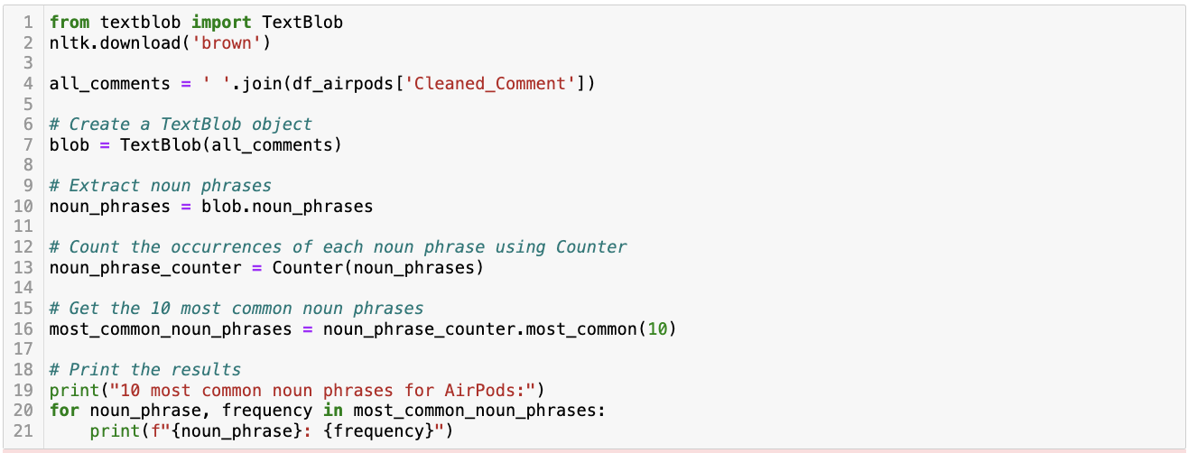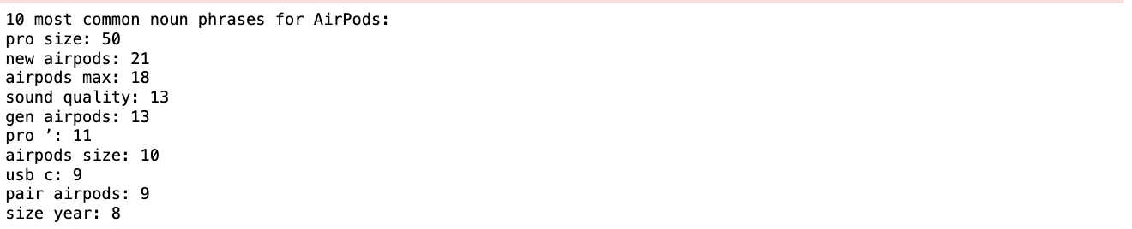

**Figure 102** This is a screenshot of the Python script and its result showing the most common noun phrases in the Reddit AirPods comments dataframe.

##### Topic Modelling Analysis

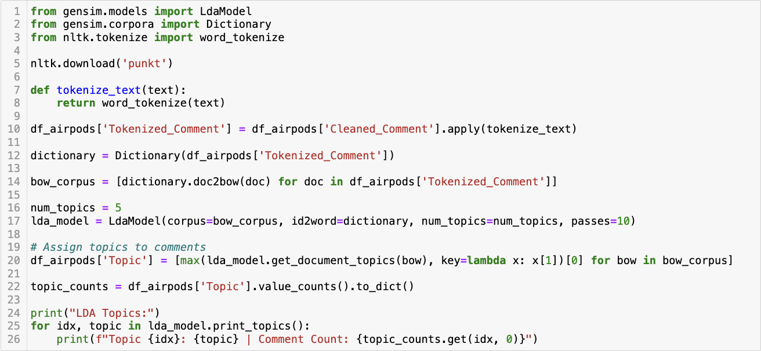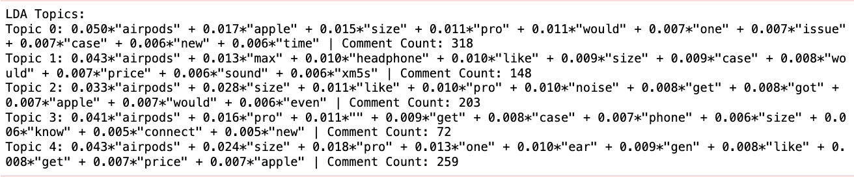

**Figure 103** This is a screenshot of the Python script and its result showing LDA Topic Modelling for Reddit AirPods comments dataframe.

For AirPods, topic 0, with the highest comment count, focuses on general aspects of AirPods, discussing attributes like size, the Pro model, and issues with the case. Topic 1 shifts attention to the AirPods Max and headphones, highlighting considerations like size, case, price, and sound quality. Topic 2 seems to blend discussions about the AirPods Pro with aspects like size and noise, suggesting a focus on the practical usage of the product. Topic 3, with the lowest comment count, appears to deal more with technical aspects such as connectivity and compatibility with phones. Finally, Topic 4 brings a more product-specific discussion, cantering on the AirPods Pro, their size, and price, also touching on aspects like fit in the ear.

##### Sentiment Analysis

The sentiment analysis conducted on Reddit comments about AirPods demonstrates a predominant skew towards positive sentiment among all applied algorithms (Figure 104). It is noted in the results that despite the distinctive computational techniques and sentiment dictionaries utilized by each algorithm, there is a consistent trend of positivity in user comments.

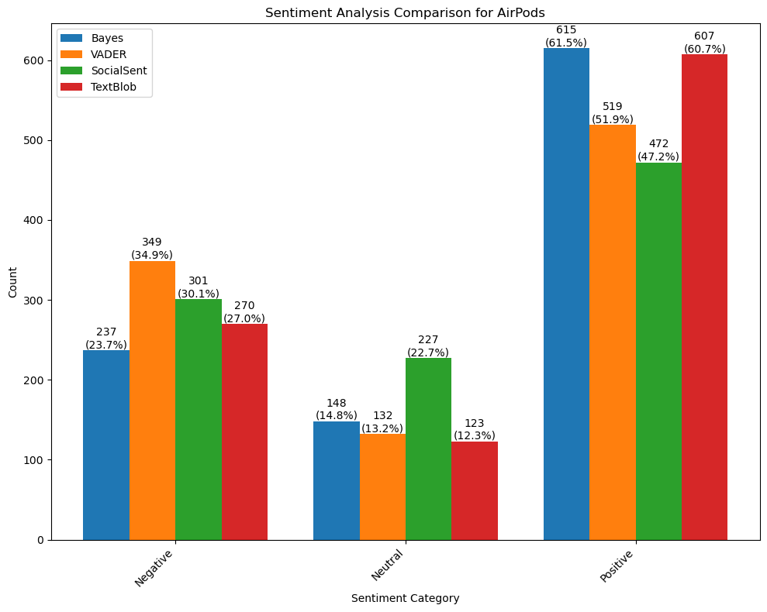

**Figure 104** This is a bar graph showing a sentiment analysis comparison for the Reddit AirPods comments dataframe.

##### Emotion Analysis

The predominant emotions identified were anticipation and trust, suggesting a generally positive outlook towards AirPods among Reddit users (Figure 105). Interestingly, a significant number of comments also expressed sadness and fear, indicating concerns or negative experiences associated with the product. The presence of anger and disgust in a notable proportion of the comments highlighted critical viewpoints or frustrations related to AirPods. Joy, while present, was not the most dominant emotion, contrasting with the high levels of anticipation and trust. The occurrence of surprise in the comments was relatively moderate, indicating occasional unexpected reactions or viewpoints regarding AirPods.

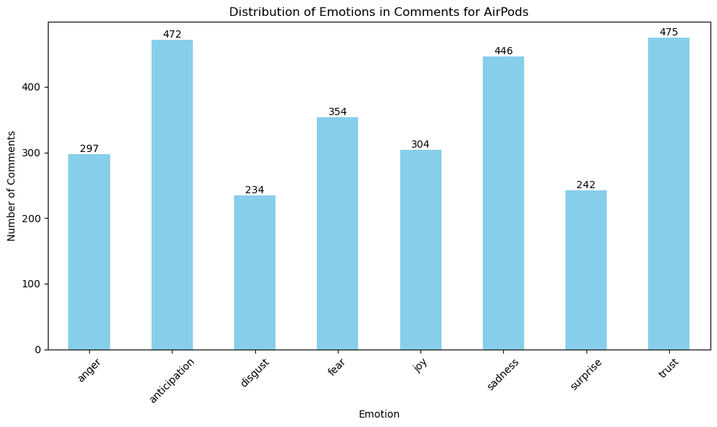

**Figure 105** This is a bar graph showing an emotion analysis comparison for the Reddit AirPods comments dataframe.

#### Apple Watch

Analysing Reddit's Apple Watch comments reveals a focus on product features and user experience (Figure 106). Keywords like ”watch”, ”apple”, and ”size” highlight the emphasis on the product and its physical aspects. Frequent mentions of ”battery”, ”life”, ”day”, and ”time” indicate user concerns about battery life and daily efficiency. ”Ultra” suggests interest in a specific model, while ”like”, ”would”, ”use”, and ”need” show personal opinions and preferences. ”Phone” points to smartphone comparisons or integrations.

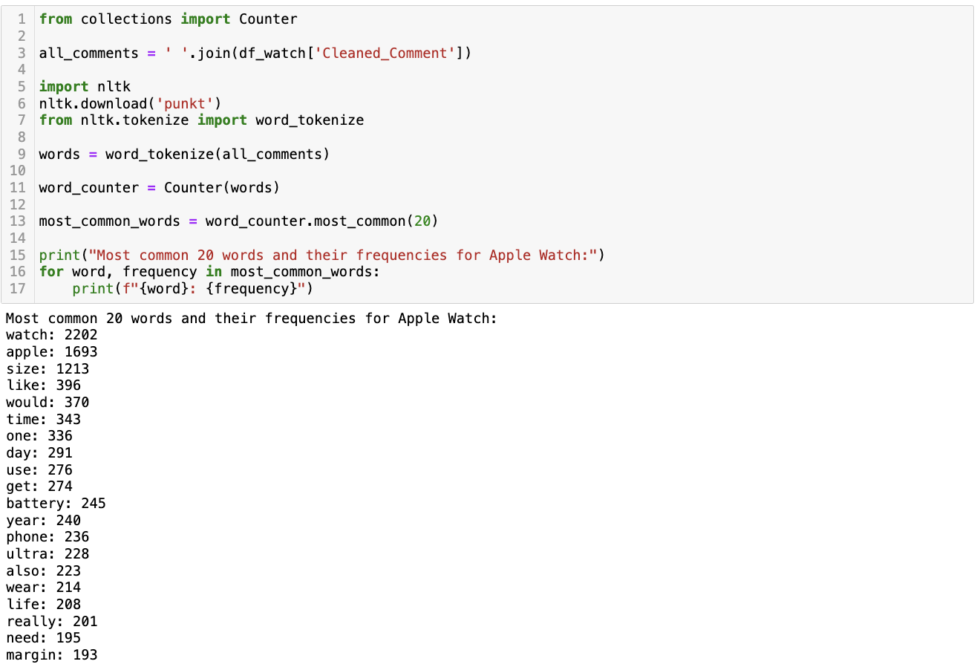

**Figure 106** This is a screenshot of the Python script and its result showing the most common words in the Reddit Apple Watch comments dataframe.

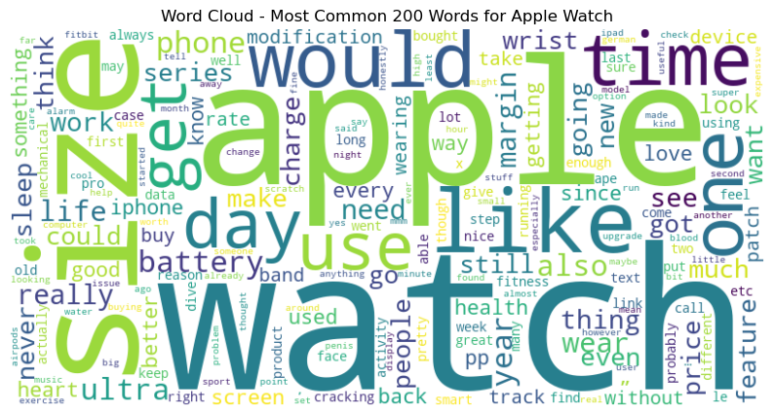

**Figure 107** This is a screenshot of the word cloud showing the most common words in the Reddit Apple Watch comments dataframe.

Analysing Reddit's Apple Watch comments (Figure 108) reveals key user interests. The frequent “series size” mentions show a focus on model dimensions, indicating user preference for specific physical attributes. “Battery life” underscores practical concerns about device longevity. “Apple patch” likely relates to software updates, showing interest in software maintenance. “Heart rate” discussions highlight the device's health and fitness features. “New apple” signals excitement for upcoming models or features. Temporal terms like “size year”, “size day”, and “size month” may discuss the watch's evolution, daily use, or monthly updates. “Regular apple” suggests comparisons between standard and variant models, demonstrating the Apple Watch's diverse appeal.

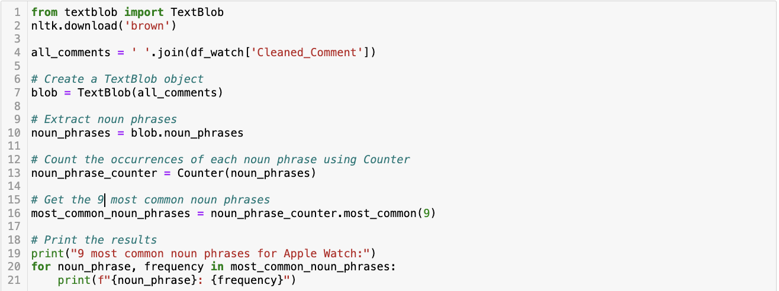 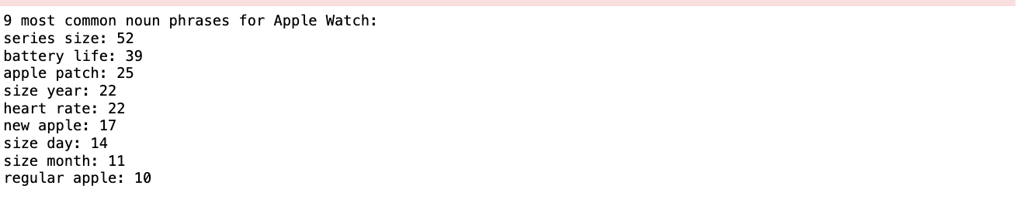

**Figure 108** This is a screenshot of the Python script and its result showing the most common noun phrases in the Reddit Apple Watch comments dataframe.

##### Topic Modelling Analysis

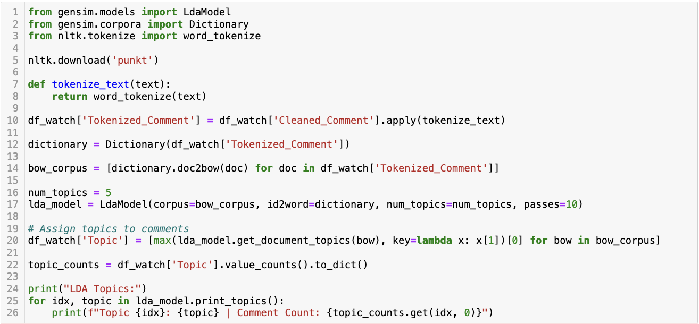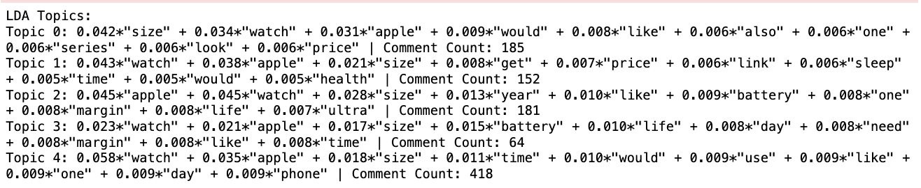

**Figure 109** This is a screenshot of the Python script and its result showing LDA Topic Modelling for the Reddit Apple Watch comments dataframe.

For the Apple Watch, topic 0 primarily focuses on the size, appearance, and pricing of the Apple Watch, indicating consumer interest in its physical attributes and affordability. Topic 1 also emphasizes the watch's size and price but includes aspects like sleep tracking and health features, suggesting a keen interest in its functionalities related to well-being. Topic 2 seems to balance discussions about the watch's size with technical aspects like battery life and newer models (e.g., Apple Watch Ultra), indicating an audience that is both tech-savvy and concerned about practical features. Topic 3, the smallest group, centres around battery life and daily usage needs, pointing to practical, day-to-day concerns of users. Finally, Topic 4, the largest group, broadly discusses the watch's utility in daily life, indicating a general interest in how the Apple Watch integrates into and enhances everyday routines.

##### Sentiment Analysis

In the sentiment analysis conducted on Reddit comments about the Apple Watch, a discernible trend toward positive sentiment was detected across all four algorithms employed in the study (Figure 110). This trend was consistent despite the divergent analytical frameworks and sentiment dictionaries inherent to each algorithm.

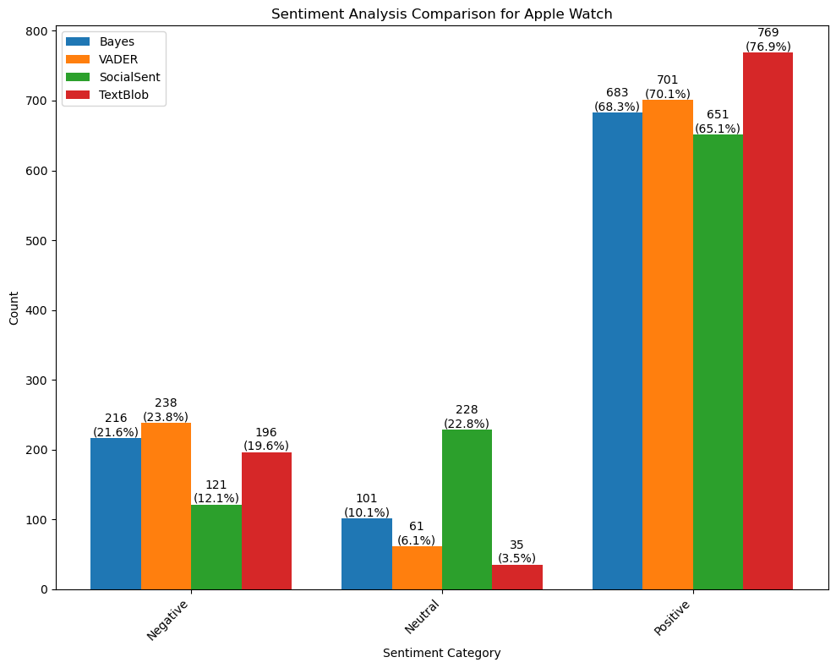

**Figure 110** This is a bar graph showing a sentiment analysis comparison for the Reddit Apple Watch comments dataframe.

##### Emotion Analysis

A predominant anticipation sentiment was observed for Apple Watch comments on Reddit, indicating a high level of interest and expectation among the users regarding the product (Figure 111). This was followed by a significant representation of fear, reflecting concerns or apprehensions related to the product. Trust also emerged as a notable emotion, suggesting a degree of confidence or reliability attributed to the Apple Watch by the users. In contrast, emotions such as joy, sadness, anger, and disgust were present but to a lesser extent. The minimal occurrence of surprise in the comments pointed towards either a well-informed user base or a lack of unexpected features or news related to the Apple Watch.

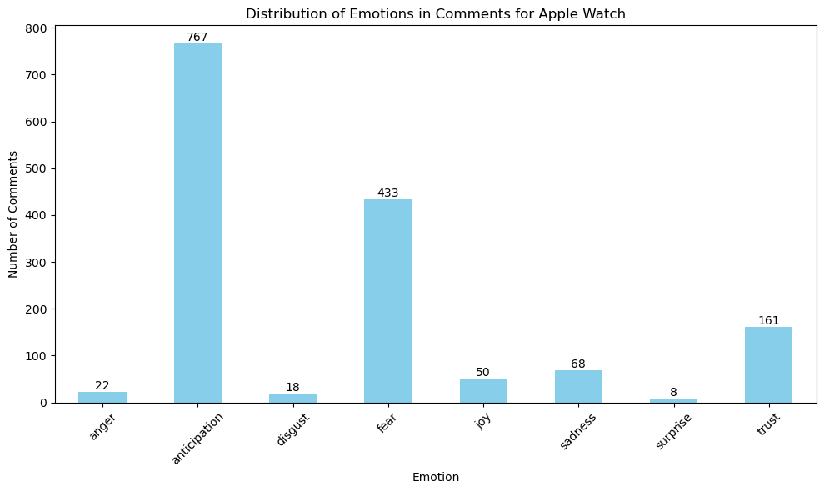

**Figure 111** This is a bar graph showing an emotion analysis comparison for the Reddit Apple Watch comments dataframe.

### YouTube

The chronological analysis of the YouTube comments dataset presents a timeline spanning from January 2020 to today (Figure 112).

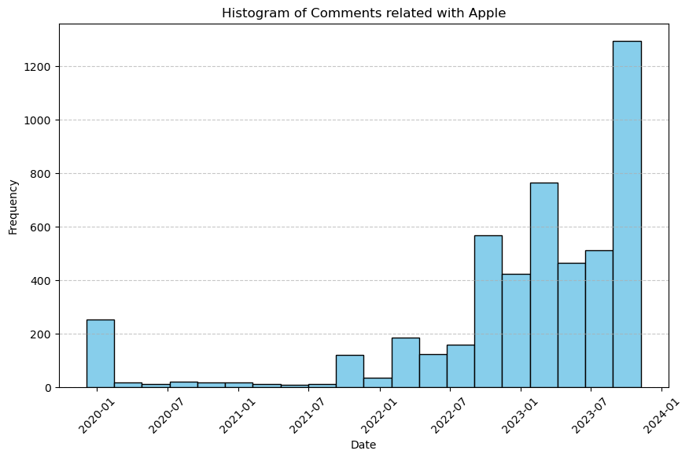

**Figure 112** This is a screenshot of the histogram showing the distribution of comments for Apple products on YouTube over time.

#### iPhone

Analysing iPhone-related YouTube comments (Figure 113), key smartphone market trends and sentiments emerge. Terms like ”iPhone”, ”phone”, ”Apple”, and ”Android” highlight brand comparison, focusing on loyalty and competition, especially between Apple and Android. Words such as ”like”, ”better”, and ”even” suggest feature-based comparative discussions, while ”Samsung” indicates another key player. ”Year”, ”time”, and ”one” likely discuss product lifecycles and release timings. ”Pro” points to interest in high-end models. The presence of ”people”, ”user”, and ”thing” broadens the conversation to user experience and personal preferences, underlining the subjective nature of technology use.

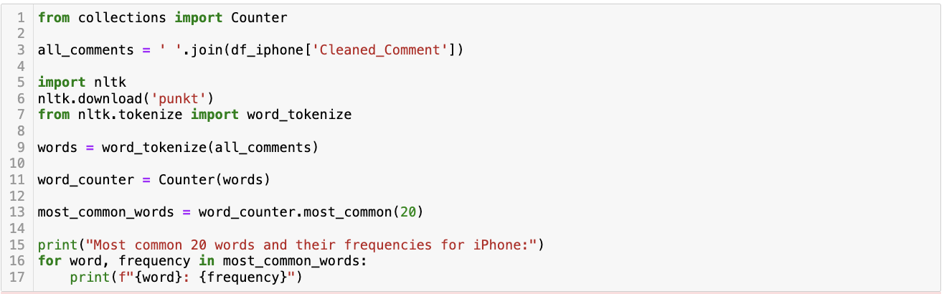 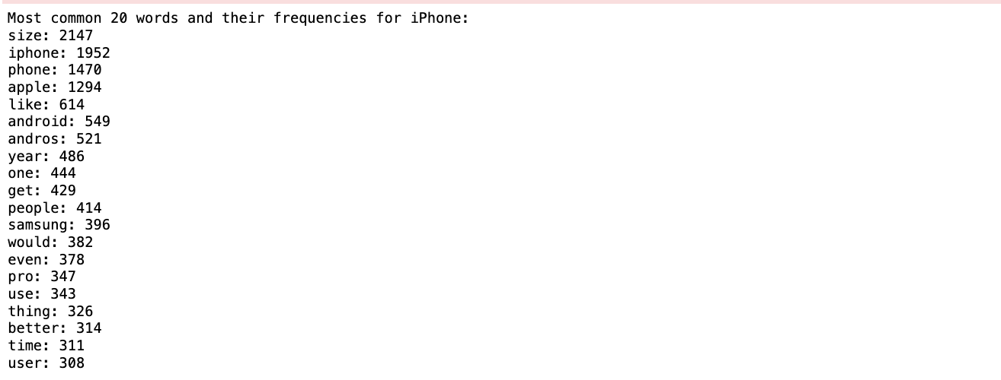

**Figure 113** This is a screenshot of the Python script and its result showing the most common words in the YouTube iPhone comments dataframe.

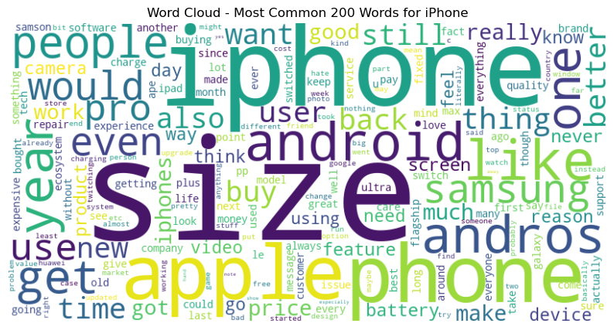

**Figure 114** This is a screenshot of the word cloud showing the most common words in the YouTube iPhone comments dataframe.

Analysing common iPhone-related noun phrases from YouTube comments (Figure 115), “iPhone size” and “pro max” suggest a focus on larger, high-end models, reflecting a trend for bigger screens and advanced features. “Apple product”, “new phone”, and “new iPhone” highlight brand loyalty and anticipation for new releases. Comparisons like “android phone” and “andros phone” indicate cross-brand interests, while “top iPhones” and “iPhone user” imply model preferences and community identity.

 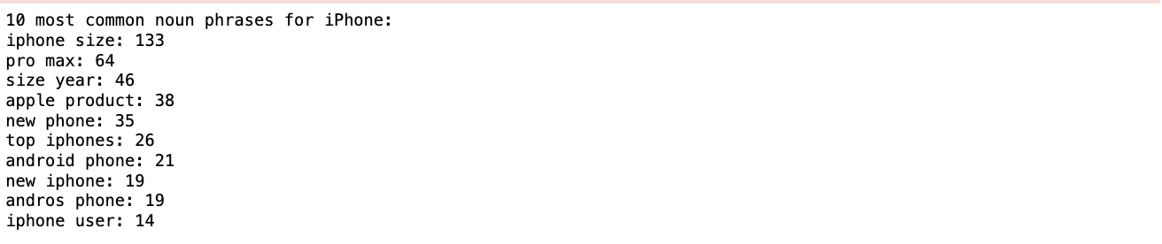

**Figure 115** This is a screenshot of the Python script and its result showing the most common noun phrases in the YouTube iPhone comments dataframe.

##### Topic Modelling

 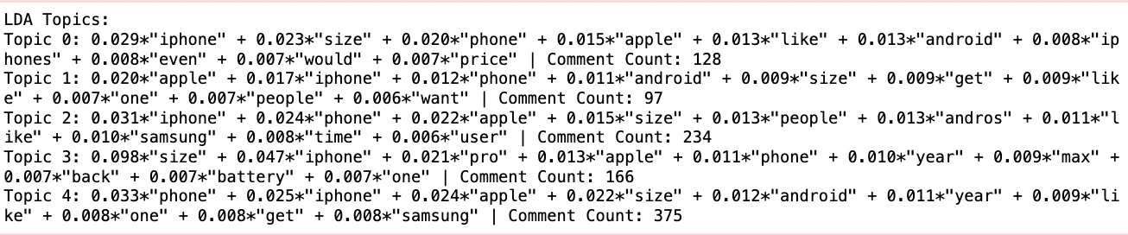

**Figure 116** This is a screenshot of the Python script and its result showing LDA Topic Modelling for the YouTube iPhone comments dataframe.

For iPhone, topic 0 predominantly discusses the iPhone's size, comparing it with other phones and considering aspects like price and Apple's brand influence. Topic 1, the smallest, also centres around Apple and the iPhone, but with a stronger focus on user preferences and the comparison to Android devices. Topic 2 emphasises the iPhone and Apple brands, alongside discussions about phone size and comparisons with Samsung. Topic 3 is particularly focused on the size aspect, specifically referencing the ”Pro” and ”Max” models, indicating a keen interest in the larger variants of the iPhone. Lastly, Topic 4, the most populated, broadly covers phone-related discussions, including comparisons between iPhone, Apple, and Android devices, as well as Samsung, indicating a general interest in smartphone brands and features.

##### Sentiment Analysis

It was observed that, regardless of the analytical approach employed, a predominant positivity was reflected in the sentiment distribution of the comments for iPhone (Figure 117). This tendency towards positive sentiment was consistently detected across all four algorithms, indicating a general favourability in public opinion towards the iPhone within the sampled YouTube commentary.

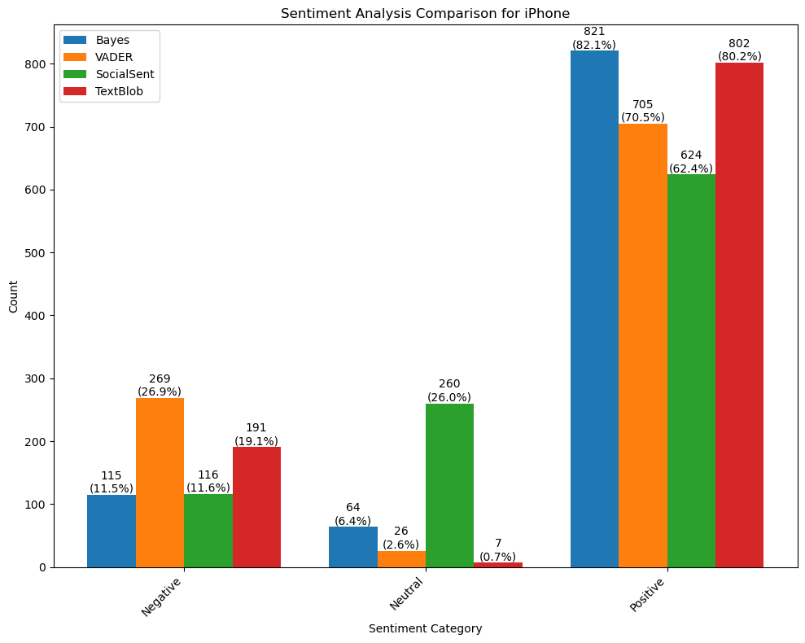

**Figure 117** This is a bar graph showing a sentiment analysis comparison for the YouTube iPhone comments dataframe.

##### Emotion Analysis

A significant prevalence of anticipation and trust was observed, indicating a dominant sentiment of positive expectations and reliability associated with the iPhone (Figure 118). These emotions are often reflective of consumer optimism and brand loyalty, factors crucial in technology markets. In contrast, emotions such as anger, disgust, and fear, though present, were less prominent. This pattern suggests a minority of responses characterized by dissatisfaction, aversion, and apprehension. Interestingly, the presence of joy and sadness in nearly equal proportions highlighted a polarized emotional response, which can be attributed to varied user experiences and expectations. The occurrence of surprise, although not predominant, pointed towards unexpected reactions, possibly stemming from product features or brand announcements.

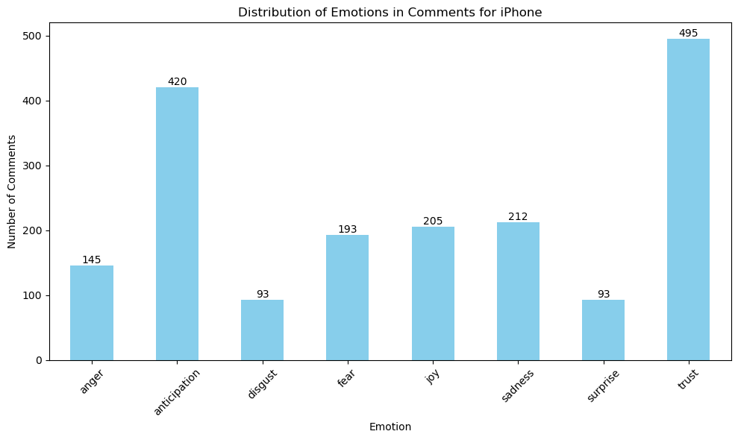

**Figure 118** This is a bar graph showing an emotion analysis comparison for the YouTube iPhone comments dataframe.

#### iPad

Analysing common words in YouTube's iPad comments (Figure 119) reveals a focus on product specifications, models, and user experience. Terms “iPad”, “Pro”, “Air”, and “size” emphasize interest in specific iPad models. “Use”, “need”, and “work” reflect practical considerations in usage, highlighting functionality. “Price” and “year” suggest cost and product lifecycle awareness. The frequent “stranger” might denote unexpected features or outlier discussions.

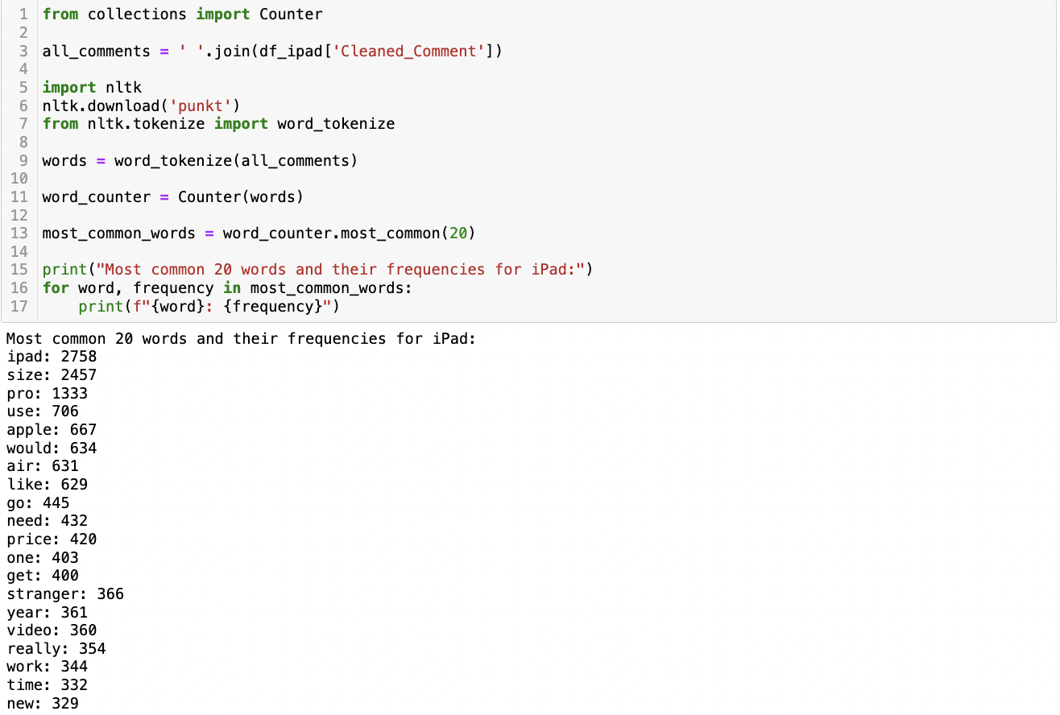

**Figure 119** This is a screenshot of the Python script and its result showing the most common words in the YouTube iPad comments dataframe.

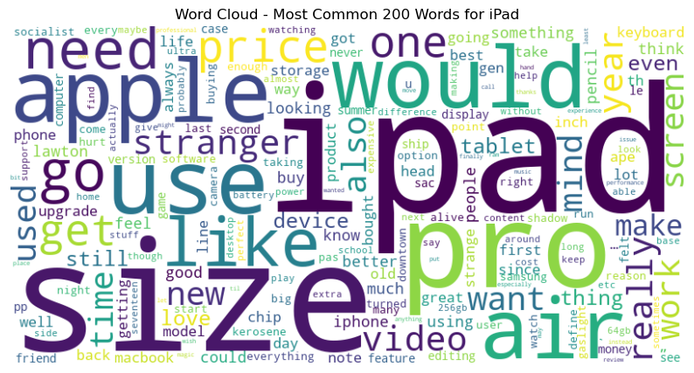

**Figure 120** This is a screenshot of the word cloud showing the most common words in the YouTube iPad comments dataframe.

Analysing common iPad-related noun phrases from YouTube comments (Figure 121), abstract phrases like “socialist ship pas summer night shadow” and “gaslight kerosene” indicate a metaphorical approach to technology discussions. “Pro size” and “iPad Air” emphasize focus on device dimensions. “Hurt til” might discuss ergonomic design or usage, while “new iPad” shows interest in the latest models. Abstract terms like “life cellophane” and “strange stranger” reflect the complex technology-life relationship.

 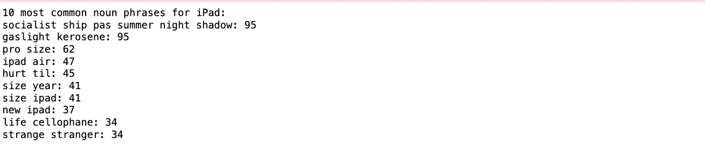

**Figure 121** This is a screenshot of the Python script and its result showing the most common noun phrases in the YouTube iPad comments dataframe.

##### Topic Modelling Analysis

 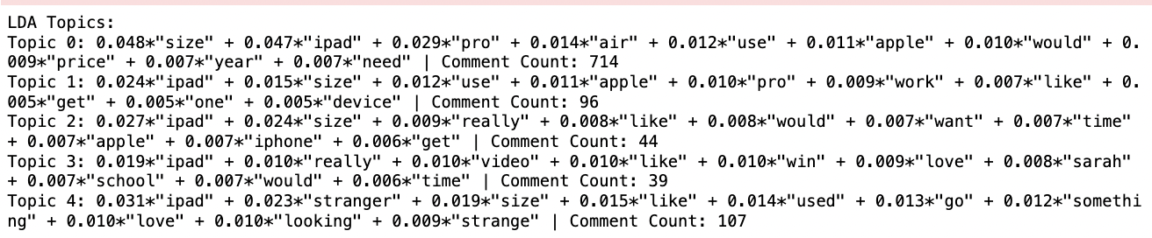

**Figure 122** This is a screenshot of the Python script and its result showing LDA Topic Modelling for the YouTube iPad comments dataframe.

The most prominent topic (Topic 0) centres on practical aspects such as size, specific models (Pro, Air), usage, and pricing, reflecting a keen interest in the functional and comparative details of iPads. Topics 1 and 2 continue this trend but with less emphasis on model specifics, suggesting a general interest in how the iPad integrates into daily life for work or personal use. Interestingly, Topic 3 shifts focus to personal sentiments and possibly contest-related discussions, indicated by terms like ”love”, ”win”, and ”school”. Topic 4, with its unique mentions of ”stranger” and ”strange”, alongside typical iPad-related terms, hints at conversations about unusual experiences or features of the device.

##### Sentiment Analysis

It was observed that the distribution of sentiment categories across all algorithms skewed towards positivity, indicating a generally favourable view of the iPad among commenters (Figure 123). This trend was consistent despite the inherent methodological differences between the algorithms.

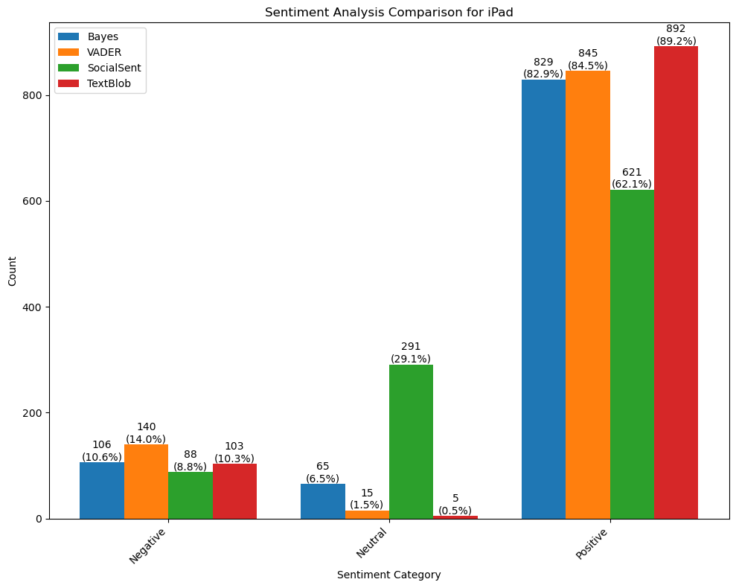

**Figure 123** This is a bar graph showing a sentiment analysis comparison for the YouTube iPad comments dataframe.

##### Emotion Analysis

The predominant emotions identified were anticipation and trust, suggesting a generally positive outlook towards the iPad (Figure 124). Notably, joy also constituted a significant portion of the emotional responses, reinforcing the overall optimistic sentiment. On the other hand, emotions such as anger, disgust, and fear, though present, were less prevalent, indicating that negative sentiments were not the dominant emotional response. Sadness and surprise were observed to a moderate extent, contributing to a more nuanced understanding of the emotional reactions.

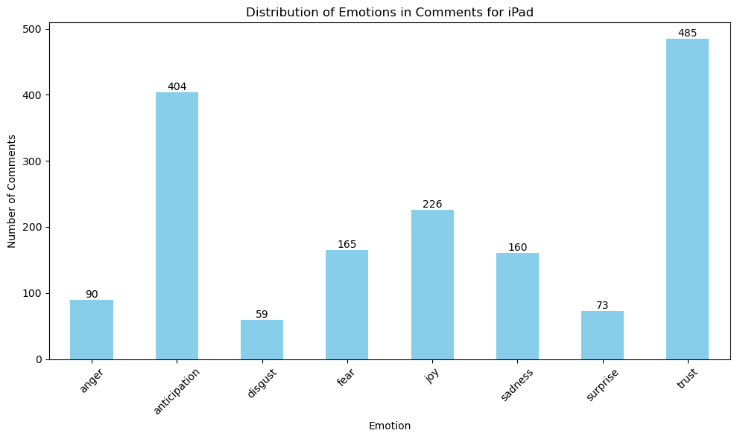

**Figure 124** This is a bar graph showing an emotion analysis comparison for the YouTube iPad comments dataframe.

#### Macbook

Analysing YouTube comments on the MacBook (Figure 125), key themes include product specifics and consumer preferences. Terms “MacBook”, “Pro”, “Apple”, “Air”, and “price” suggest a focus on model types and cost. “Size” and “inch” indicate interest in physical dimensions, important for usability and portability. “New”, “upgrade”, and “ram” highlight the emphasis on the latest features and performance. “Window” may refer to cross-compatibility or Windows comparisons, while “Lawton” appears as a unique, context-specific term.

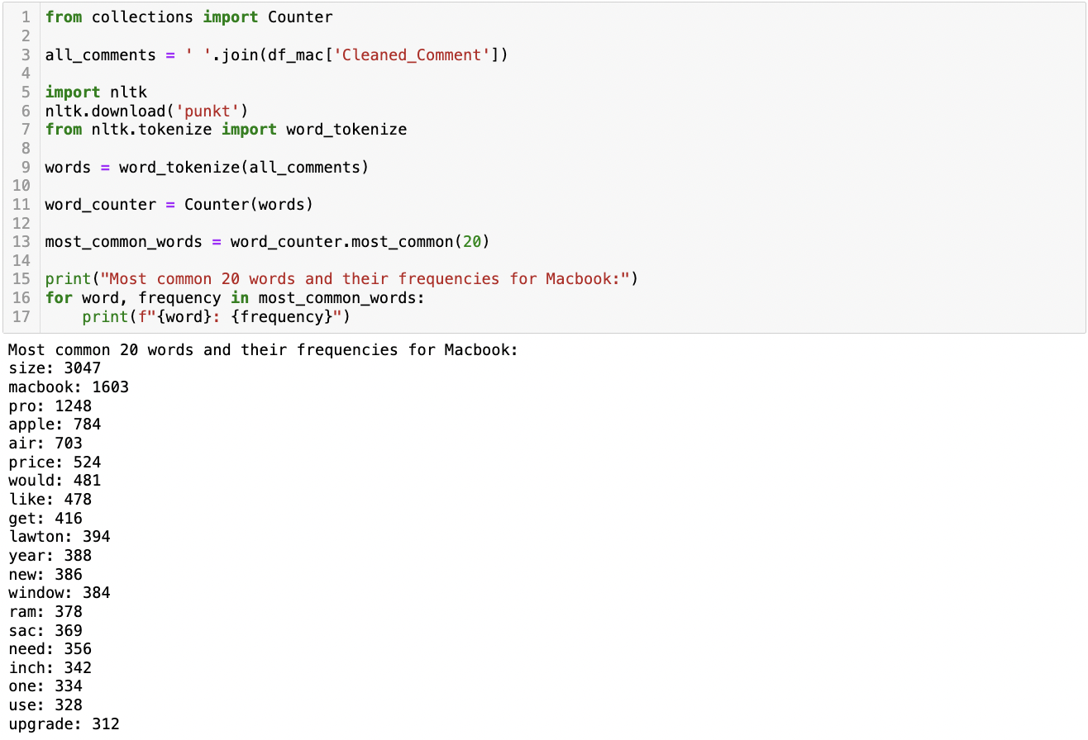

**Figure 125** This is a screenshot of the Python script and its result showing the most common words in the YouTube Macbook comments dataframe.

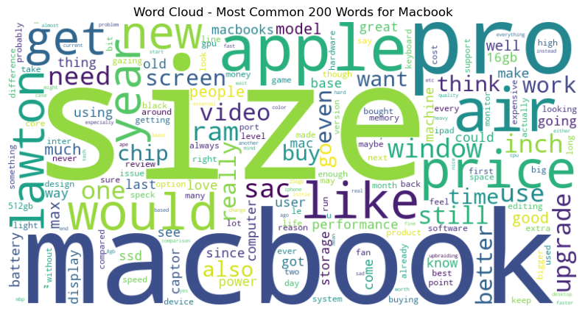

**Figure 126** This is a screenshot of the word cloud showing the most common words in the YouTube Macbook comments dataframe.

Analysing YouTube comments on the MacBook (Figure 127) reveals a focus on dimensions and models. Phrases like “MacBook Air”, “Pro MacBook”, and “Pro Max” indicate strong interest in different models and features. “Size”, often paired with “inch” and “year”, highlights user concern with screen size and release year, reflecting portability and advancement interests. “Base model” underscores attention to entry-level specifications.

 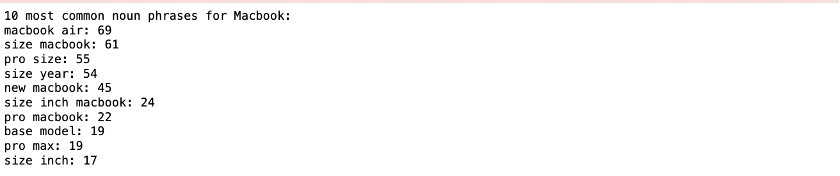

**Figure 127** This is a screenshot of the Python script and its result showing the most common noun phrases in the YouTube Macbook comments dataframe.

##### Topic Modelling Analysis

 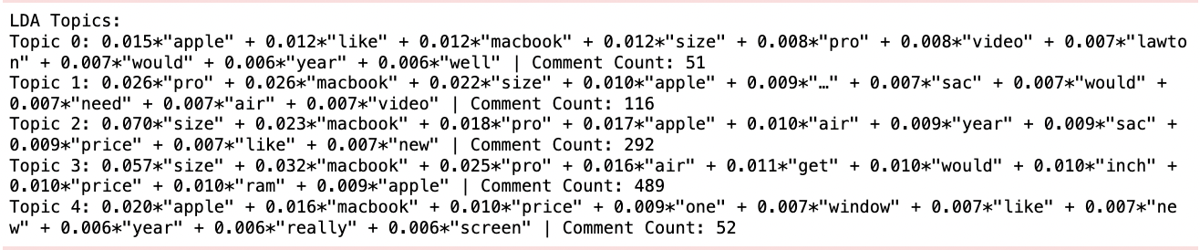

**Figure 128** This is a screenshot of the Python script and its result showing LDA Topic Modelling for the YouTube Macbook comments dataframe.

For Macbook, topic 0 moderately focuses on Apple, MacBook, and size, suggesting discussions about the physical characteristics of the MacBook. Topic 1 shows a strong emphasis on ”pro” and”macbook” along with ”size”, hinting at a specific interest in the MacBook Pro model and its dimensions. Topic 2 heavily emphasizes ”size”, followed by”macbook” and ”pro”, indicating a significant concern about the size dimensions of the MacBook models. Topic 3, the largest, also focuses primarily on ”size” and”macbook”, but introduces ”air”, ”price”, and ”ram”, suggesting a broader discussion that includes the MacBook Air model and technical specifications like price and memory. Finally, Topic 4 appears to contrast Apple with other options ('window'), possibly discussing the MacBook in comparison to Windows-based systems, and also touches on aspects like ”price” and ”screen”.

##### Sentiment Analysis

Each algorithm, grounded in distinct methodological principles ranging from probabilistic models to lexicon-based approaches, consistently categorized the majority of comments as positive for Macbook (Figure 129). This convergence suggests a generally favourable public opinion towards Macbook in the YouTube community.

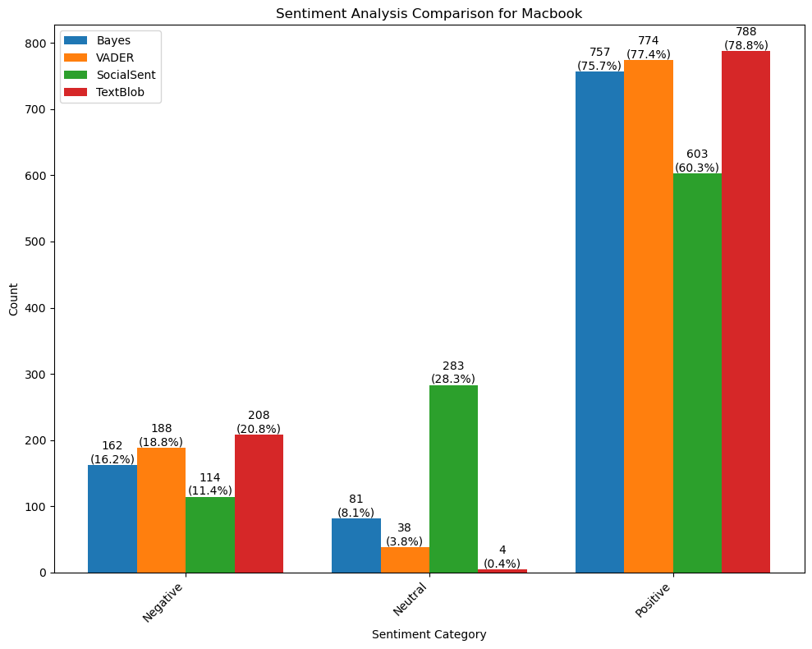

**Figure 129** This is a bar graph showing a sentiment analysis comparison for the YouTube Macbook comments dataframe.

##### Emotion Analysis

A significant presence of anticipation and trust was observed for the Macbook, indicating a generally positive outlook and confidence in the product or brand (Figure 130). However, the analysis also highlighted notable instances of negative emotions, such as anger, disgust, and fear, which could be indicative of specific concerns or issues raised by the users. Joy and sadness were also present in the data, reflecting a range of user experiences and sentiments towards the MacBook. The lesser frequency of surprise suggests that the comments largely aligned with expectations, lacking elements of unpredictability or novelty.

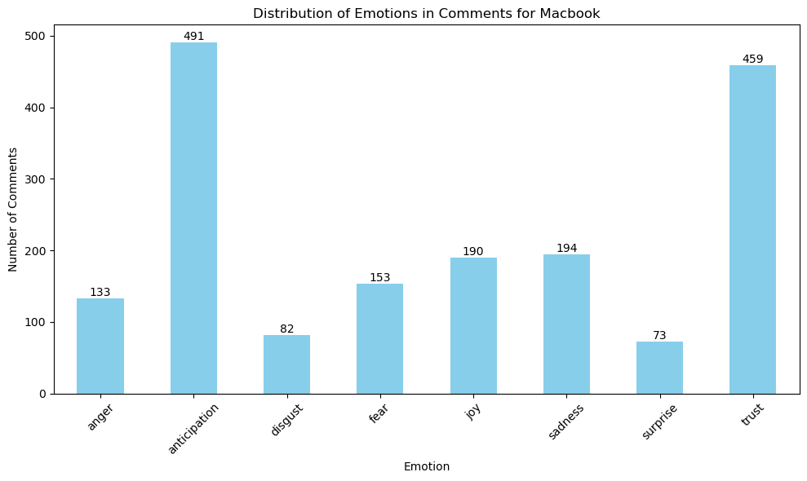

**Figure 130** This is a bar graph showing an emotion analysis comparison for the YouTube Macbook comments dataframe.

#### AirPods

Analysing common words in YouTube comments about AirPods (Figure 131) reveals brand focus and consumer concerns. Frequent use of “airpods”, “pro”, and “apple” shows emphasis on specific models and brands. Words like “size”, “case”, and “ear” indicate interest in ergonomics and fit. “Fake”, “real”, and “bought” highlight concerns about authenticity and purchasing, while “sound” and “good” suggest audio quality is a key user priority, and “video” hints at responses to video content.

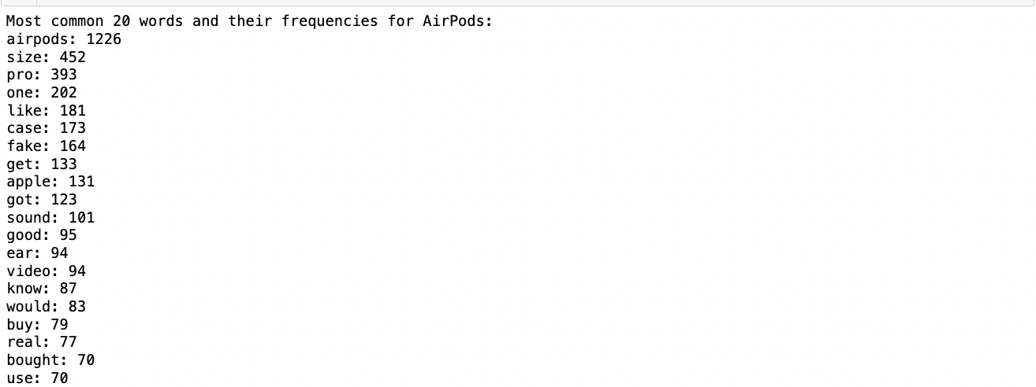

**Figure 131** This is a screenshot of the Python result showing the most common words in the YouTube AirPods comments dataframe.

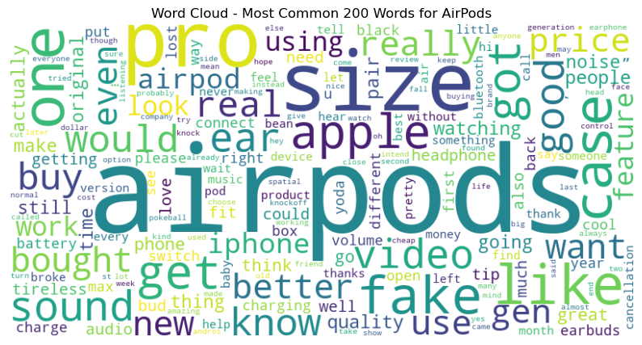

**Figure 132** This is a screenshot of the word cloud showing the most common words in the YouTube AirPods comments dataframe.

Analysing YouTube comments on AirPods (Figure 133), terms like “pro size” and “fake airpods” highlight concerns about authenticity and dimensions. “New airpods” and “original airpods” indicate interest in product evolution. “Sound quality” emphasizes its importance in decision-making, while “real airpods” and “black airpods” show concerns about authenticity and aesthetics. “Pro max” and repeated “airpods airpods” suggest interest in high-end models and brand loyalty. 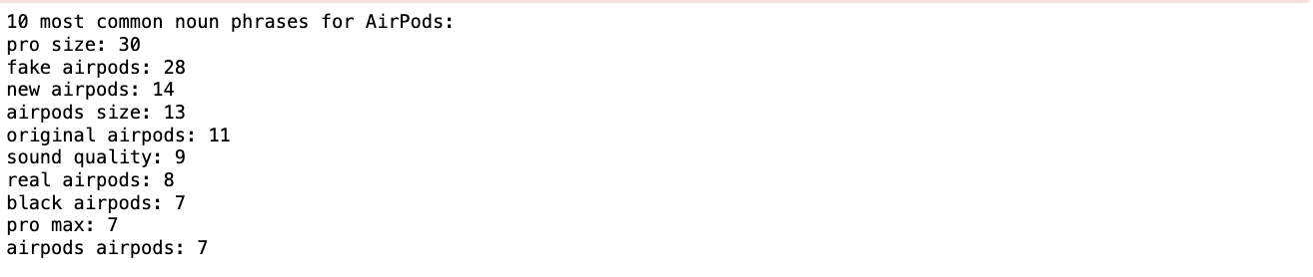

**Figure 133** This is a screenshot of the Python result showing the most common noun phrases in the YouTube AirPods comments dataframe.

##### Topic Modelling Analysis

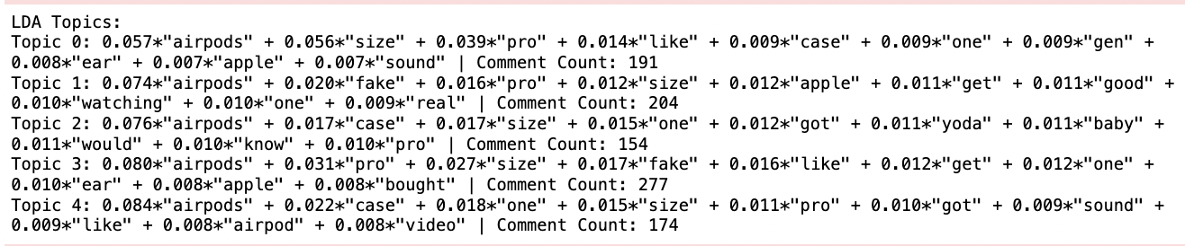

**Figure 134** This is a screenshot of the Python result showing LDA Topic Modelling for the YouTube AirPods comments dataframe.

For YouTube, topic 0 emphasizes product specifics like size, model (Pro), and design aspects (case, ear fit). Topic 1 shifts towards authenticity, with terms like “fake” and “real”, suggesting consumer concerns about counterfeit products. Topic 2, though still centred on AirPods, diverges slightly with unique terms like “yoda” and “baby”, possibly indicating a reference to popular culture or specific video content. Topic 3 combines elements of Topics 0 and 1, with a strong focus on the “Pro” model and issues of authenticity (“fake”). Finally, Topic 4, while still product-focused, includes terms like “sound” and “video”, hinting at discussions around audio quality and multimedia content.

##### Sentiment Analysis

It was observed that, across all four algorithms, the sentiment leaned towards positivity for AirPods (Figure 135). This trend highlights a general favourability towards AirPods within the sampled YouTube comments.

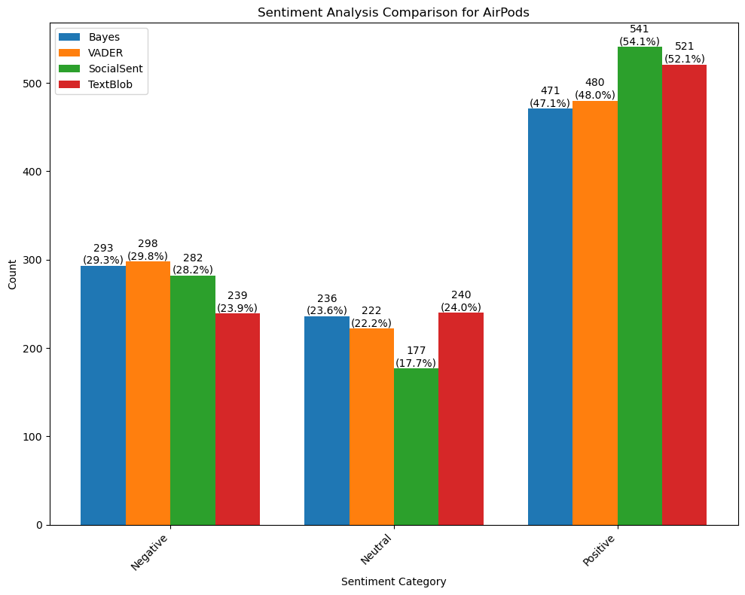

**Figure 135** This is a bar graph showing a sentiment analysis comparison for the YouTube AirPods comments dataframe.

##### Emotion Analysis

The analysis for AirPods revealed a significant presence of anticipation and trust, indicating a prevailing sense of expectancy and reliability among commenters (Figure 136). Interestingly, sadness was also notably prevalent, suggesting a degree of dissatisfaction or unmet expectations in the discourse. This was juxtaposed with a substantial manifestation of fear, hinting at underlying concerns or apprehensions related to the product. In contrast, joy and surprise were also observed, albeit to a lesser extent, indicating moments of positive reception and unexpected reactions among the users. On the other hand, the analysis identified considerable instances of anger and disgust, reflecting strong negative sentiments in public opinion.

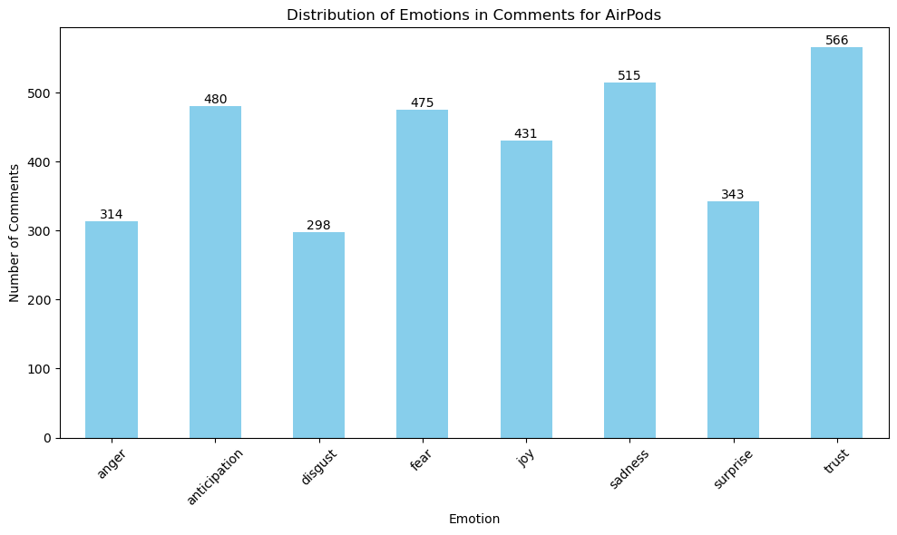

**Figure 136** This is a bar graph showing an emotion analysis comparison for the YouTube AirPods comments dataframe.

#### Apple Watch

Analysing YouTube comments on the Apple Watch (Figure 137) reveals a focus on product attributes and consumer expectations. Terms “watch”, “Apple”, and “ultra” highlight interest in specific models, especially the high-end Ultra series, reflecting brand-consciousness and a preference for premium products. “Size” suggests the importance of dimensions, while “battery”, “life”, “feature”, and “series” indicate technical discussions. “Price” points to cost considerations, and “think” and “people” reflect shared community opinions and experiences.

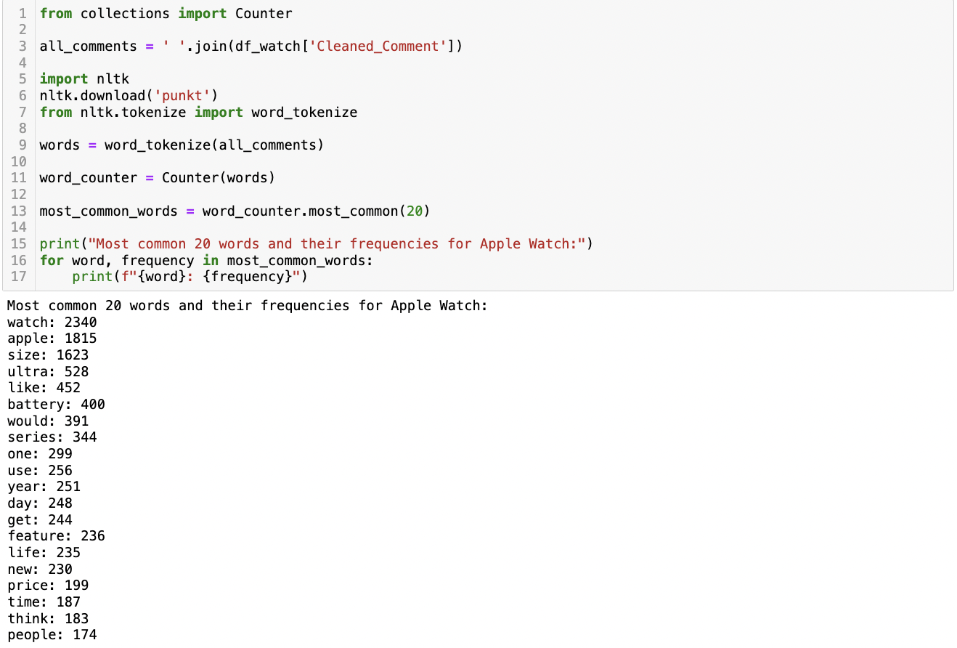

**Figure 137** This is a screenshot of the Python script and its result showing the most common words in the YouTube Apple Watch comments dataframe.

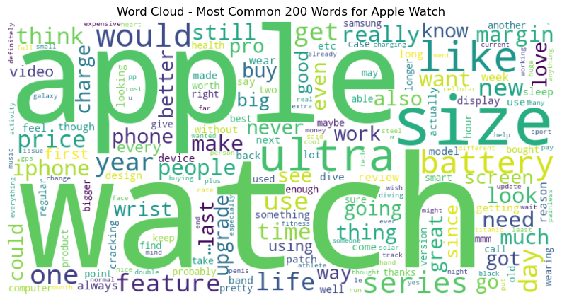

**Figure 138** This is a screenshot of the word cloud showing the most common words in the YouTube Apple Watch comments dataframe.

Analysing YouTube comments on the Apple Watch (Figure 139), key themes include “series size”, “battery life”, and variations like “new apple” and “ultra size.” This highlights consumer interest in physical dimensions and battery performance across models. Frequent mentions of “size” in contexts like “size year” and “iPhone size” suggest concerns about daily functionality and compatibility with other Apple products. Overall, the focus is on the watch's physical attributes and battery efficiency.

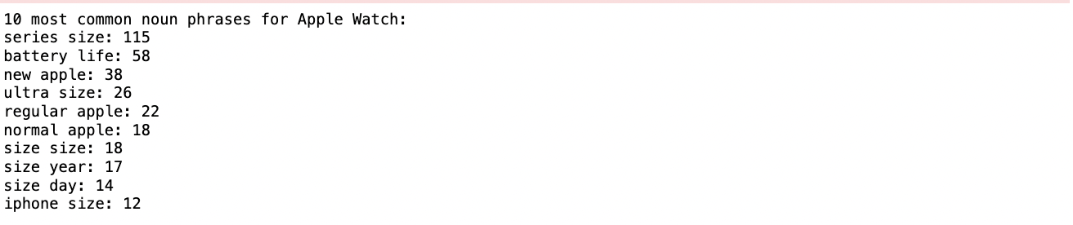

**Figure 139** This is a screenshot of the Python result showing the most common noun phrases in the YouTube Apple Watch comments dataframe.

##### Topic Modelling Analysis

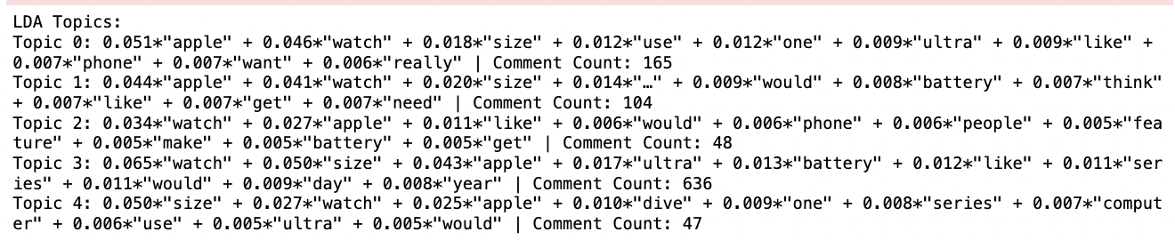

**Figure 140** This is a screenshot of the Python script and its result showing LDA Topic Modelling for the YouTube Apple Watch comments dataframe.

For Apple Watch, topic 0 focuses on general aspects of the Apple Watch, including its size, usability, and the desire for specific features like the ”Ultra” version. Topic 1 appears to delve more into practical considerations such as battery life and the need for specific functionalities, with a hint of speculation or wishful thinking (indicated by words like ”would” and ”need”). Topic 2, the smallest group, seems to emphasize user perceptions and expectations, touching on features and battery life. Topic 3, the largest, strongly emphasizes the watch's size and the ”Ultra” series, indicating significant interest in specific models and their features, including battery life. Finally, Topic 4 uniquely brings in a niche aspect of ”dive” and ”computer”, suggesting a specialized interest in using the Apple Watch for specific activities or functions.

##### Sentiment Analysis

It was observed that all four algorithms demonstrated a tendency to categorize the majority of comments as positive for Apple Watch (Figure 141). This indicates a generally favourable reception of the Apple Watch among the Reddit discussions analysed.

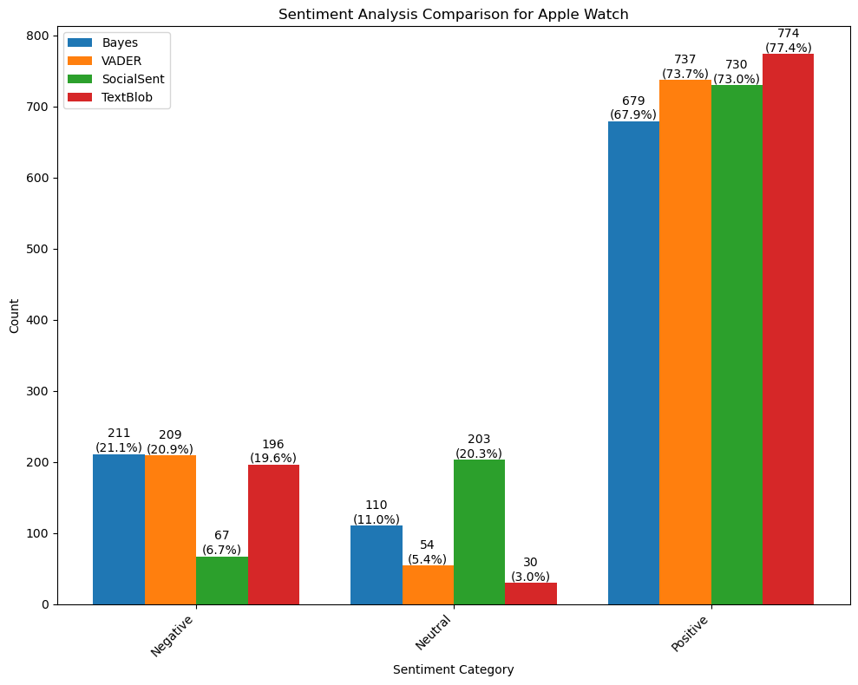

**Figure 141** This is a bar graph showing a sentiment analysis comparison for the YouTube Apple Watch comments dataframe.

##### Emotion Analysis

The emotion analysis of 1000 YouTube comments about the Apple Watch revealed a diverse spectrum of emotional responses (Figure 142). Anticipation emerged as the most prevalent emotion, indicating a high level of expectancy or interest in future developments related to the product. This was closely followed by fear, reflecting concerns or apprehensions among viewers, possibly regarding the product's features, performance, or impact. Trust, though less dominant, was still notable, suggesting a degree of confidence or reliability attributed to the Apple Watch by some commenters. The analysis also uncovered minimal expressions of joy, anger, disgust, sadness, and surprise, which, although less frequent, contribute to the understanding of a varied emotional landscape in the digital discourse surrounding the Apple Watch.

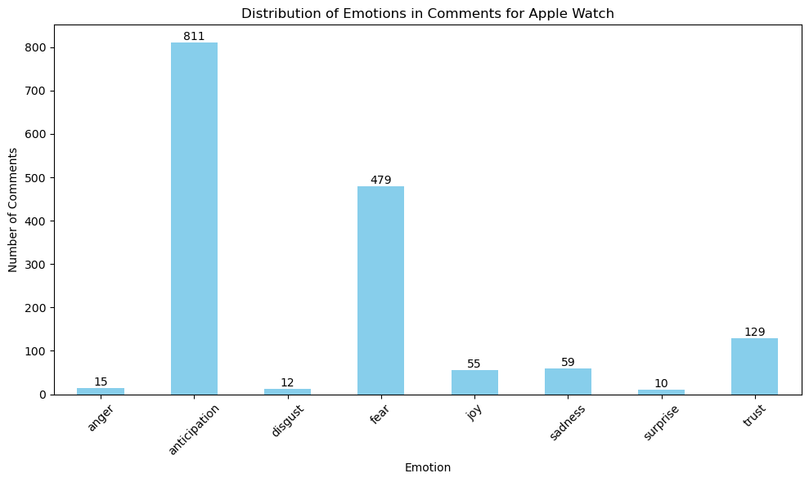

**Figure 142** This is a bar graph showing an emotion analysis comparison for YouTube Apple Watch comments dataframe.

### Comparison

#### iPhone

Across all platforms, the overarching sentiment towards the iPhone is predominantly positive. The observed pattern remains consistent regardless of the sentiment analysis tools employed, indicating an overall positive public attitude towards the iPhone. Discussions across various platforms commonly highlight the iPhone's technical attributes, such as its battery performance, display quality, and camera features. This suggests a strong consumer interest in the practical functionalities of the device. Moreover, there's a pronounced focus on the iPhone's physical characteristics, especially its design. This points to a significant interest in the ergonomics and aesthetic appeal of the phone. Further, these conversations often involve comparisons among different iPhone models, reflecting active consumer involvement in evaluating the array of choices provided by Apple.

eBay and Amazon discussions tend to be more product-centric, focusing on the iPhone's technical features and accessories. In contrast, Reddit covers a wider range of topics, including brand loyalty, model comparisons, and overall user experiences. YouTube stands out for its comparative nature, with discussions often revolving around brand loyalty and competition between Apple and other smartphone manufacturers.

The emotion analysis across platforms presents an interesting contrast. eBay and Amazon show a clear leaning towards positive emotions like trust and joy, possibly reflecting a more transactional and product-focused nature of these platforms. In contrast, Reddit and YouTube display a broader range of emotions, including negative sentiments such as anger and fear, likely due to the more opinionated and diverse nature of discussions on these platforms.

#### iPad

On eBay and Amazon, there is a strong positive sentiment. eBay discussions lean more towards customer satisfaction and product quality, while Amazon focuses on practical aspects like accessories and functionality. On Reddit and YouTube, the sentiment is also predominantly positive. However, Reddit emphasizes brand and model specifics, whereas YouTube concentrates on practicality and unique user experiences.

The topics of discussion vary across platforms. On eBay, users focus on satisfaction and product quality. Amazon's conversation revolves around accessories and their compatibility with the iPad. Reddit presents a broader range of topics, including model preferences, general use, and the iPad's role in Apple's ecosystem. YouTube discussions are more centred on model selection, functional requirements, and personal experiences.

The emotional responses on eBay and Amazon include a range of emotions, with a notable emphasis on trust in Amazon, suggesting strong confidence in the product. On Reddit and YouTube, anticipation and trust are the leading emotions. However, Reddit shows more varied emotions, likely due to the diverse nature of its discussions.

Each platform exhibits unique nuances in user discussions. eBay users express satisfaction with their purchases, focusing on product quality and value. Amazon users discuss functional aspects like accessories and protective features. Reddit's discourse highlights brand loyalty, model comparisons, and integration within the Apple ecosystem. In contrast, YouTube discussions are more model-specific, focusing on practicality and individual experiences.

While a positive sentiment towards the iPad is a common thread across all platforms, the focus and nature of discussions vary significantly. eBay and Amazon users are more oriented towards product quality and practicality, respectively. Reddit encompasses diverse topics ranging from brand loyalty to product integration within the Apple ecosystem. YouTube comments delve into specific model features and personal experiences with the iPad. The emotional landscape across these platforms indicates a well-rounded engagement with the product, with trust and anticipation being prominent emotions.

#### Macbook

On eBay, a strong positive sentiment was evident with frequent use of words like “great”, “good”, and “love”, suggesting high user satisfaction with the MacBook's features and performance. Amazon discussions also leaned positively, balancing the focus on practicality, quality, and performance of the MacBook. Reddit displayed a predominant trend of positive sentiment but with a distinct emphasis on product specifics, cost considerations, and practical utility. YouTube echoed this positivity, focusing on product models, performance, and multimedia usage.

The thematic focus varied across platforms. On eBay, discussions revolved around performance, product quality, technical specifications, purchase satisfaction, and aesthetics, emphasizing the MacBook's efficiency and brand value. Amazon conversations centred around hardware specifications, user experience, and cost-effectiveness, highlighting technical details and practical usage. Reddit's discourse was diverse, spanning topics from MacBook size and practicality to technical aspects and user preferences. YouTube comments focused on model preferences, performance requirements, pricing, and brand evaluation.

eBay comments were dominated by positive emotions like anticipation, joy, and trust, indicating a favourable emotional engagement with the MacBook. Amazon's emotional landscape was led by trust and anticipation, suggesting consumer confidence and positive expectations. The emotional range on Reddit was more complex, including anticipation and trust but also negative emotions like anger and disgust. YouTube also showed a mix of emotions, with anticipation and trust being prevalent, yet peppered with instances of negative sentiments, reflecting specific user concerns.

eBay users expressed satisfaction with their MacBook purchases, focusing on quality and performance. On Amazon, discussions were more technical, emphasizing hardware specifications and practical benefits. Reddit's discourse was wide-ranging, covering everything from model comparisons to personal experiences and technical aspects. YouTube conversations revolved around model specifics, brand evaluation, and performance, indicative of a tech-savvy user base.

Overall, there is a generally positive sentiment towards the MacBook across all platforms, but each platform exhibits its unique focal points. eBay and Amazon discussions are more oriented towards product quality and technical specifics, respectively. Reddit shows a diverse range of topics, including personal experiences and technical details, while YouTube focuses on model comparisons and brand evaluation. The emotional landscape across these platforms is predominantly positive, with trust and anticipation being key emotions, yet there are also instances of negative emotions on platforms like Reddit and YouTube, reflecting the complex nature of consumer relationships with technology products.

#### AirPods

On eBay, the sentiment analysis showed a strong positive trend, with frequent mentions of words like “good”, “great”, and “quality”, suggesting high customer satisfaction with AirPods” sound quality and ease of use. Similarly, Amazon discussions focused on technical aspects and experiential factors like sound quality, indicating positive sentiment and appreciation for the AirPods' design and auditory experience. Reddit conversations revolved around product features, models, and brand association, reflecting a keen interest in the AirPods' variations and advancements with a generally positive public perception. On YouTube, comments also displayed a positive sentiment, with a focus on brand association, product authenticity, and audio quality.

eBay discussions covered a range of topics including gift value, usability, charging features, sound quality, and comfort, with a notable focus on sound quality and brand perception. On Amazon, conversations were centred around comfort, performance, fit and sound quality, technical features, and wireless technology, highlighting an emphasis on comfort and performance. Reddit's discourse was diverse, covering product features, comparisons, user experience, connectivity, and design, with a general focus on product features and issues. YouTube comments revolved around model selection, authenticity, personalization, user experience, and functional use, predominantly focusing on model selection and fit.

The emotional landscape for AirPods on eBay was dominated by trust, joy, and anticipation, indicating positive consumer engagement with the product. On Amazon, trust and anticipation were the leading emotions, mixed with an undercurrent of sadness, suggesting a combination of positive engagement and some dissatisfaction. Reddit displayed a diverse range of emotions, from anticipation and trust to sadness and fear, indicating complex and multifaceted public sentiment. On YouTube, anticipation and trust were significant, but emotions such as sadness, fear, anger, and disgust were also notable, suggesting a range of complex emotional responses.

Users on eBay expressed satisfaction with the AirPods, focusing on their audio performance and ease of use. Amazon discussions were more detailed, emphasizing user experience, comfort, and technical features of the AirPods. Reddit's discourse covered a wide array of topics, ranging from model specifications to personal experiences and comparisons. On YouTube, the conversation centred on model specifics, product authenticity, and audio quality, indicative of a tech-savvy and brand-conscious user base.

#### Apple Watch

On eBay, there was a strong positive sentiment towards the Apple Watch, with frequent mentions of words like “great”, “good”, and “love”, suggesting high user satisfaction with its features and quality. Amazon discussions similarly showed a positive sentiment, focusing on the watch's features, design, and user satisfaction. On Reddit, the focus was primarily on the product's features and user experience, reflecting a keen interest in the Apple Watch's physical characteristics and functionality, with a generally positive sentiment. YouTube comments also displayed a positive orientation, centring around specific models, particularly the high-end series, indicating a brand-conscious and feature-oriented user base.

eBay discussions covered a range of topics, from new features and quality assessment to brand loyalty and series evaluation, with a significant emphasis on product accuracy and user expectations. On Amazon, conversations were centred around practicality, comfort, and product quality, showing a different focus compared to more technical discussions about other tech products. Reddit's discourse was diverse, covering topics such as model comparisons, health features, battery life, and daily use, with a general focus on integration with daily life and smartphone use. On YouTube, the conversation topics revolved around brand loyalty, functional considerations, user experience, series comparison, and specialized features, with a predominant focus on series comparison and daily use.

The emotional analysis on eBay revealed anticipation, joy, and trust as the dominant emotions, indicating positive consumer engagement with the Apple Watch. Amazon's emotional landscape was characterized by anticipation and trust, along with other emotions like sadness, fear, and joy, reflecting a broad spectrum of consumer experiences. On Reddit, the predominant emotions were anticipation and trust, alongside notable fear and other emotions, indicating diverse and multifaceted public sentiment. YouTube's emotional analysis showed anticipation and fear as significant emotions, along with trust and others, suggesting a complex range of emotional responses.

### Summary

Public opinion towards Apple products is largely favourable. Conversations often centre on the technical aspects, the experience of the user, and the overall quality of the products. There is a discernible emphasis on the functionality and the design elements of these devices. While eBay and Amazon tend to centre around product specifics and practical utility, platforms like Reddit and YouTube offer a broader spectrum of discussions, encompassing brand loyalty, model comparisons, and user experiences. Emotionally, positive sentiments such as trust and joy are prevalent, particularly on transactional platforms like eBay and Amazon, indicating high consumer satisfaction and confidence in Apple products. However, more opinionated platforms like Reddit and YouTube exhibit a wider range of emotions, including negative sentiments, which reflect the diverse and complex nature of consumer relationships with Apple's technology offerings. This multifaceted sentiment landscape underscores Apple's strong brand presence and the varied consumer engagement it inspires across different digital platforms.

## Testing with Machine Learning Model

### Introduction

Utilizing machine learning, distinct models of “Logistic Regression”, “MultinomialNB”, and “BernoulliNB” were developed for each product created by experimenting with various NLP techniques such as N-Grams, count vectorization, and TF-IDF. The most successful model was selected after examining metrics such as accuracy, precision, recall, and F1 scores.

### Preprocessing for Model

The “CountVectorizer” from scikit-learn is used to convert a collection of text documents into a matrix of token counts to transform the text into numerical data, allowing machine learning algorithms to process and analyse textual information (Figure 143).

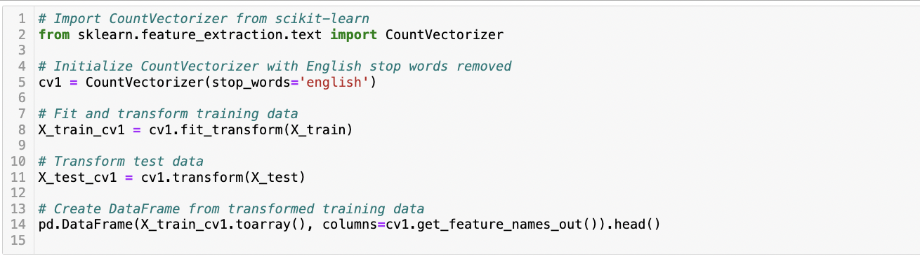

**Figure 143** This is a screenshot of a Python script showing count vectorization with words.

Text data was transformed into a feature matrix using a binary 2-way N-gram tokenizer to capture both individual words and their adjacent pairs in text data, enhancing the model's understanding of context and relationships between words, while representing each term's presence or absence as a binary value (Figure 144).

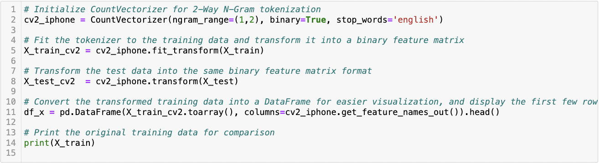

**Figure 144** This is a screenshot of a Python script showing count vectorization with binary 2-way N-gram tokenization.

Two different Term Frequency-Inverse Document Frequency (TF-IDF) vectorizers for words and bigrams from the scikit-learn library were initialized and applied to convert text data into numerical values, emphasizing words that are frequent in a document but not across multiple documents, thereby helping to identify their relative importance (Figure 151).

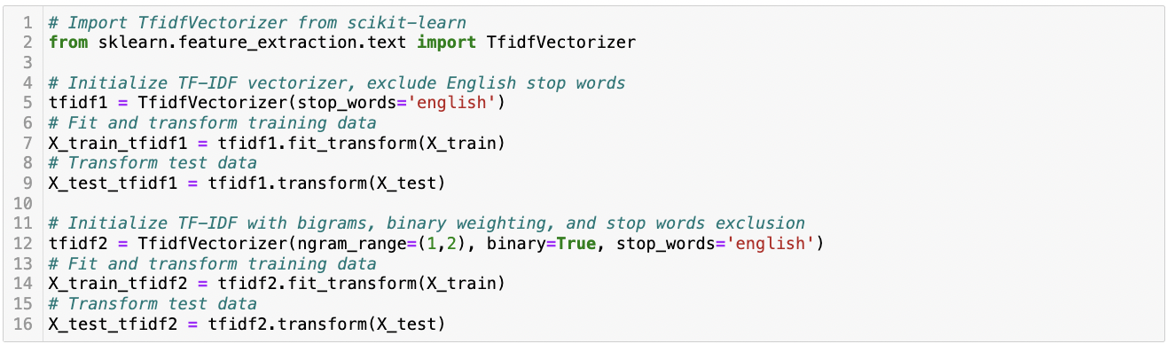

**Figure 145** This is a screenshot of the Python script showing for tf-idf.

### Model Results

In this section, the dataset was strategically divided, allocating 30% as test data to evaluate the performance of various predictive models.

#### iPhone

The empirical investigation highlighted the Logistic Regression model combined with the bigram count vectorization technique as the most effective approach. This configuration demonstrated a remarkable accuracy of 94% in classifying sentiments associated with iPhone-related reviews (Figure 146).

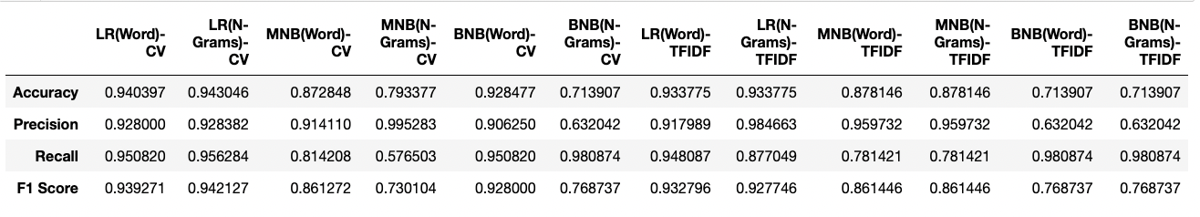

**Figure 146** This is a screenshot of the table showing NLP model results for iPhone.

An in-depth feature analysis was conducted to understand the factors contributing to this high accuracy. It was observed that certain words had a significant influence on the model's predictive capabilities. The terms “love”, “great”, and “like” emerged as the top contributors positively affecting the model's performance. These words, frequently appearing in positive sentiments, played a pivotal role in guiding the model towards accurate predictions of positive reviews. Conversely, the word “disappoint” was identified as having one of the most negative impacts on model predictions. This term, predominantly present in negative reviews, was instrumental in enabling the model to accurately categorize negative sentiments (Figure 147).

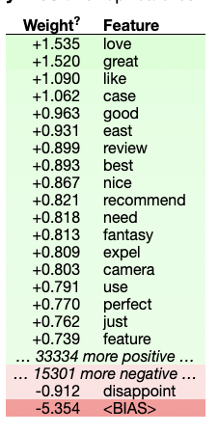

**Figure 147** This is a screenshot of the table showing feature weights for the iPhone NLP model.

#### iPad

The Bernoulli Naïve Bayes model, combined with word count vectorization, achieved an accuracy of 90% on the test data. This metric is a testament to the model's efficacy in correctly classifying iPad-related reviews (Figure 148).

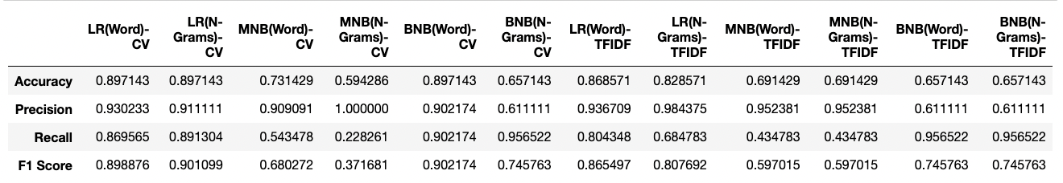

**Figure 148** This is a screenshot of the table showing NLP model results for iPad.

#### Macbook

Among the models tested, the Logistic Regression model, coupled with a word count vectorization technique, emerged as the most successful. It achieved an impressive accuracy of 92% in predicting customer satisfaction (Figure 149).

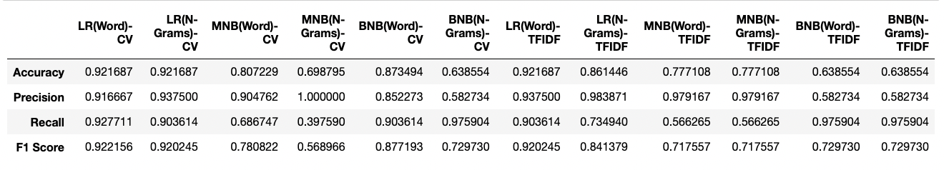

**Figure 149** This is a screenshot of the table showing NLP model results for Macbook.

The analysis of word influence on the model's predictions revealed fascinating insights. The words that most positively affected the model's predictions were “great”, “good”, and “like” (Figure 150). These words are typically associated with positive sentiments and their strong influence aligns with intuitive expectations about customer feedback language.

Conversely, the words with the most negative impact on predictions were “return” and “refund”. These terms are often used in the context of dissatisfaction or issues with a product, thereby negatively influencing the model's prediction towards a negative sentiment.

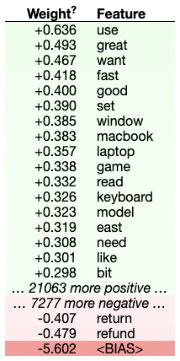

**Figure 150** This is a screenshot of the table showing feature weights for the Macbook NLP model.

#### AirPods

The Logistic Regression model demonstrated a remarkable performance, achieving an accuracy rate of 94% on the test dataset (Figure 151). This result stands out as the highest accuracy obtained across all models tested in this study. The model's performance was rigorously evaluated using standard cross-validation techniques to ensure the reliability and validity of the results.

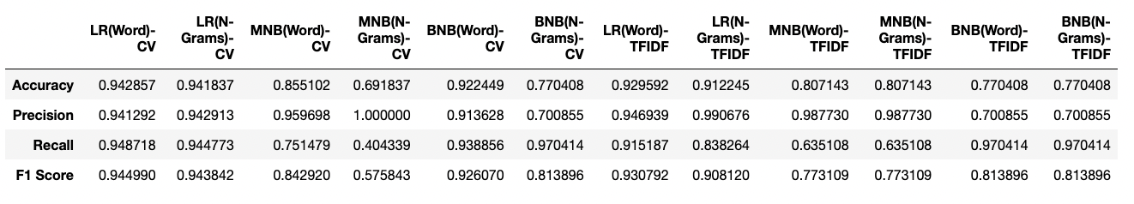

**Figure 151** This is a screenshot of the table showing NLP model results for Macbook.

A critical aspect of the analysis involved understanding the words that most significantly influenced the model's predictions (Figure 152). The words with the most positive impact on the model's accuracy were “prefer”, “recommend”, “fine”, and “great.” These terms, frequently appearing in positive reviews, contributed to the model's ability to classify reviews effectively.

Conversely, the words that had the most negative effect on model performance were “shame” and “poor.” These terms were predominantly found in negative reviews and were instrumental in guiding the model towards accurate negative predictions.

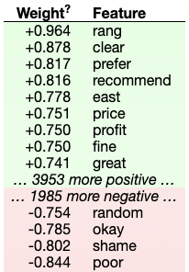

**Figure 152** This is a screenshot of the table showing feature weights for the Macbook NLP model.

#### Apple Watch

The logistic regression model, coupled with bigrams count vectorization, exhibited superior performance compared to other models tested in this study (Figure 153). Specifically, this combination achieved an impressive accuracy of 93% when applied to the test data.

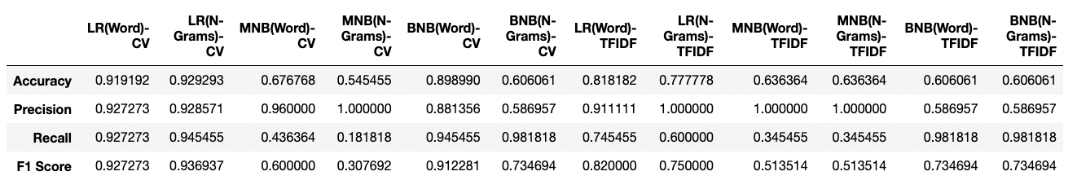

**Figure 153** This is a screenshot of the table showing NLP model results for Apple Watch.

A further examination of the model revealed the significant impact of certain bigrams on the sentiment analysis (Figure 154). The words “perfect”, “good”, and “like” were found to have the most positive influence on the model's output. This suggests that these terms are strongly associated with positive sentiments towards the Apple Watch in the dataset. Conversely, the bigram “wouldn't” was identified as having the most negative impact on the model. This indicates a strong correlation between this term and negative sentiments in the context of the Apple Watch.

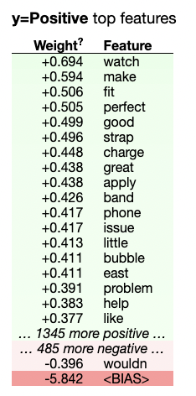

**Figure 154** This is a screenshot of the table showing feature weights for the Apple Watch NLP model.

### Summary

This section presents a comprehensive sentiment analysis of various Apple products, employing diverse predictive models and vectorization techniques. The analysis reveals insightful patterns in language usage across product reviews. Common positive terms like “love”, “great”, “like”, and “recommend” across different products signify a generally favourable perception of Apple's offerings. Notably, each product exhibits unique influential terms that significantly impact the models' predictive accuracy, reflecting the distinct customer sentiments associated with each product such that “disappoint” in iPhone reviews and “refund” in MacBook feedback indicate specific areas of customer dissatisfaction.

# ISSUES AND CHALLENGES

Significant challenges were encountered during the research. Ensuring data quality and integrity was a primary concern, as data from diverse varied in format and content. Heterogeneous data sources required sophisticated preprocessing pipelines for harmonization. The presence of noise such as irrelevant comments and spam necessitated meticulous cleaning for reliable analysis.

Limitations in data scraping were evident due to restricted access and anti-scraping measures, impacting data completeness and retrieval scope. Methodological challenges were faced in sentiment analysis due to platform-specific linguistic variations, especially in technology-centric discussions about Apple products. The complexity of sentiment analysis algorithms, particularly the balance between advanced models like deep learning and interpretability, was a critical issue.

Practical challenges included managing the large data volume with limited computational resources and influencing the scope of analysis. Additionally, the evolving nature of digital platforms necessitated continuous adaptation of tools and techniques, highlighting the dynamic landscape of social media and e-commerce platforms in sentiment analysis studies.

# EVALUATION

## Introduction

The evaluation of this dissertation provides an opportunity to reflect critically on the comprehensive sentiment analysis conducted across various social media and e-commerce platforms concerning Apple products. This analysis aimed to discern the public's sentiment towards Apple's suite of products and to understand the nuances of consumer discourse within different digital contexts.

## Conclusion of the Objectives

### Comparative Evaluation of Sentiment Analysis Methods

The effectiveness of various sentiment analysis methods was evaluated, focusing on their ability to accurately interpret sentiments in social media and e-commerce text data, particularly about platform variations and product features. The findings indicated notable differences in performance among these methods. Naïve Bayes and VADER excelled in identifying general sentiment trends across platforms but fell short in detecting nuanced emotional expressions in opinion-rich forums like Reddit and YouTube. In contrast, SocialSent and LexMo showed enhanced proficiency in capturing complex emotional undercurrents, particularly in environments with a broader spectrum of sentiments. This comparative analysis highlighted the significance of choosing suitable sentiment analysis tools tailored to the specific characteristics of the data source and discussion context, ensuring more accurate and nuanced insights into consumer sentiments across various digital platforms.

### Comparative Sentiment Analysis of Apple Products

An in-depth comparative sentiment analysis was performed on discussions surrounding Apple products across various social media and e-commerce platforms. This analysis employed advanced data science techniques, including natural language processing and topic modelling. The results revealed significant insights into the public perception of Apple's product range. The sentiment across these platforms was predominantly positive, with a notable emphasis on technical features, user experience, and product quality. Differing discussion focuses were observed across platforms, highlighting distinct consumer engagement patterns. eBay and Amazon discussions were more product-centric, while Reddit and YouTube encompassed a broader spectrum of topics, including brand loyalty and user experiences. These findings not only underscore the effectiveness of the applied data science methodologies in extracting nuanced consumer sentiments but also provide a comprehensive understanding of the multifaceted nature of consumer relationships with Apple products across different digital environments.

### Analysis of Dominant Emotions Across Platforms

In addressing the objective of investigating and analysing the dominant emotions experienced by users on separate platforms regarding Apple products, the study has successfully delineated sentiment trends across various digital environments. The results underscore a predominantly positive sentiment towards Apple products, with nuances in emotional expressions varying across platforms. On transactional platforms like eBay and Amazon, emotions such as trust and joy are prevalent, reflecting a consumer focus on product satisfaction and confidence. In contrast, more opinion-driven platforms like Reddit and YouTube exhibit a broader emotional spectrum, including negative sentiments like anger and fear. This diversity indicates the complex and multifaceted nature of consumer relationships with technology products. The sentiment trends identified in this analysis provide a comprehensive understanding of the emotional landscape associated with Apple products, highlighting the influence of platform dynamics on consumer emotions.

### Analysis of Sentiment Trends and Key Themes in Consumer Perceptions

The analysis reveals a predominance of positive emotions, particularly trust and joy, especially on transactional platforms like eBay and Amazon. It also uncovers a broader range of emotions, including negative sentiments, on more discussion-oriented platforms like Reddit and YouTube. The thematic exploration across these platforms uncovers a strong focus on technical features, user experiences, and product quality, with each platform presenting unique focal points and discussions. Key terms such as “love”, “great”, “quality”, and specific negative terms like “disappoint” or “refund” about different products have been identified, reflecting the nuanced consumer sentiments associated with each Apple product. This multifaceted analysis provides a detailed understanding of the influential factors shaping consumer opinions and perceptions of Apple products in the digital landscape.

### Utilizing Sentiment Analysis for Strategic Business Insights

the results obtained from analysing sentiments across different platforms for Apple products provide insightful implications. Sentiment analysis, as demonstrated, offers a rich resource for informing business strategies, particularly in areas such as innovation, marketing choices, and enhancing customer satisfaction. For a company like Apple, the diversity in sentiment and discussion topics across platforms like eBay, Amazon, Reddit, and YouTube reveals valuable consumer insights. For instance, the emphasis on technical features and design aesthetics in consumer discussions highlights areas for potential innovation and product development. Similarly, the varied emotional responses, ranging from trust and joy to fear and anger, present an opportunity for Apple to tailor its marketing strategies to address specific consumer concerns and enhance brand perception. Moreover, the identification of key terms associated with customer dissatisfaction, such as “disappoint” in iPhone reviews or “refund” in MacBook feedback, offers actionable insights for improving customer satisfaction. This nuanced understanding of consumer sentiment, facilitated by sentiment analysis, thus becomes a critical tool for companies in refining their business strategies and aligning them more closely with customer preferences and expectations.

## Limitation and Future Work

While the study offers substantial insights, it acknowledges limitations, such as the variability in data access due to scraping restrictions and the evolving nature of language on digital platforms. The sentiment analysis models faced challenges in capturing the full spectrum of nuanced human emotions, often present in textual feedback.

Future work could expand the dataset to include real-time analysis, capturing sentiment trends as they evolve. Additionally, incorporating image and video content analysis could provide a more holistic view of consumer sentiment. Delving into cross-cultural sentiments by analysing feedback in multiple languages could also yield richer insights. Furthermore, the incorporation of various sentiment analysis methodologies, including the Transformers library from Hugging Face, Google's Cloud Natural Language API, and IBM Watson could enhance the comprehensiveness of the analysis, thereby potentially yielding more accurate results.

## Project Success

In considering the success of this dissertation, it is essential to reference the original objectives set out at the project's commencement. The success criteria were clearly defined – all objectives should be met without exception.

The objectives laid the groundwork for a comprehensive comparative sentiment analysis of Apple products across social media and e-commerce platforms. These goals were ambitious, aiming to capture the nuances of public opinion in diverse digital environments and to analyse them with precision.

Upon review, it is evident that the project met all the objectives outlined in the dissertation proposal. The analytical approaches, including the utilization of machine learning models such as Logistic Regression, MultinomialNB, and BernoulliNB, were executed effectively. The integration of these models with advanced NLP techniques facilitated a detailed and accurate sentiment analysis, adhering to the project's rigorous methodological standards.

The data gathered from varied sources like eBay, Amazon, Reddit, and YouTube, was substantial both in volume and complexity. Moreover, the pre-processing and analysis were conducted meticulously, ensuring data quality and integrity. The application of various NLP techniques, such as N-Grams, count vectorization, and TF-IDF, provided a robust framework for sentiment analysis, yielding insights that were both deep and wide-ranging.

The project's adaptability was also a testament to its success. While the initial proposal mentioned specific analytical tools, the eventual selection of tools was guided by their ability to handle the dataset effectively. This flexibility did not compromise the objectives but rather enhanced the study's comprehensiveness. Each objective was not only achieved but also expanded upon, as demonstrated in the detailed discussions throughout the dissertation.

The empirical findings discussed in this dissertation affirm the project's success. The sentiment analysis results across platforms answered the research questions and achieved the dissertation's objectives. The adaptation to the initially proposed methodologies did not detract from the project's goals but rather contributed to a more robust and nuanced analysis.

## Summary

In summary, this evaluation highlights the project's success in offering a detailed comparative sentiment analysis of Apple products. The research findings enrich the understanding of consumer sentiment dynamics across digital platforms and underscore the positive reception of Apple products globally. Despite the encountered challenges, the study's objectives were achieved, providing a firm foundation for future research and practical applications in sentiment analysis and digital marketing strategies. This project successfully met all its objectives. It provided a comprehensive, comparative sentiment analysis of Apple products, utilizing a range of machine learning models and NLP techniques to achieve a nuanced understanding of consumer sentiment across digital platforms.

# REFERENCES AND BIBLIOGRAPHY

Aljuhani, S.A. and Saleh, N. (2019) ‘A comparison of sentiment analysis methods on Amazon reviews of mobile phones’, International Journal of Advanced Computer Science and Applications, 10(6). doi:10.14569/ijacsa.2019.0100678.

Banerjee, S. et al. (2021) Social Media Analytics for end-users’ expectation management in Information Systems Development Projects, Information Technology & People, 34(6), pp. 1600–1614. https://doi.org/10.1108/itp-10-2020-0706.

Chehal, D., Gupta, P. and Gulati, P. (2021) ‘Evaluating annotated dataset of customer reviews for aspect-based sentiment analysis’, Journal of Web Engineering, [Preprint]. doi:10.13052/jwe1540-9589.2122.

Kundu, S. and Chakraborti, S., 2020. A comparative study of online consumer reviews of Apple iPhone across Amazon, Twitter and MOUTHSHUT platforms. Electronic Commerce Research, 22(3), pp.925-950. doi: 10.1007/s10660-020-09429-w.

Singla, Z., Randhawa, S. and Jain, S. (2017) Statistical and sentiment analysis of Consumer Product Reviews. 2017 8th International Conference on Computing, Communication and Networking Technologies (ICCCNT). doi:10.1109/ICCCNT.2017.8203960.

Yang, Z. et al. (2023) 'Online product decision support using sentiment analysis and fuzzy cloud-based multicriteria model through multiple e-commerce platforms', IEEE Transactions on Fuzzy Systems, 31(11), pp. 3838–3852. doi:10.1109/tfuzz.2023.3269741.

Yiran, Y. and Srivastava, S. (2019) ‘Aspect-based sentiment analysis on mobile phone reviews with LDA’, Proceedings of the 2019 4th International Conference on Machine Learning Technologies [Preprint]. doi:10.1145/3340997.3341012.

Chamekh, A., Mahfoudh, M. and Forestier, G., 2022. Sentiment analysis based on deep learning in e-commerce. In: Knowledge Science, Engineering and Management. pp. 498–507. doi: 10.1007/978-3-031-10986-7_40.

Chen, J. et al. (2022) 'Learning user sentiment orientation in social networks for sentiment analysis', Information Sciences, 616, 526–538. doi:10.1016/j.ins.2022.10.135.

Das, S. & Kolya, A.K., 2017. Sense GST: Text mining & sentiment analysis of GST tweets by naive Bayes algorithm. In: 2017 Third International Conference on Research in Computational Intelligence and Communication Networks, ICRCICN. [online] Available at: doi:10.1109/ICRCICN.2017.8234513.

Drus, Z. and Khalid, H. (2019) 'Sentiment Analysis in social media and its application: Systematic Literature Review', Procedia Computer Science, 161, 707–714. doi:10.1016/j.procs.2019.11.174.

Gupta, R. and Chen, M. (2020) ‘Sentiment analysis for stock price prediction’, in 2020 IEEE Conference on Multimedia Information Processing and Retrieval (MIPR). [Preprint]. doi:10.1109/MIPR49039.2020.00051.

Indrayuni, E. and Nurhadi, A. (2020) ‘Optimizing genetic algorithms for sentiment analysis of Apple product reviews using SVM’, SinkrOn, 4(2), pp. 172. doi:10.33395/sinkron.v4i2.10549.

Kaur, D. (2017) Sentimental Analysis on Apple Tweets with Machine Learning Technique. ResearchGate. Available at: https://www.researchgate.net/publication/353072253_Sentimental_Analysis_on_Apple_Tweets_with_Machine_Learning_Technique (Accessed: 31 August 2023).

Philander, K. and Zhong, Y., 2016. Twitter sentiment analysis: Capturing sentiment from integrated resort tweets. International Journal of Hospitality Management, 55, pp.16-24. doi:10.1016/j.ijhm.2016.02.001.

Saif, H., He, Y. and Alani, H. (2012) 'Semantic sentiment analysis of Twitter', in The Semantic Web – ISWC 2012, pp. 508–524. DOI: 10.1007/978-3-642-35176-1_32.

Singh, N.K., Tomar, D.S. and Sangaiah, A.K. (2018) 'Sentiment analysis: A review and Comparative Analysis Over Social Media', Journal of Ambient Intelligence and Humanized Computing, 11(1), pp. 97–117. doi:10.1007/s12652-018-0862-8.

Smailović, J., Grčar, M. and Žnidaršič, M., [no date] Sentiment analysis on tweets in a financial domain. [online] Available at: https://citeseerx.ist.psu.edu/document?repid=rep1&type=pdf&doi=ba53a72840a5e9dd5787235007a873984d3a4f3d [Accessed 31 August 2023].

Yue, L. et al. (2018) 'A survey of sentiment analysis in social media', Knowledge and Information Systems, 60(2), pp. 617–663. doi:10.1007/s10115-018-1236-4.

# APPENDICES

Project Timeline

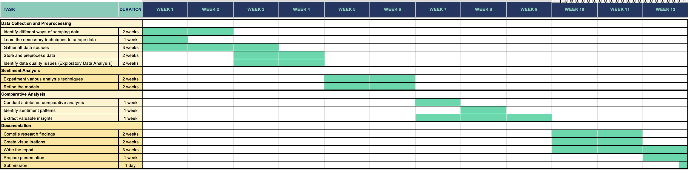

Project Methodology

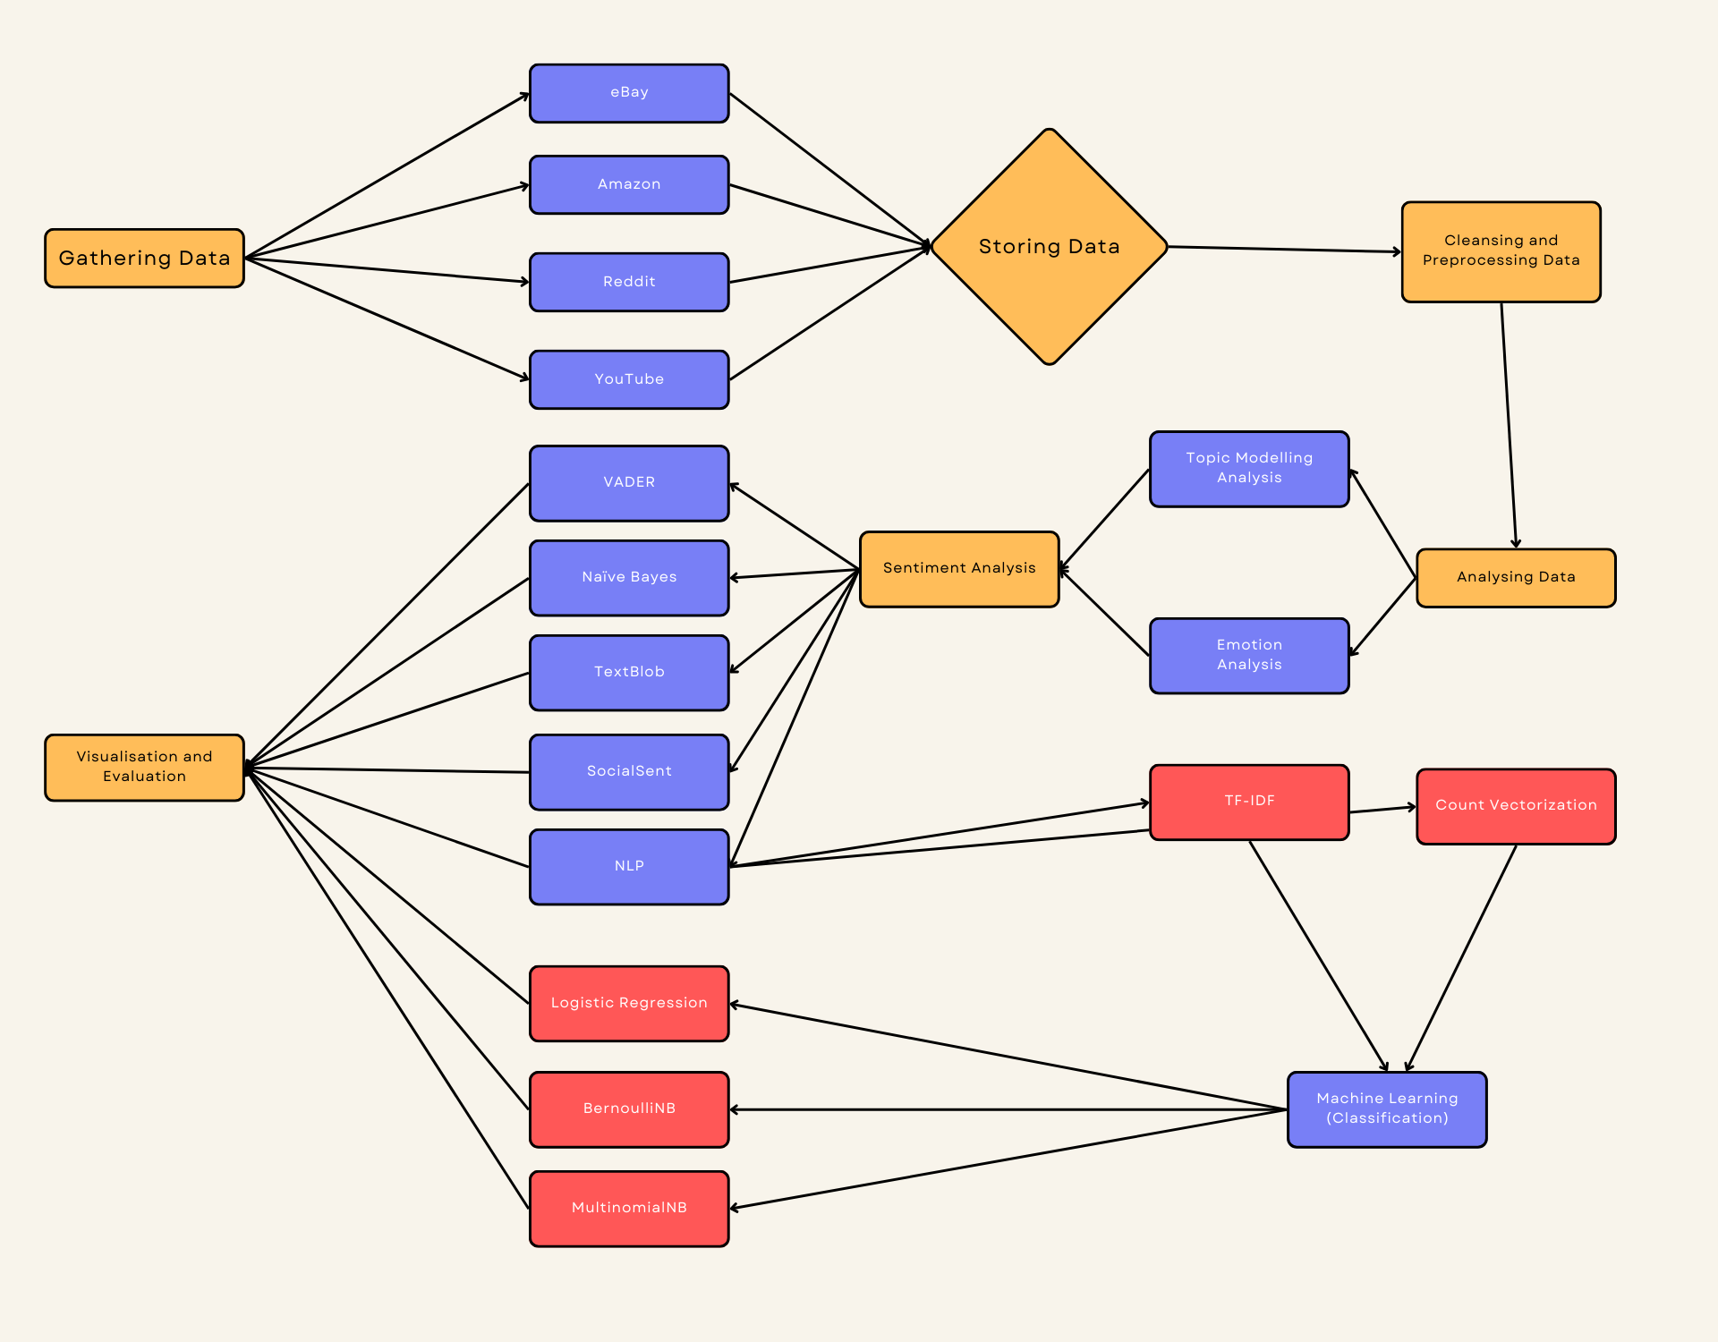

Python Code – eBay Scrape

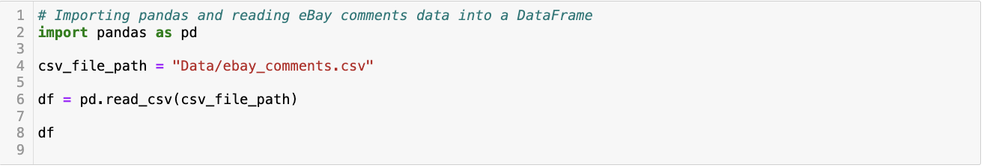



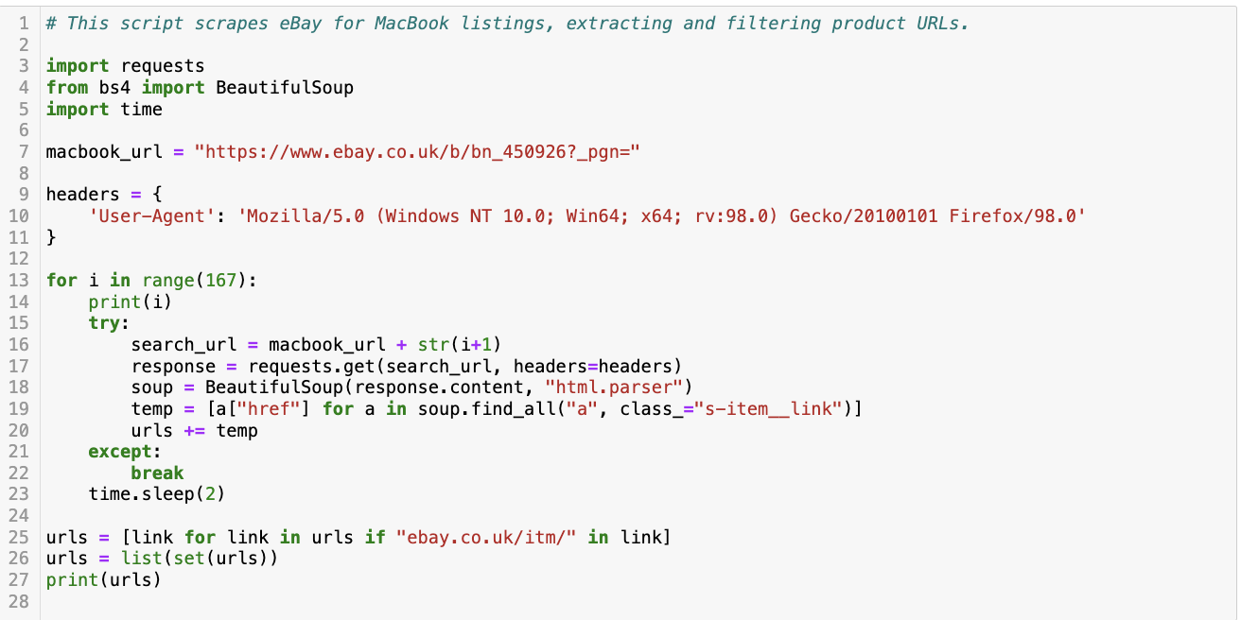

Python Code – Amazon Scrape

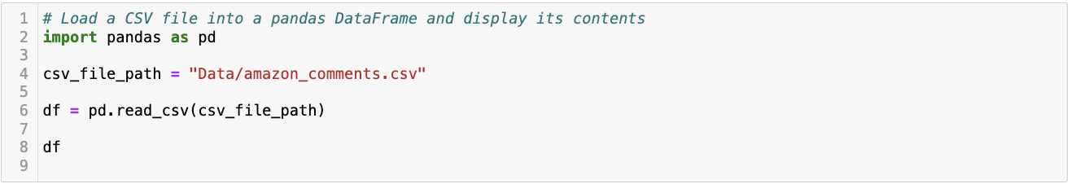

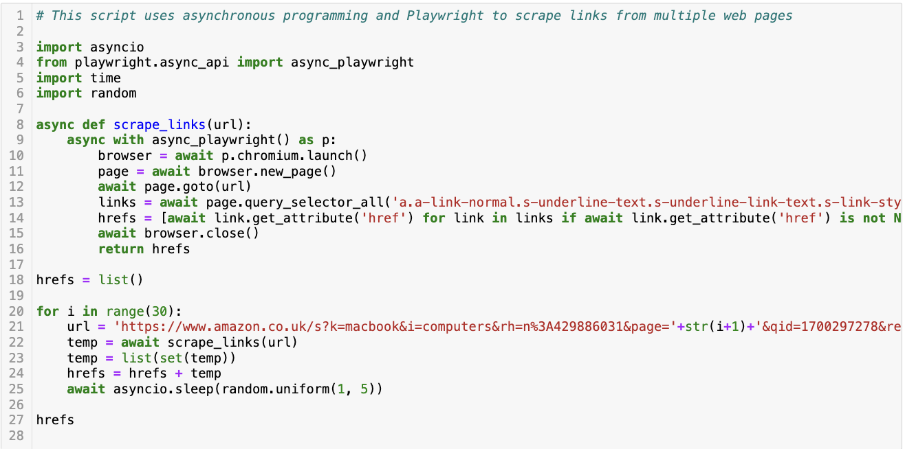

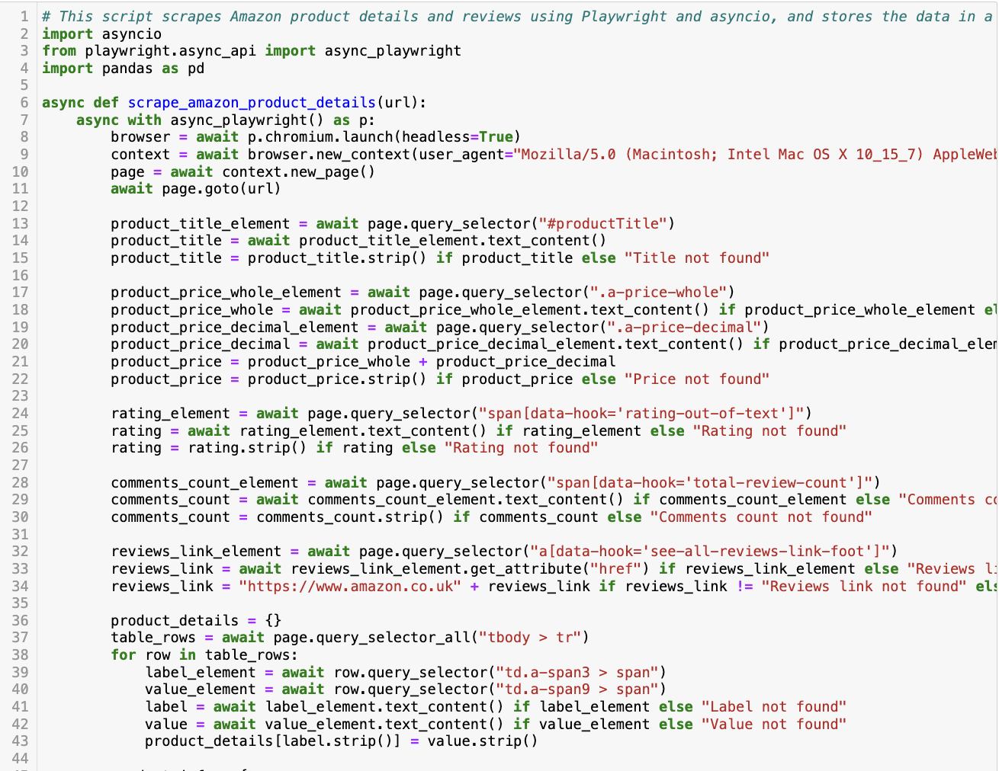

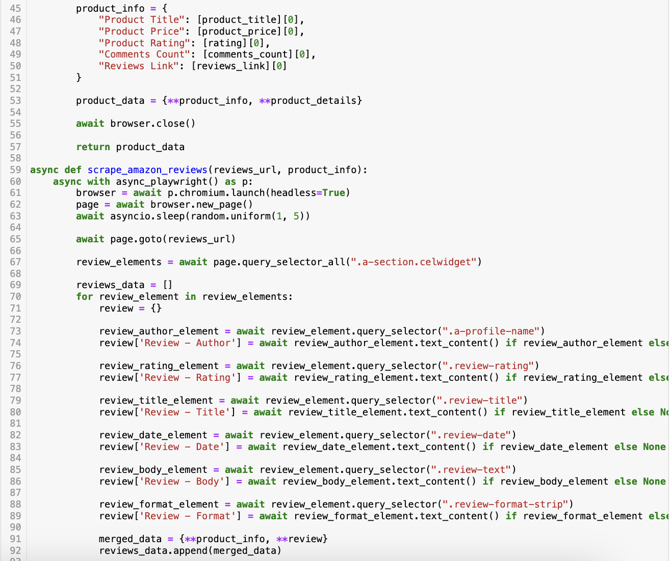

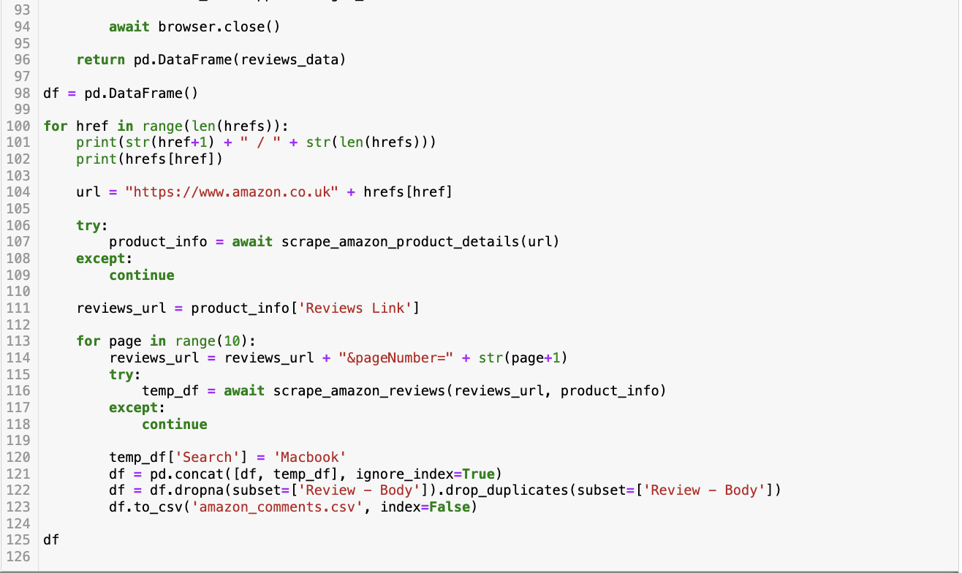

Python Code – Reddit Scrape

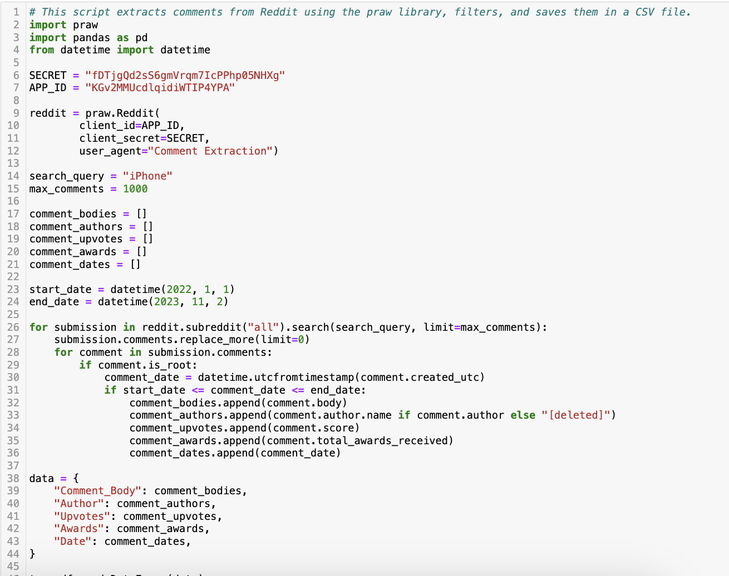

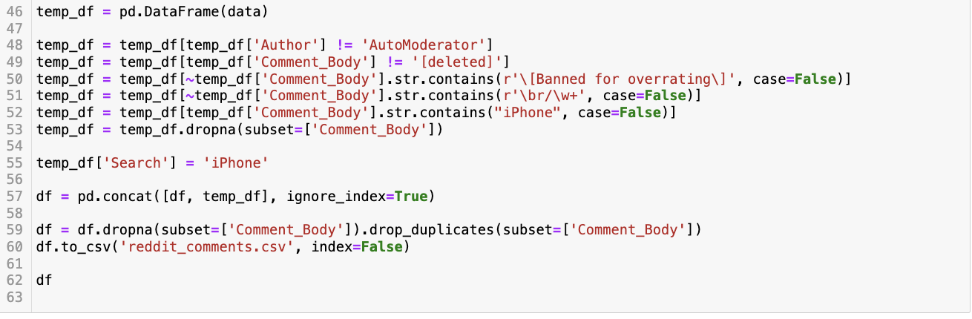

Python Code – YouTube Scrape

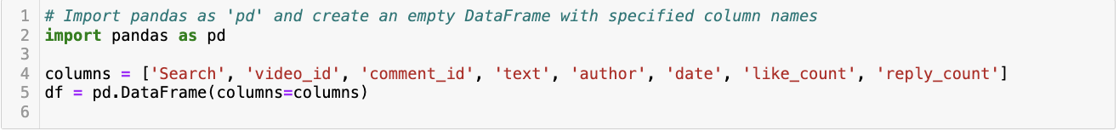

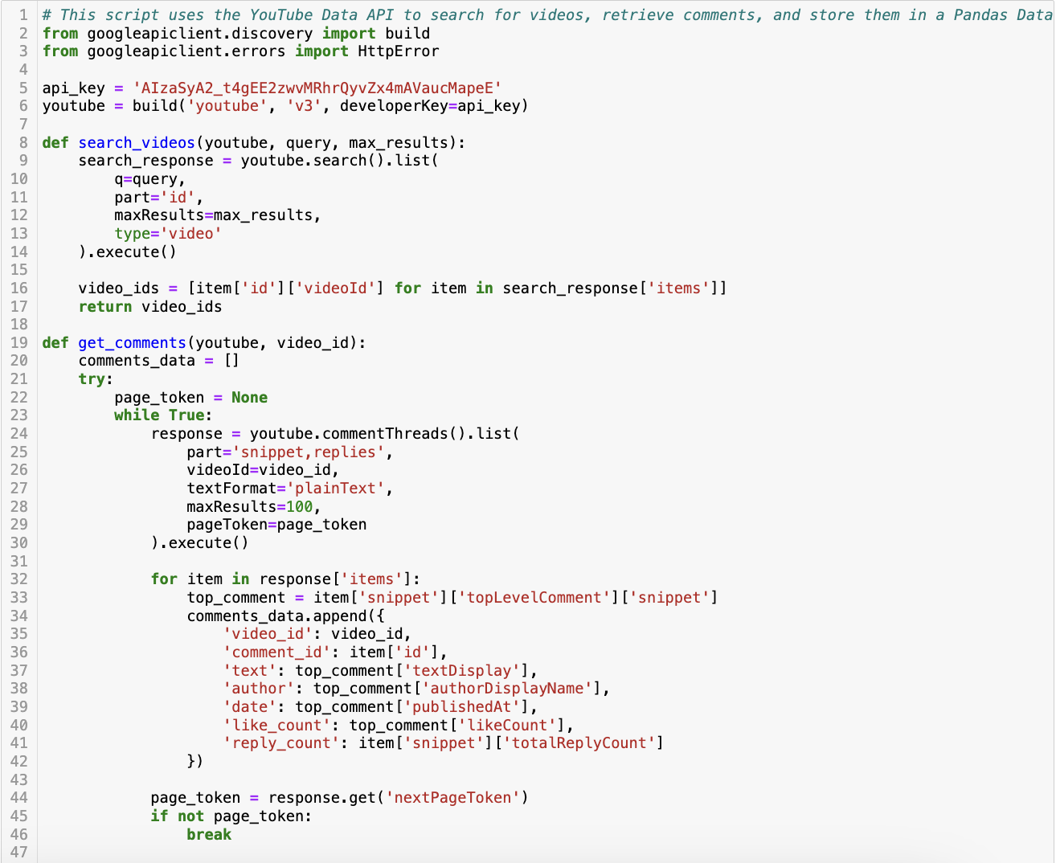

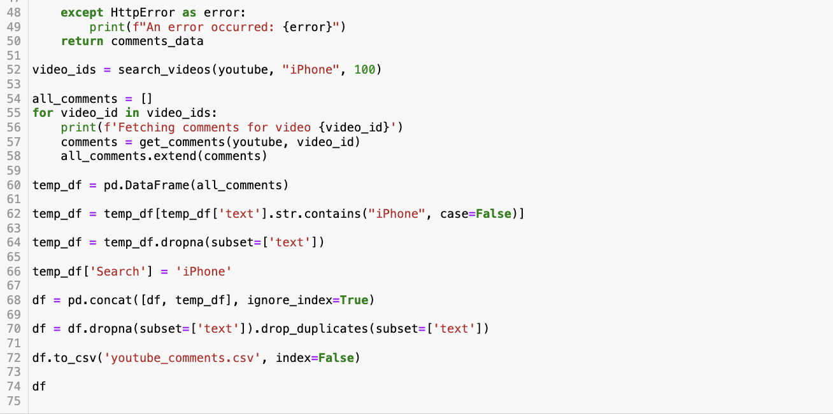

Python Code – EDA

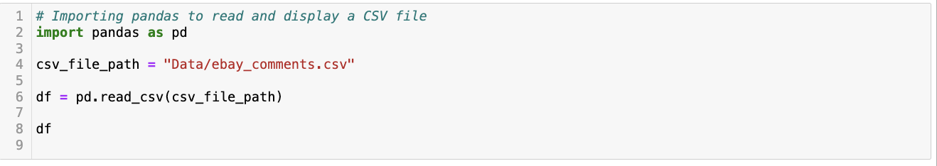









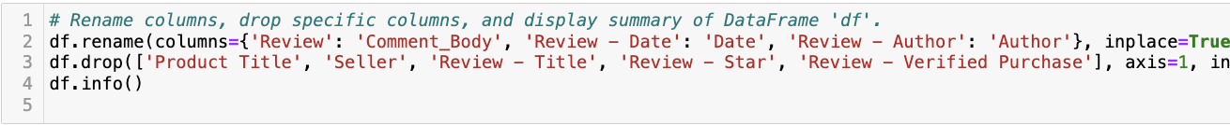







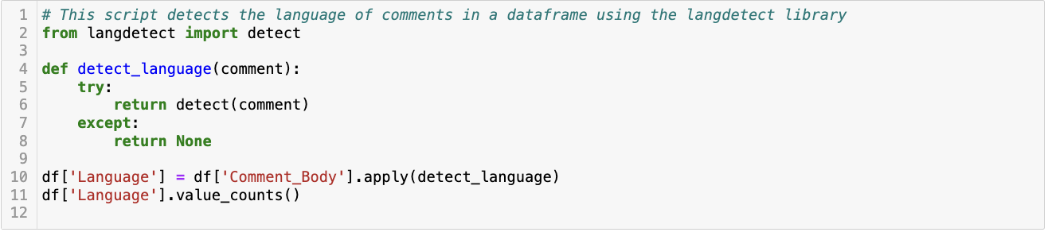

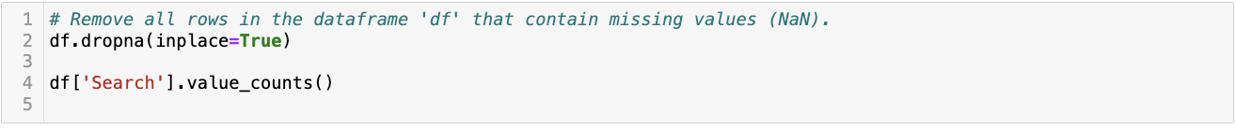



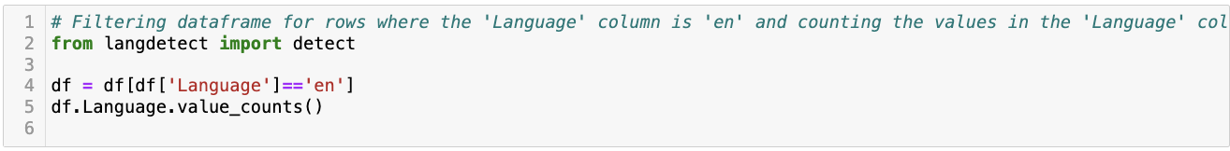

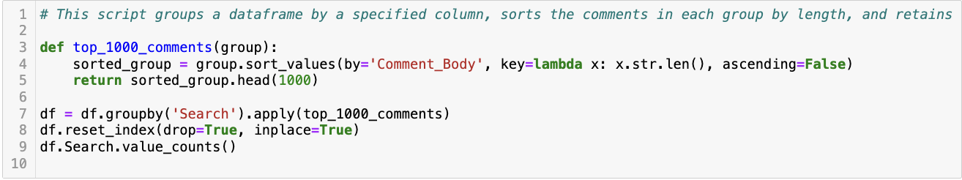

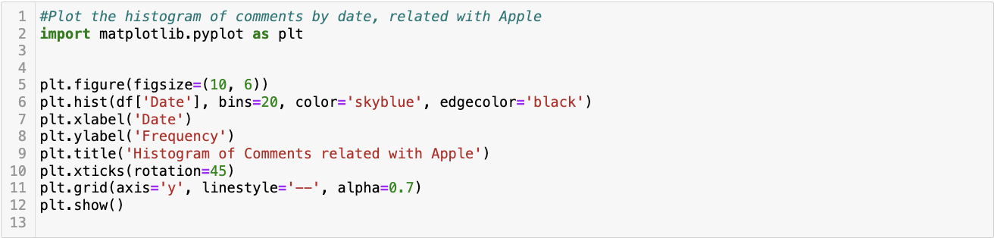



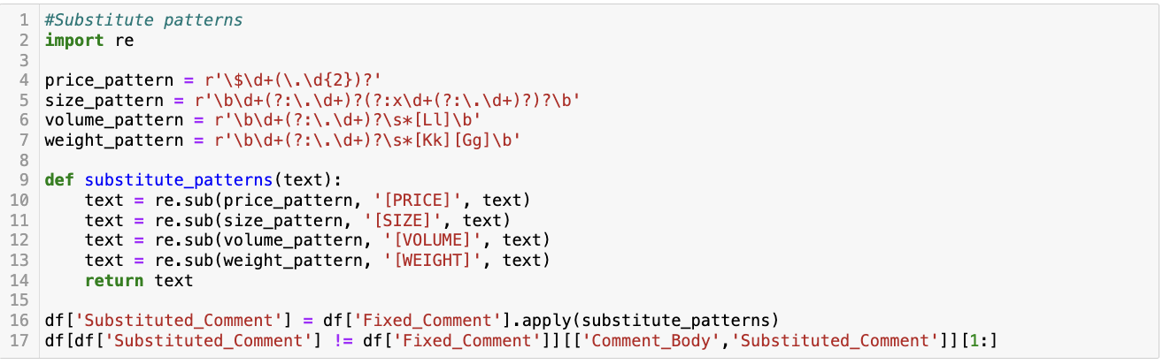

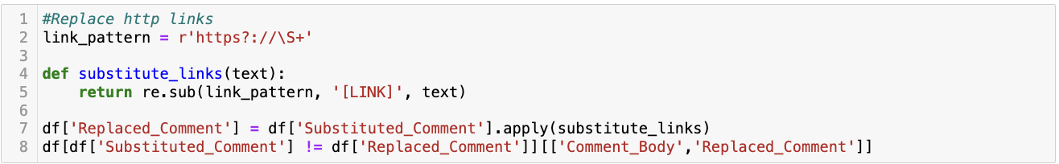

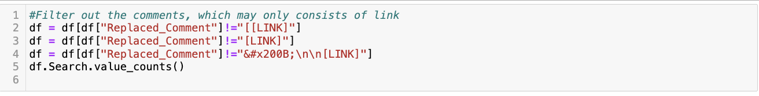

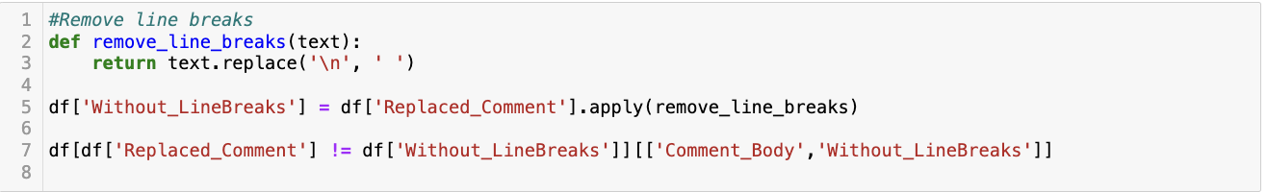

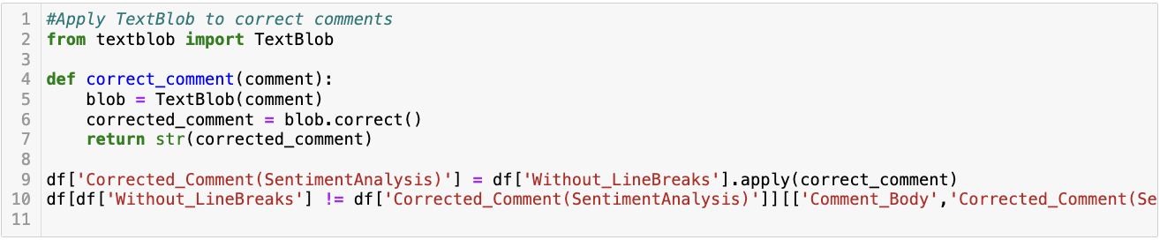



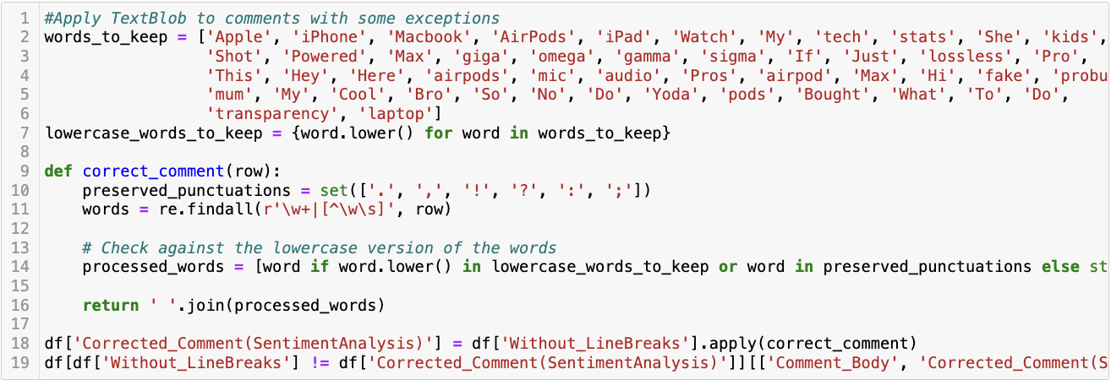



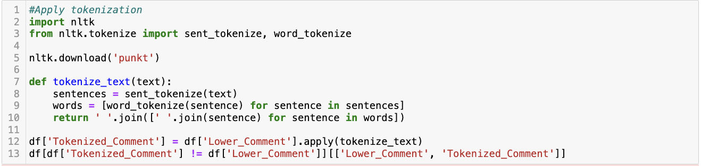

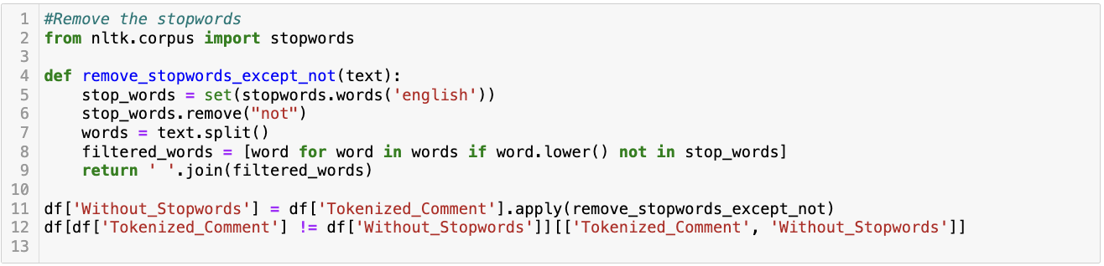

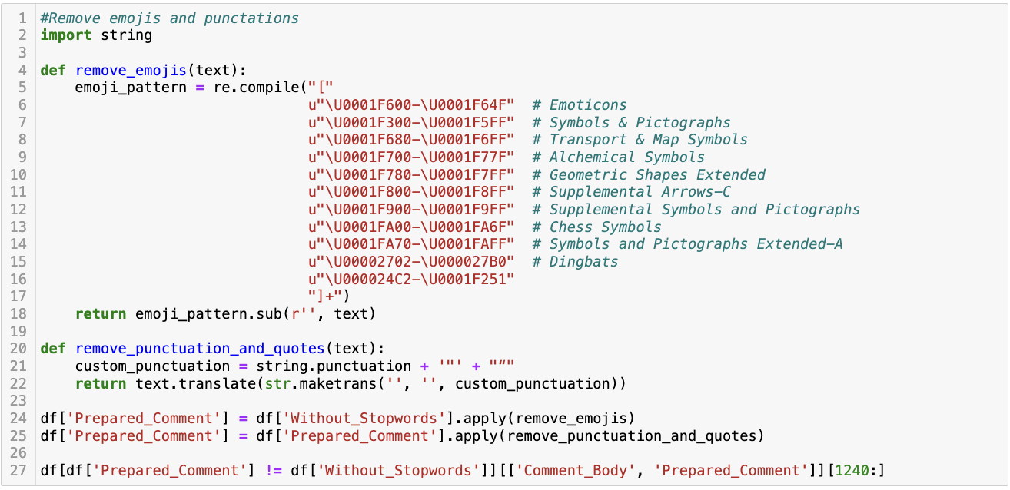

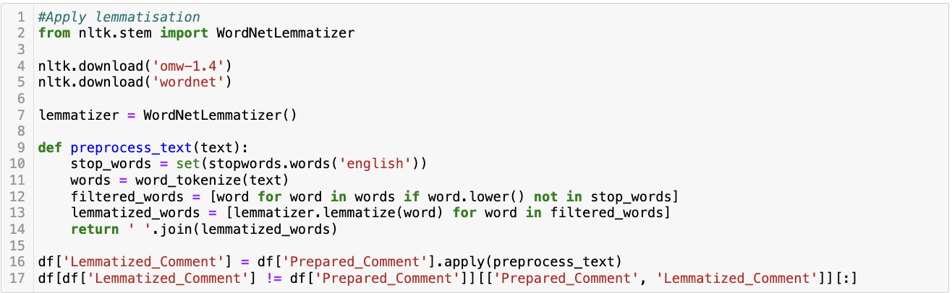





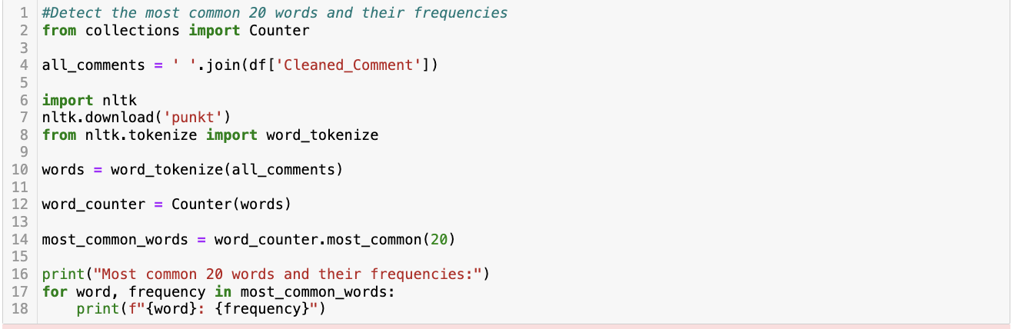

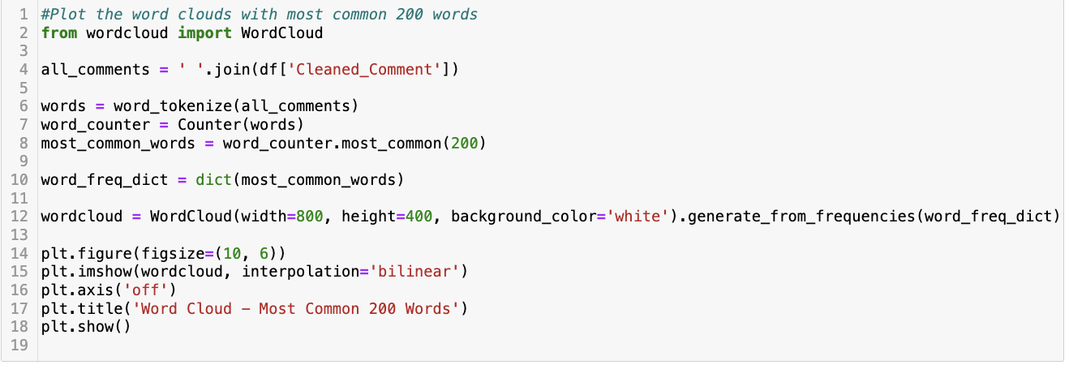

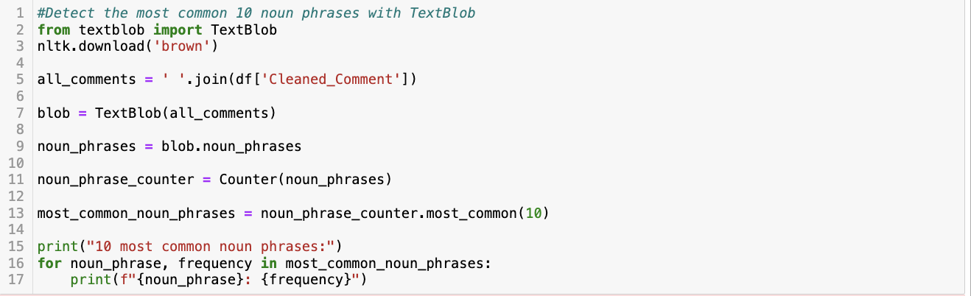

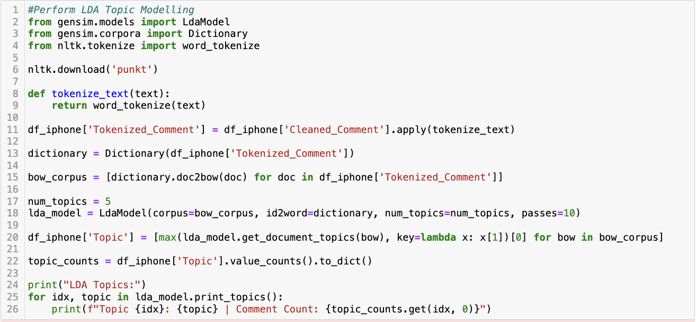

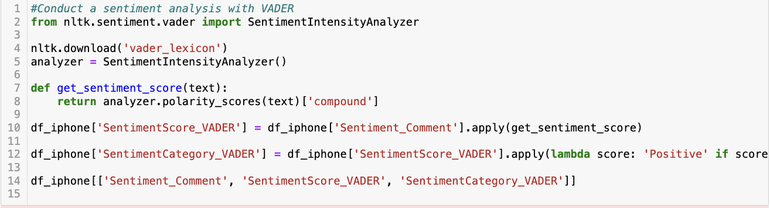

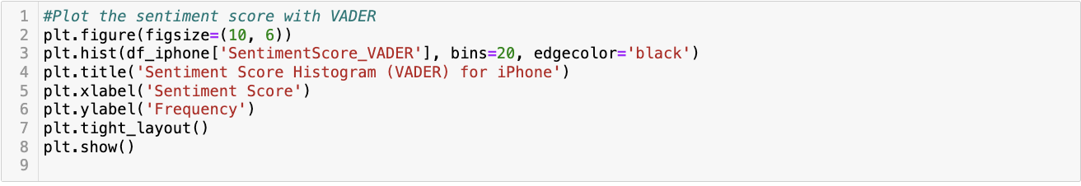

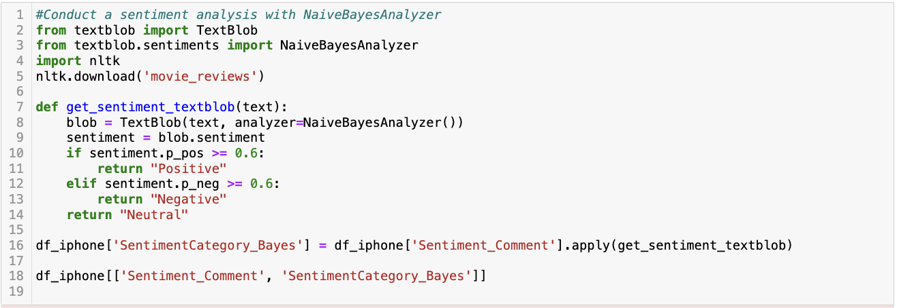



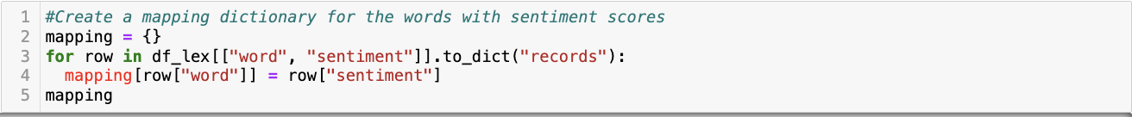

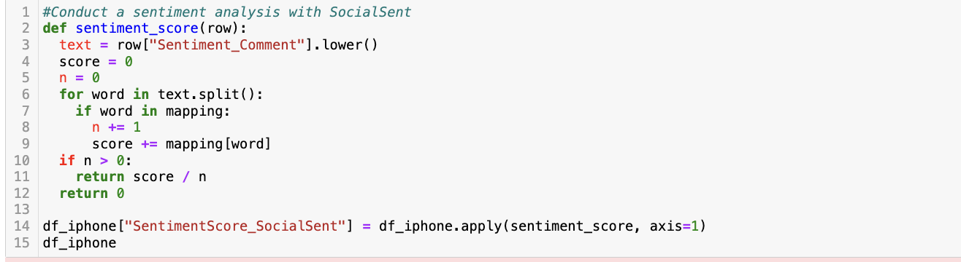

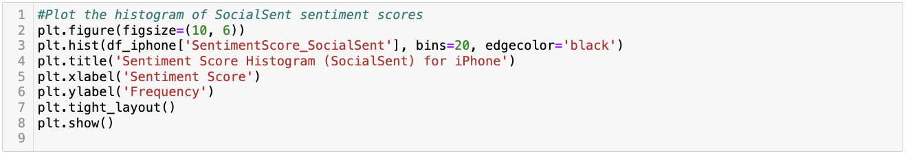

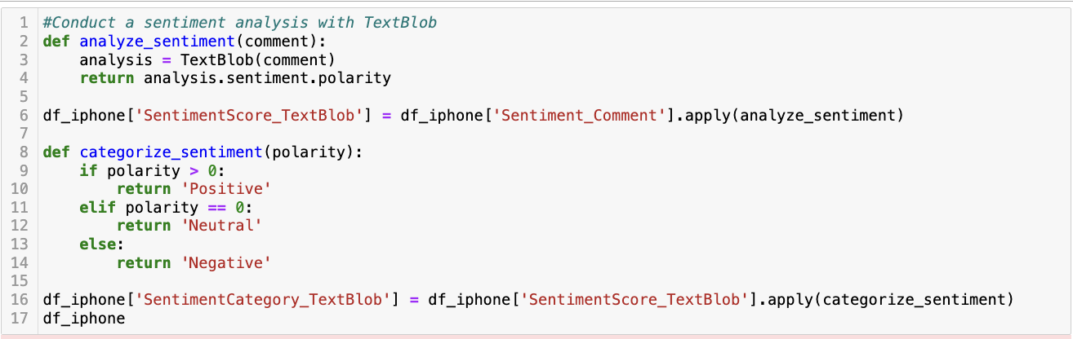

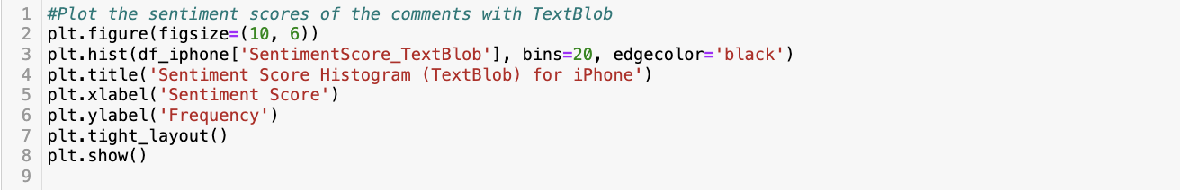

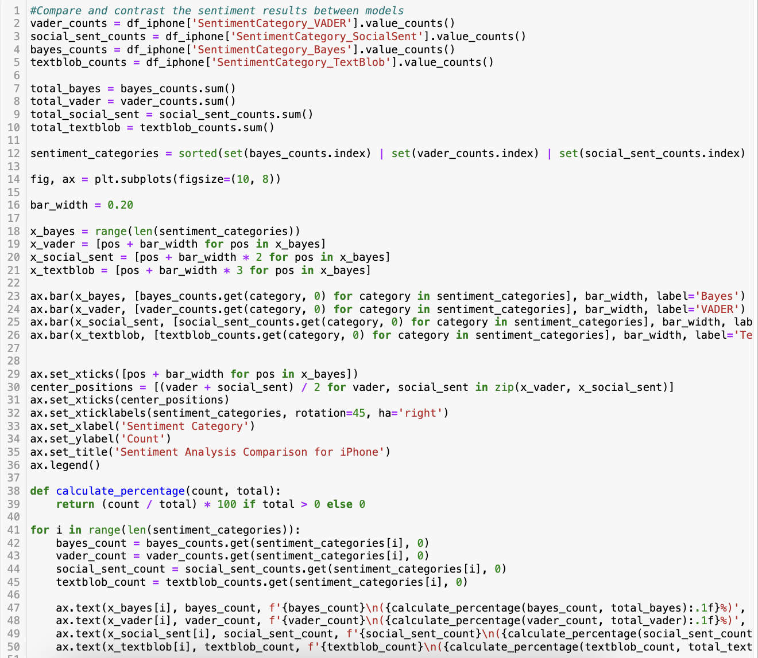



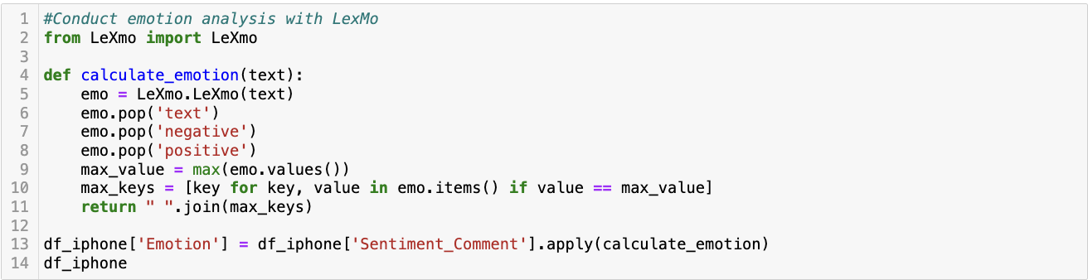

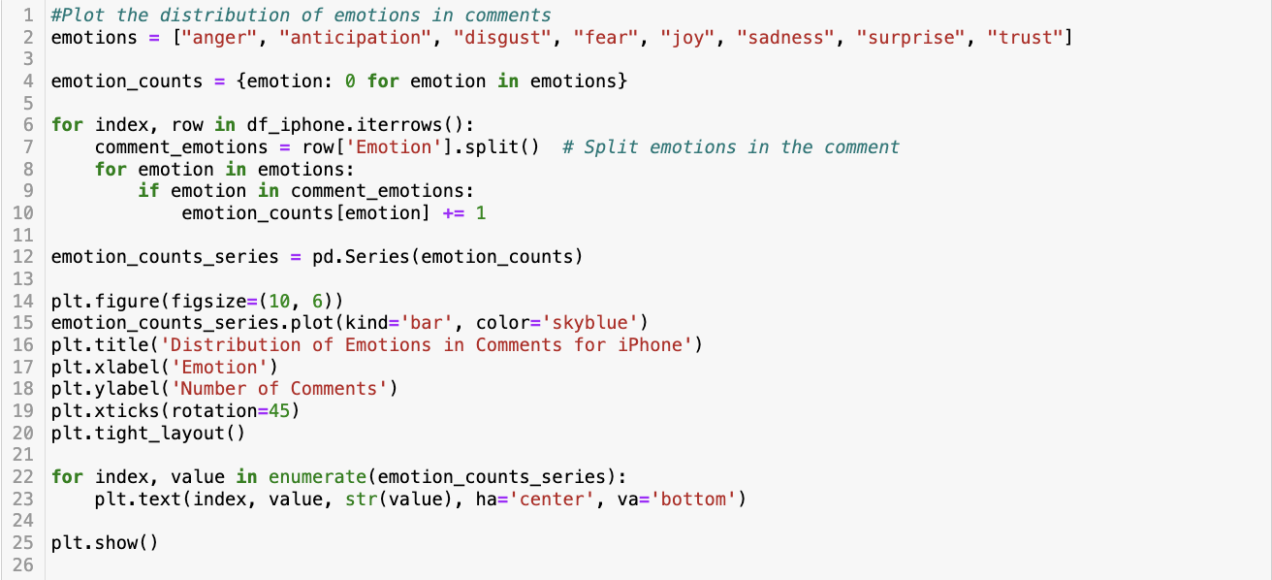

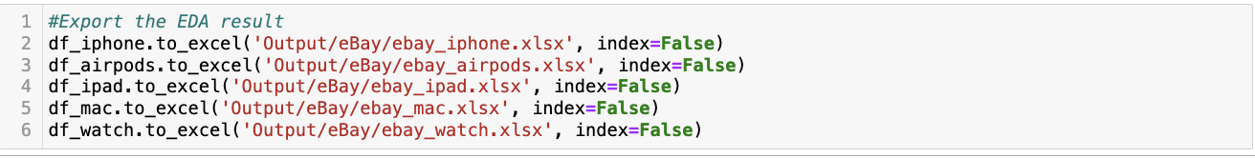

Python Code – Machine Learning Model

